**Practical 1**

**Aim: Creating and running virtual machines on Hosted Hypervisors Type 1 – KVM**

**NOTE*: The Practical is not implemented because Laptop is not suppporting it.**

STEP 1: Verifying Hardware Support $ egrep -c ‘(svm|vmx)’ /proc/cpuinfo

STEP 2: Installing the KVM Package $ sudo apt-get install qemu-kvm libvirt-bin bridge-utils virt-manager

STEP 3: Adding Your User Account to KVM $ sudo adduser [username] libvirtd

STEP 4: Verifying Successful Installation $ virsh -c qemu:///system list

STEP 5: After the successful installation of KVM, you can start working with it

STEP 6: Now create a sample virtual machine through the manager

STEP 7: You can create a new virtual machine through the File Menu, Create a new virtual

Machine icon on the toolbar, or through the right-click menu at QEMU/KVM entry under the ‘Name’

column.

STEP 8: Select your installation option from the four available options and click the Forward button.

selecting the Local install Media option as the ISO file is already downloaded on my system.

STEP 9: Choose the location for installing media. You can wish to install it through a CD ROM or DVD,

use an ISO image of the installation package.

STEP 10: For 64 bit systems, you can even choose more than 2 GB from the memory available on the host computer. Through this dialog, you can also select the CPU number from the available processors of your system.

STEP 11: Click the Forward button after enabling storage.

STEP 12: Click the Finish button. The installation of your new VM will begin depending on your choices

and the installation options you provided.

**Practical 2**

**Aim: Creating and running virtual machines on Hypervisors Type 1 – ESXI**

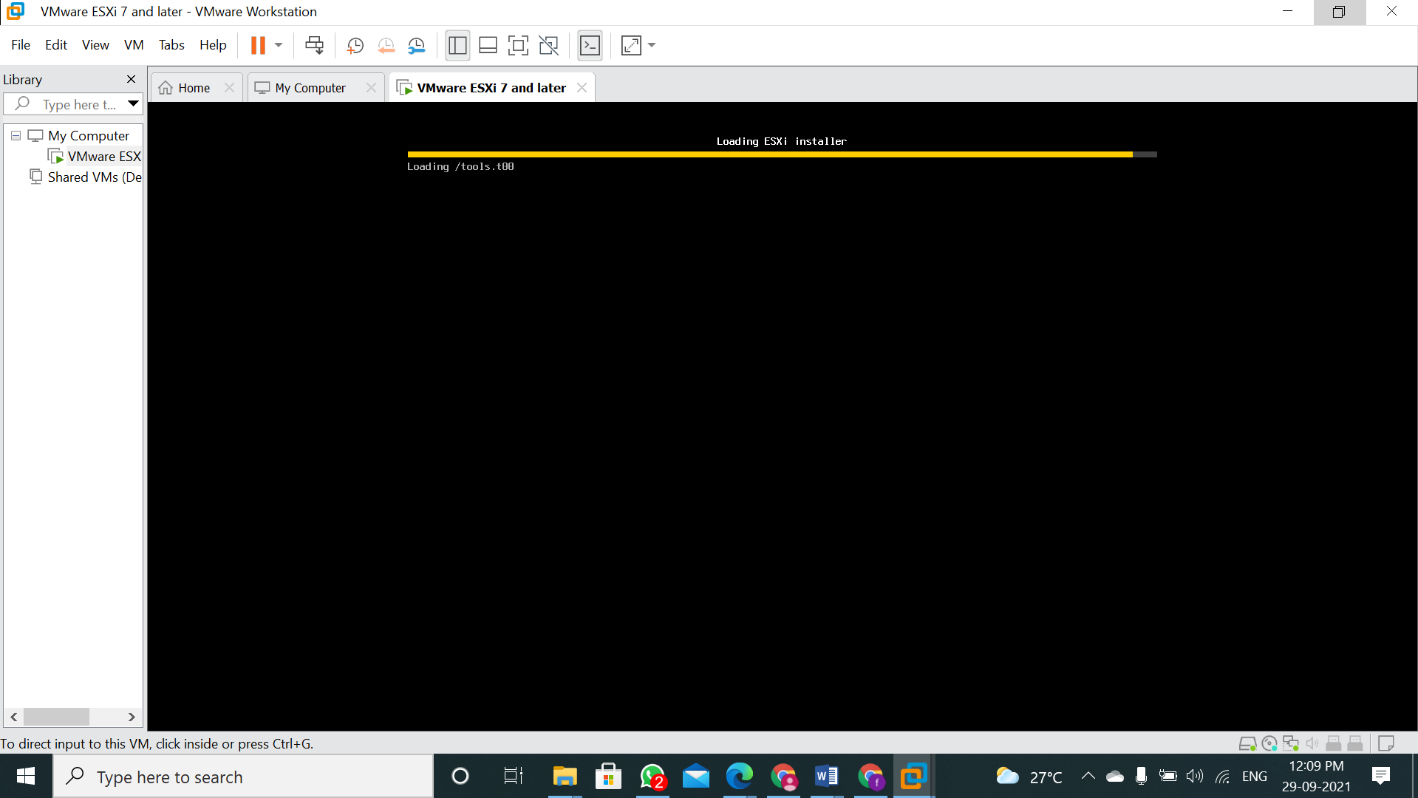

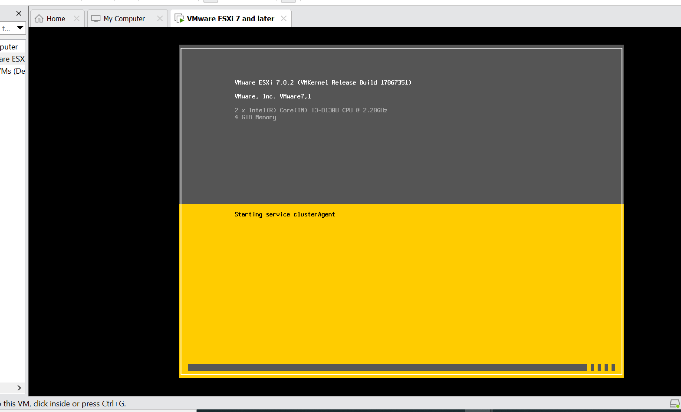

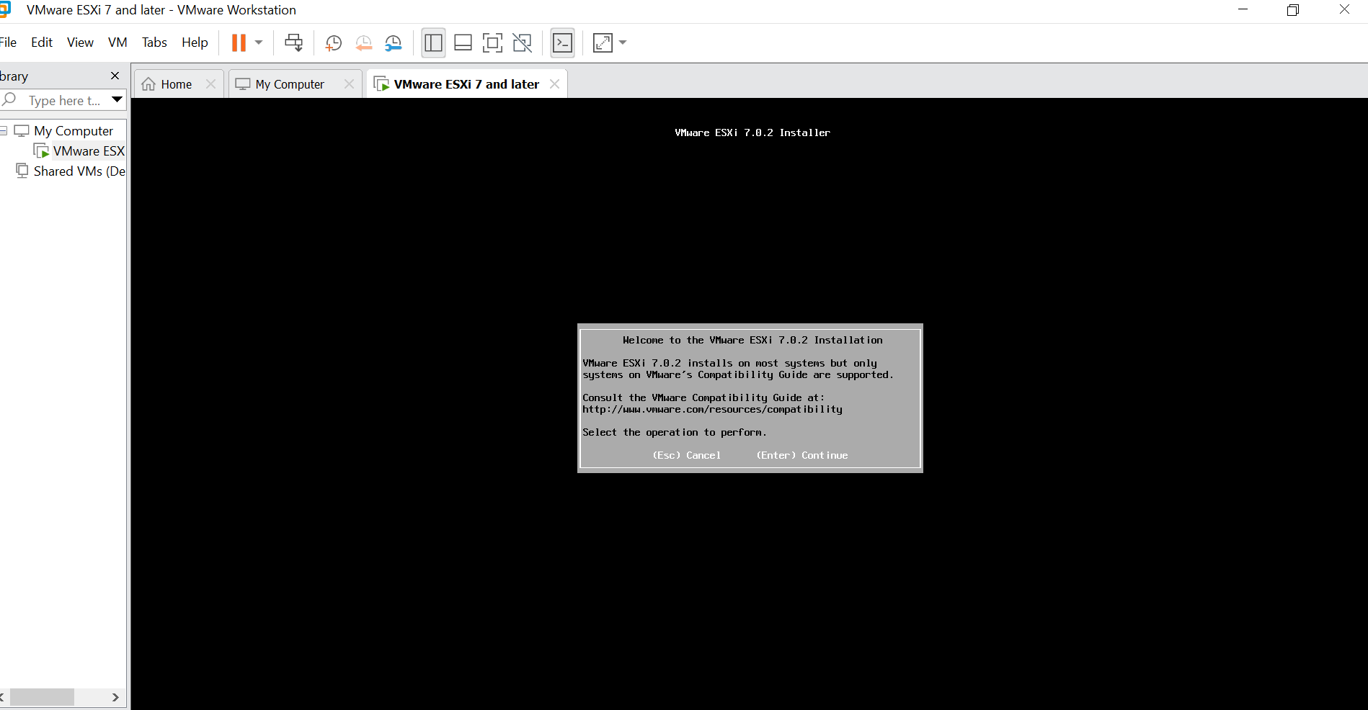

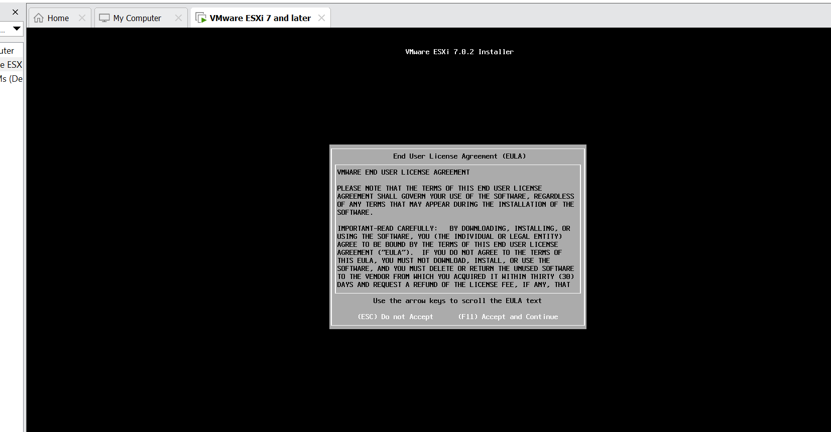

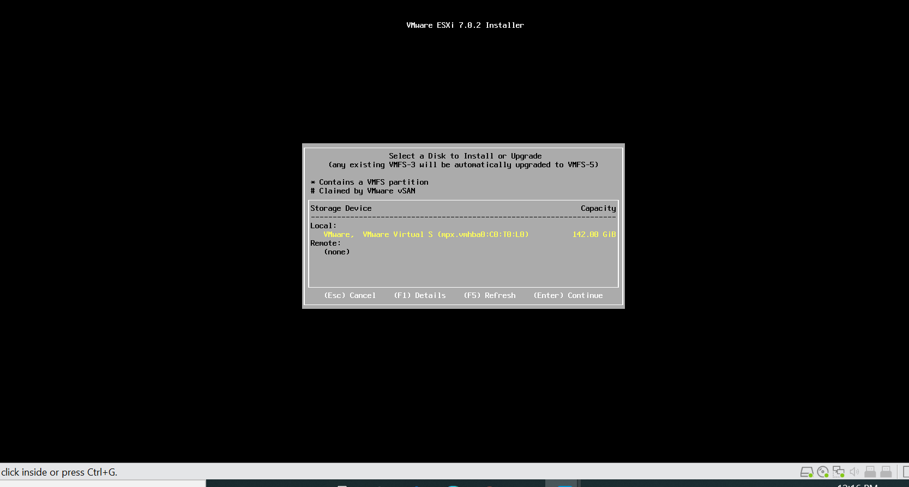

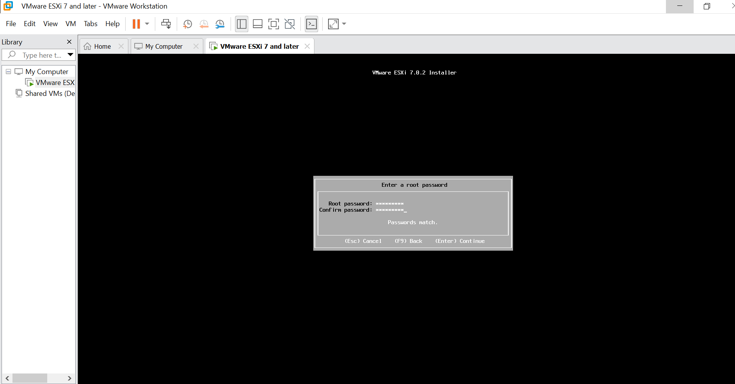

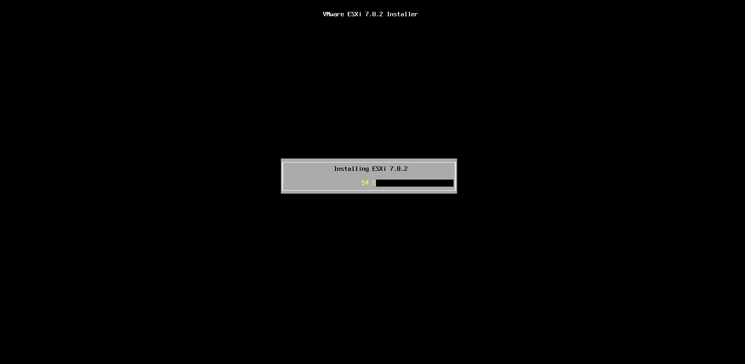

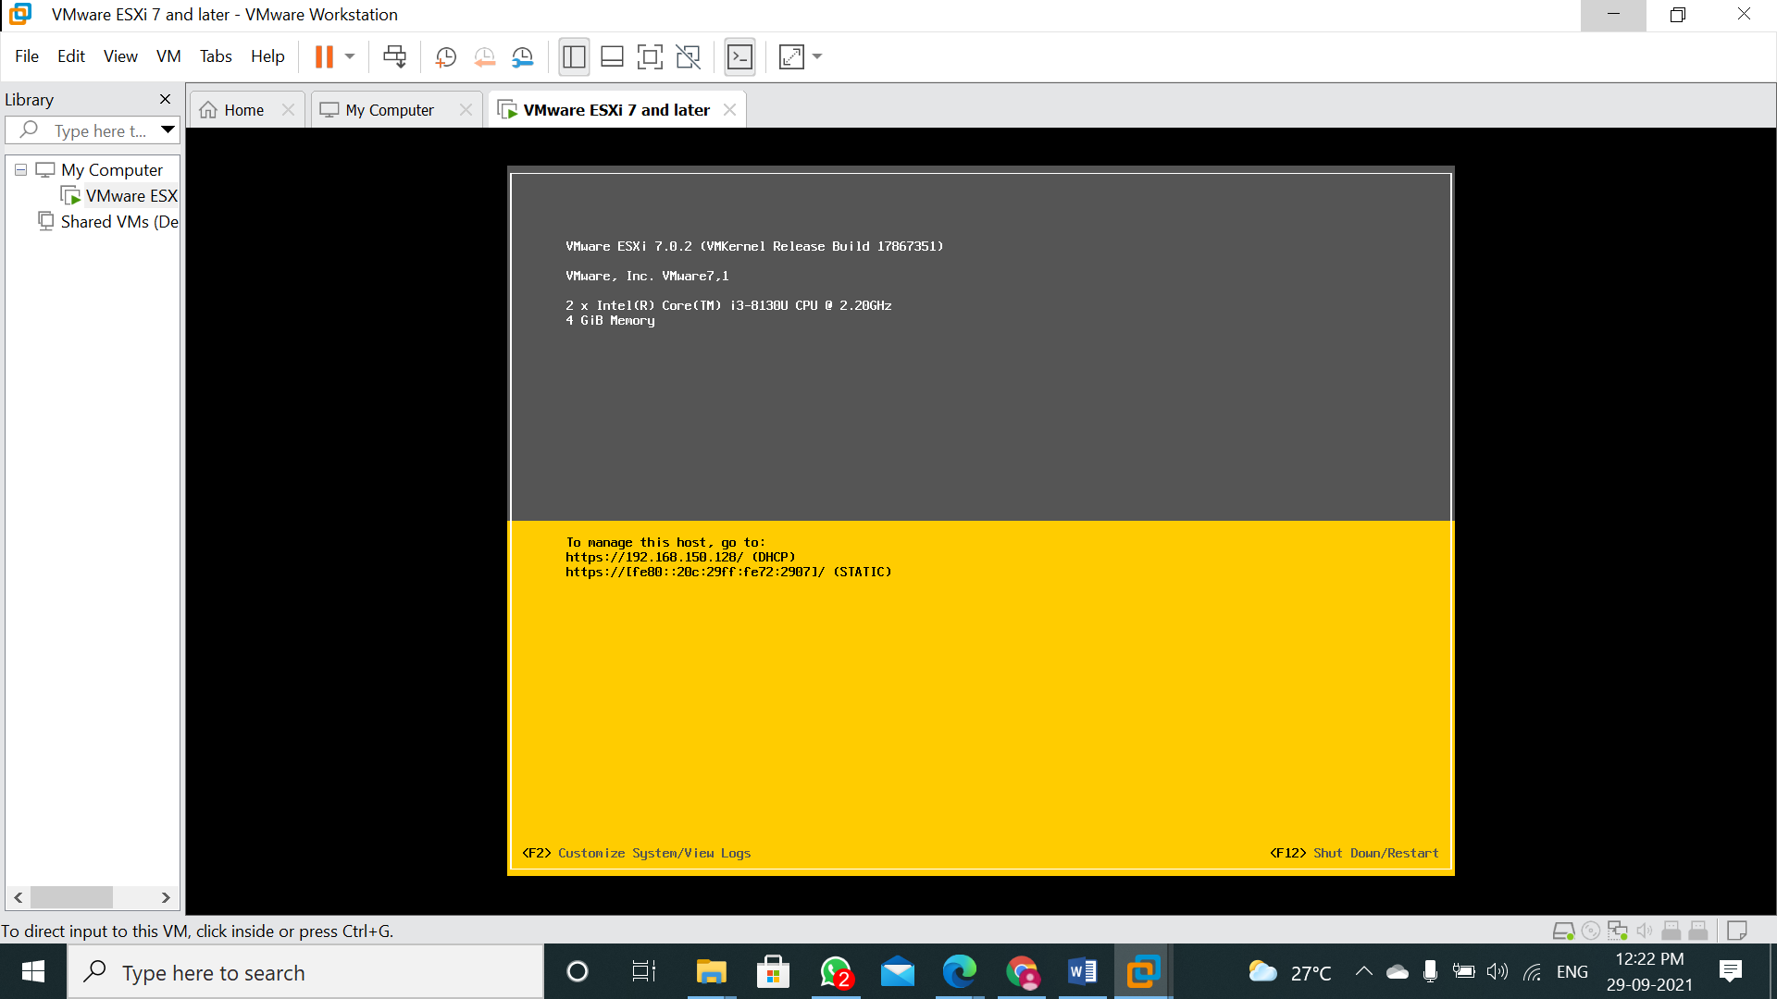

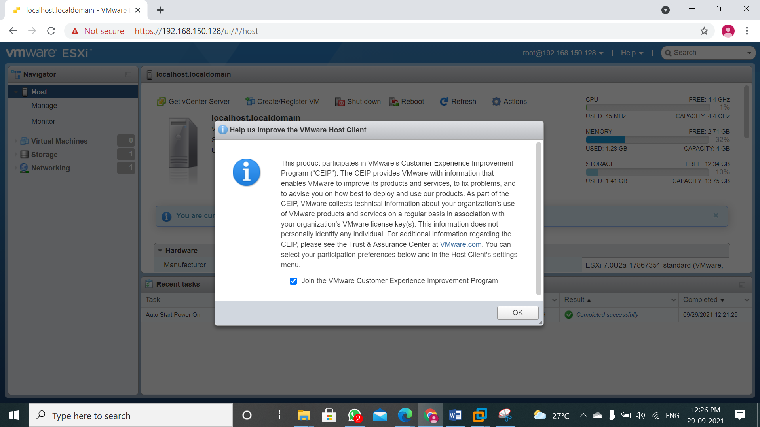

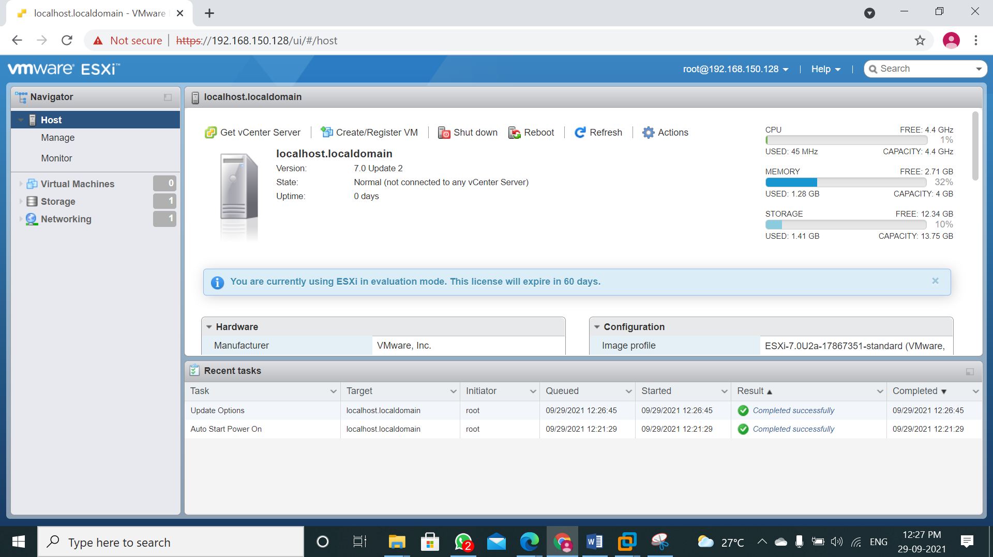

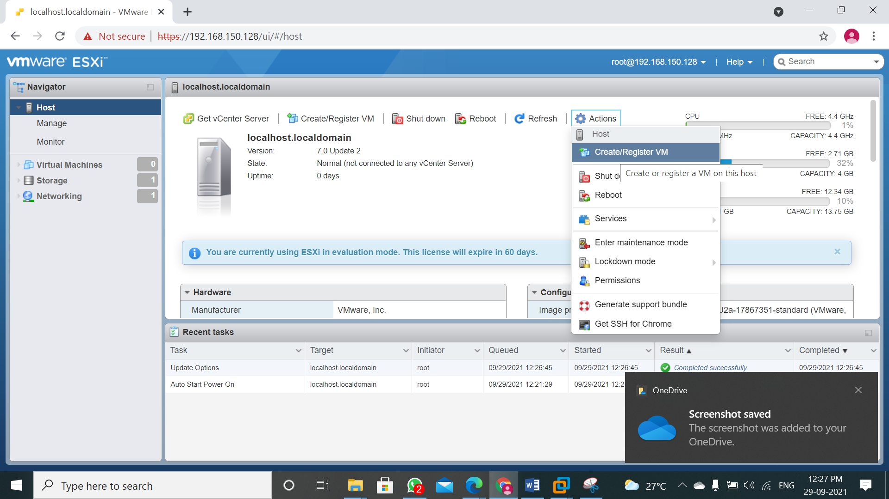

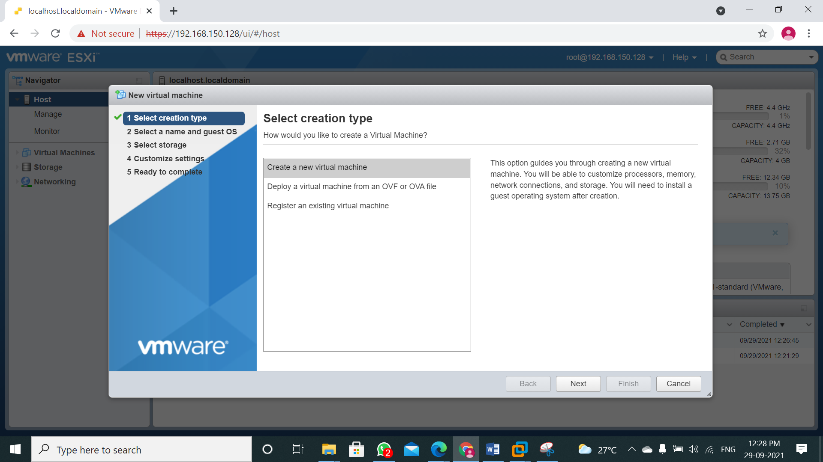

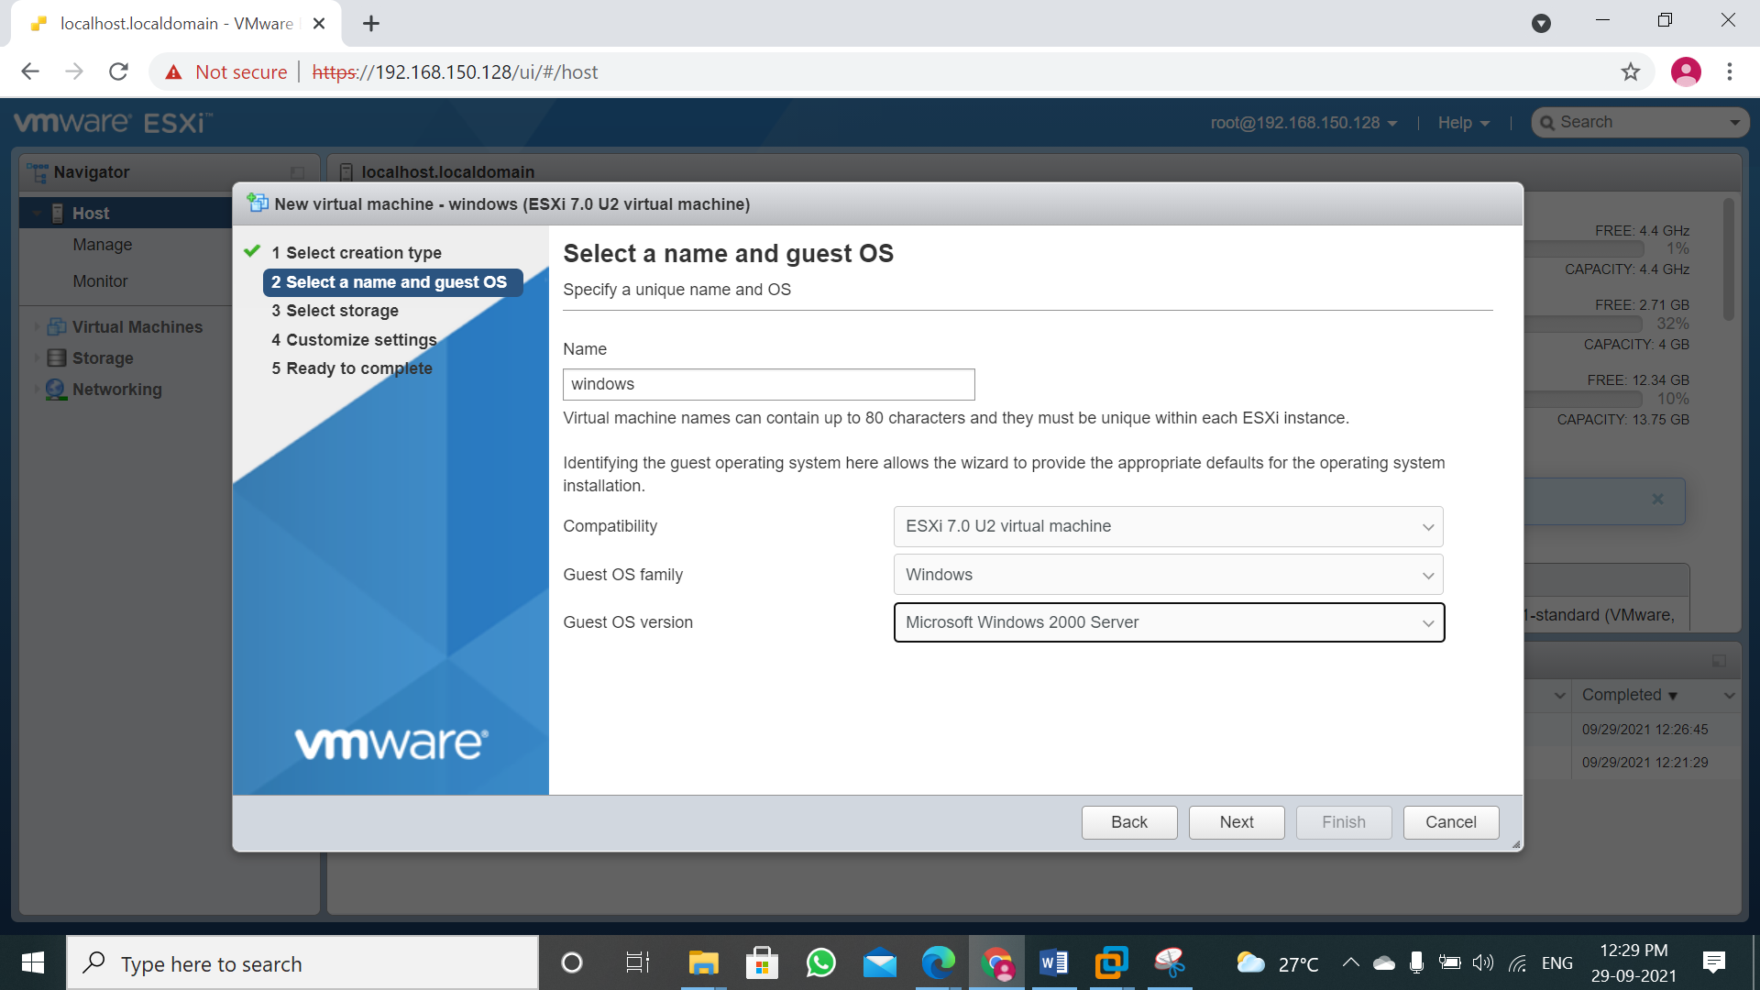

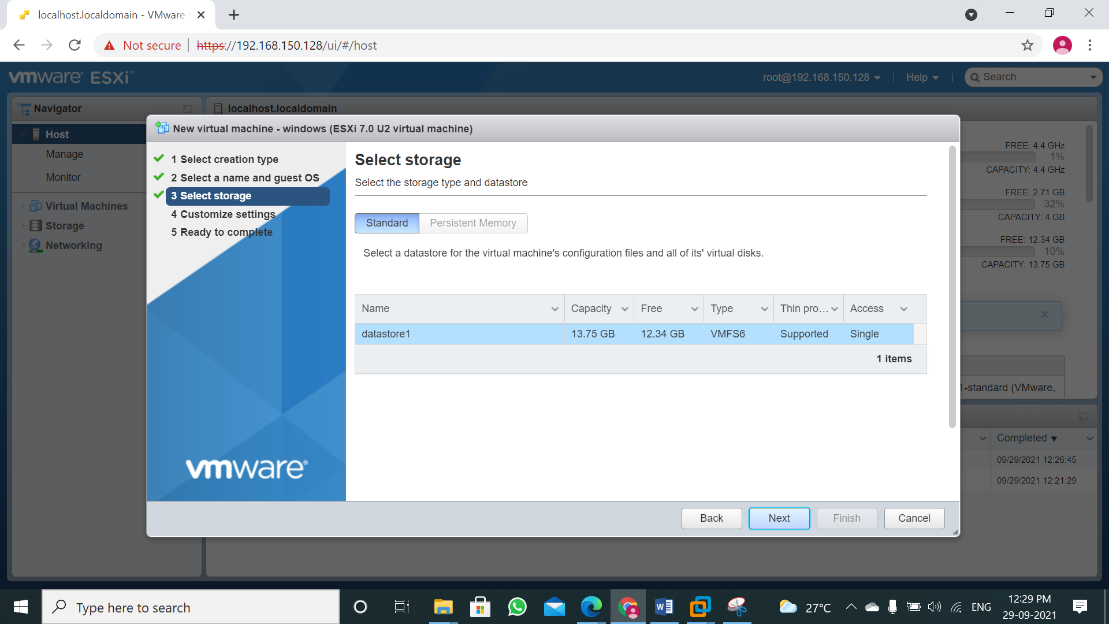

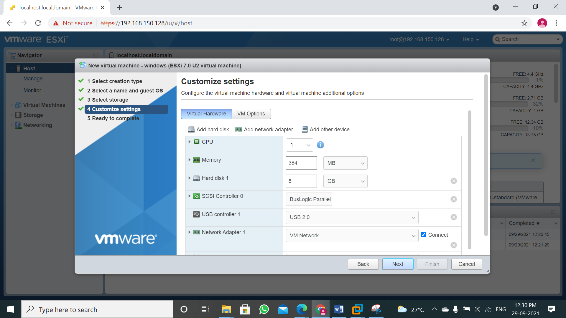

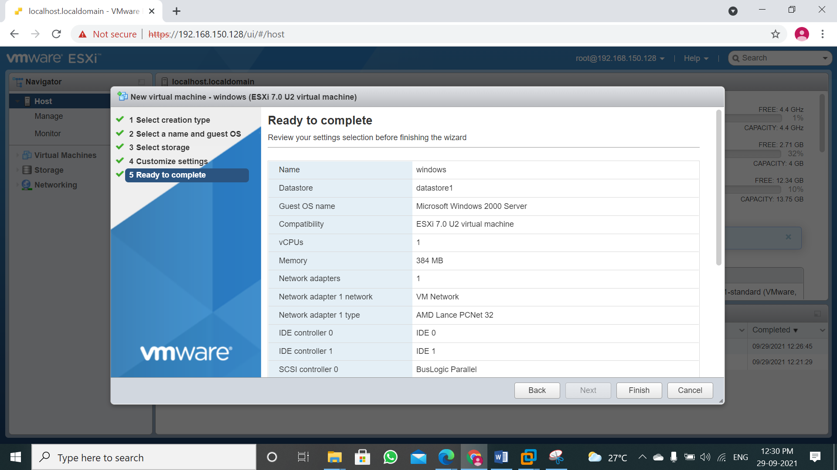

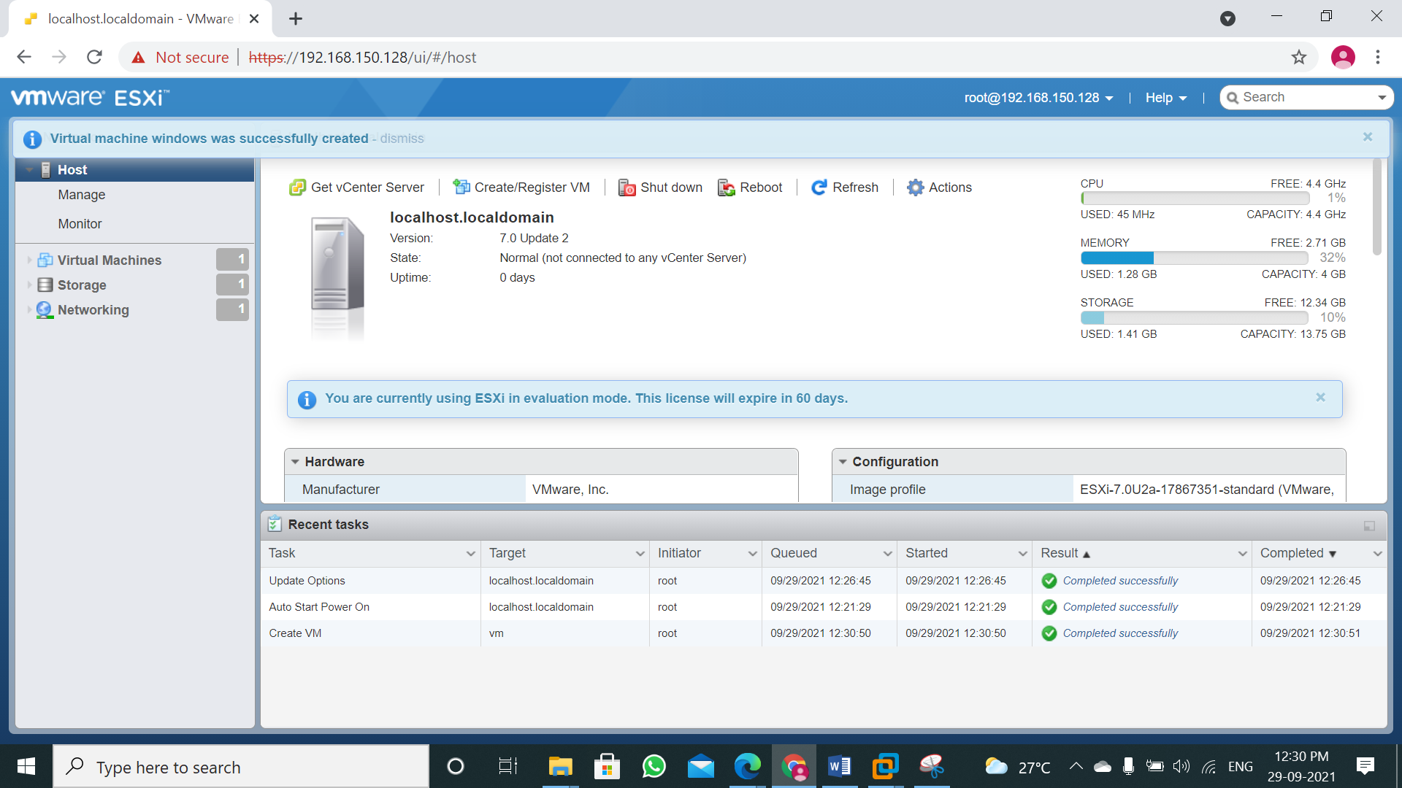

**Practical 3**

**Aim: Study and Implement Software as a service.**

**PROCEDURE:**

STEP 1: Sign into Google Drive website using Google account. If you don't have nay account create a account. Google Drive will allow you to store your files in the cloud, as well as create documents and forms through the Google Drive web Interface.

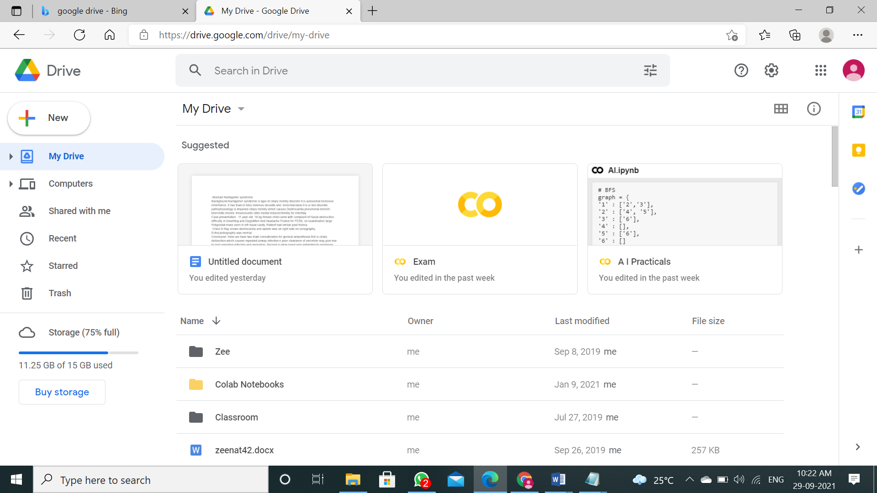

STEP 2: Add files to your drive. There are 2 ways to add files - You can create or you can upload from your computer. To create new file click NEW button, to upload click file upload or folder upload.

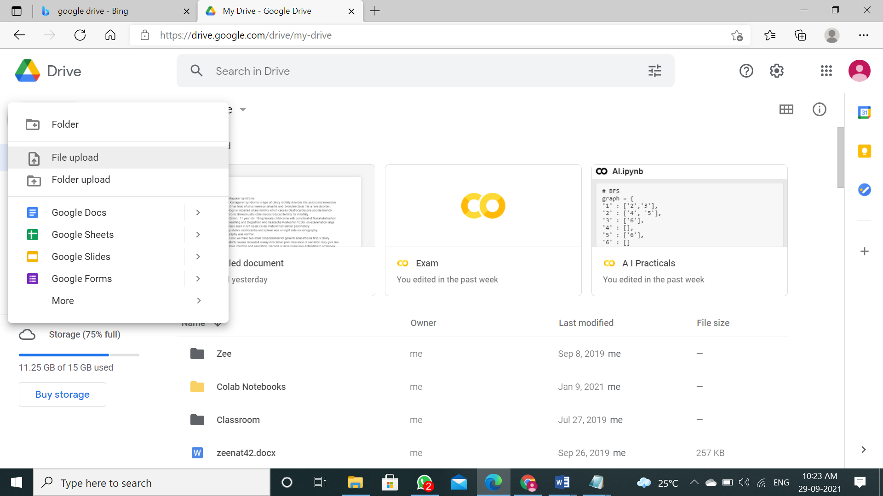

STEP 3: You can now Upload a File after clicking on the Button.

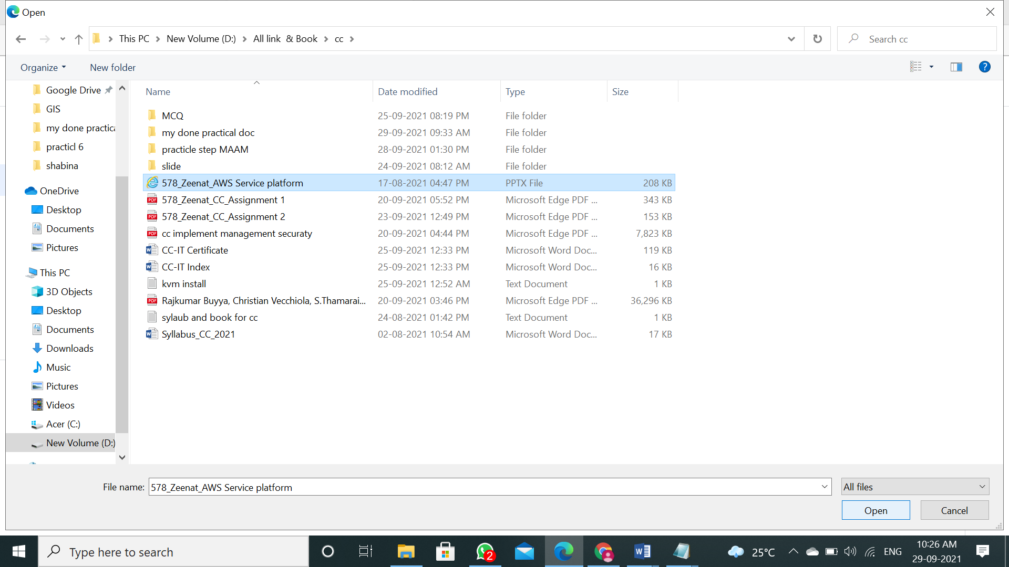

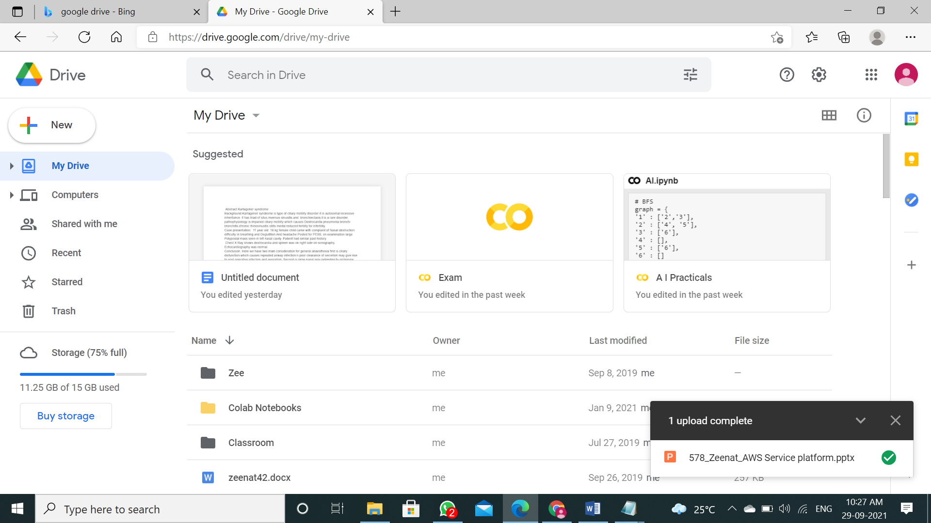

STEP 4: File successfully uploaded on Google Drive.

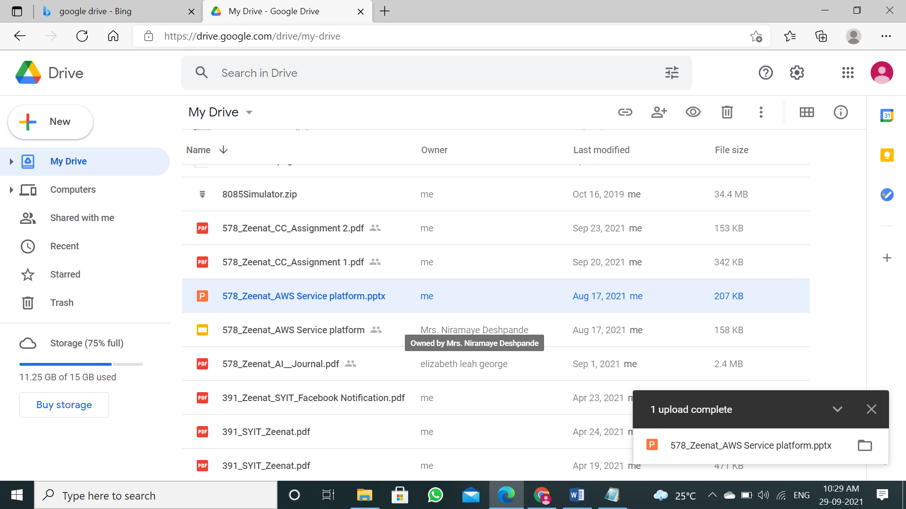

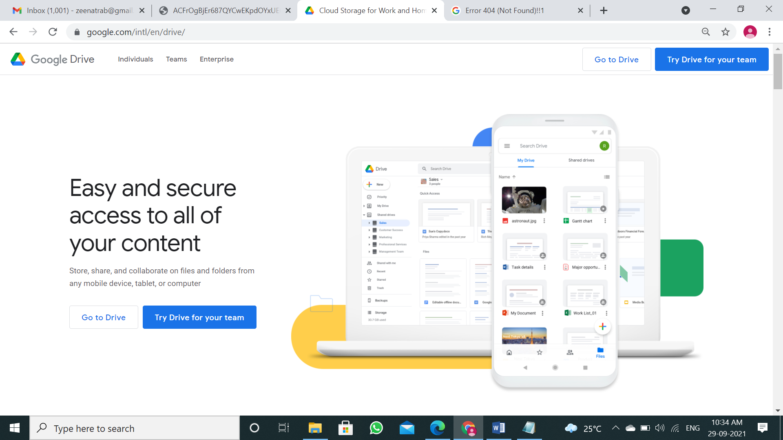

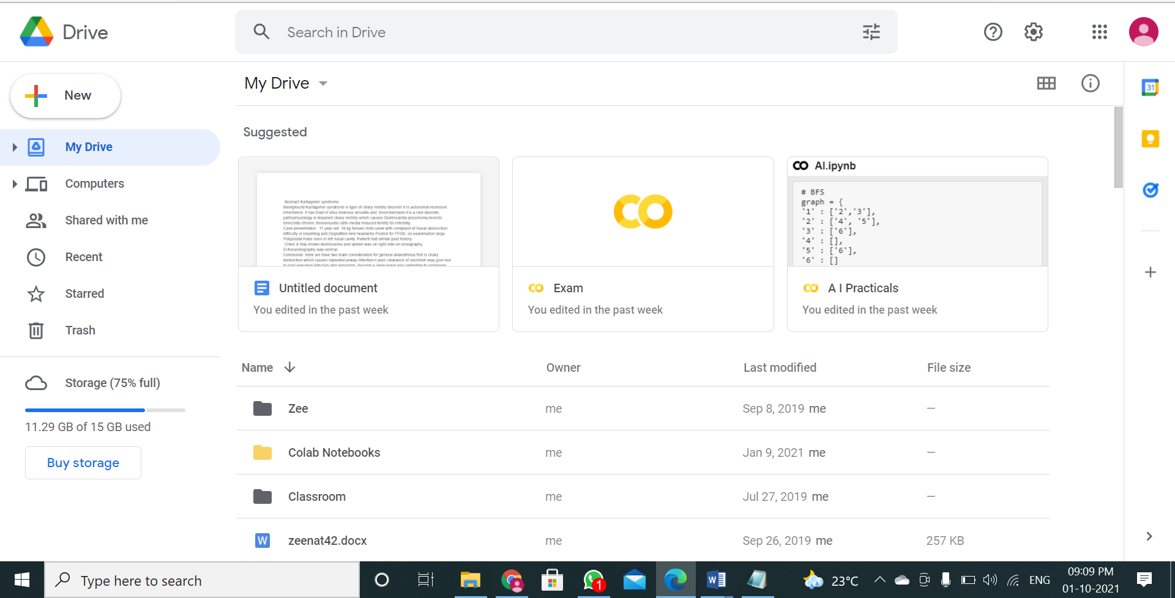

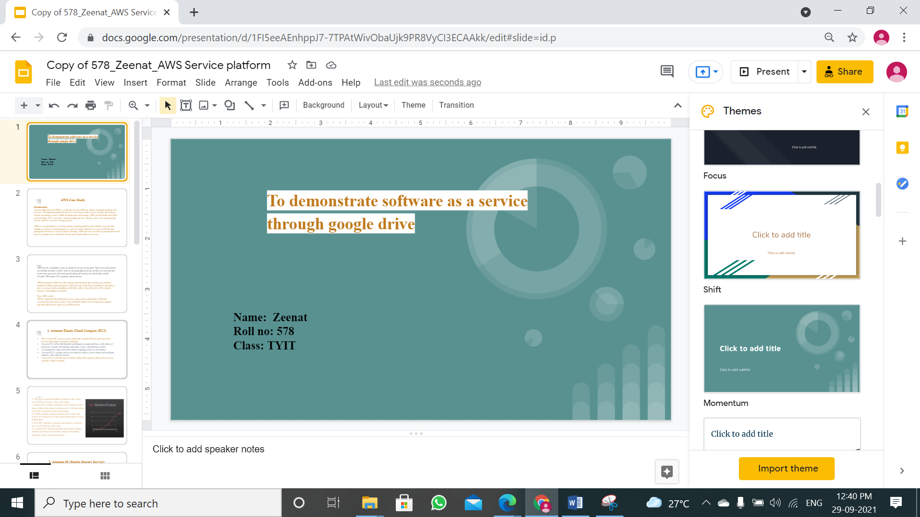

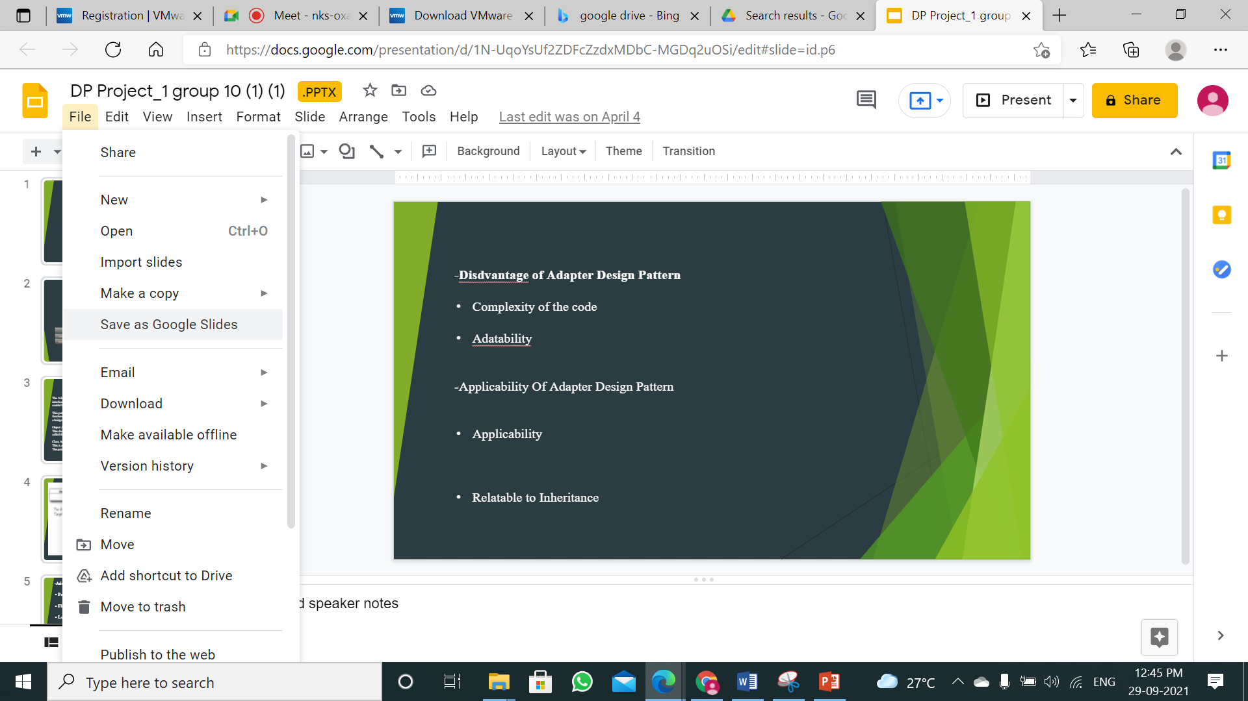

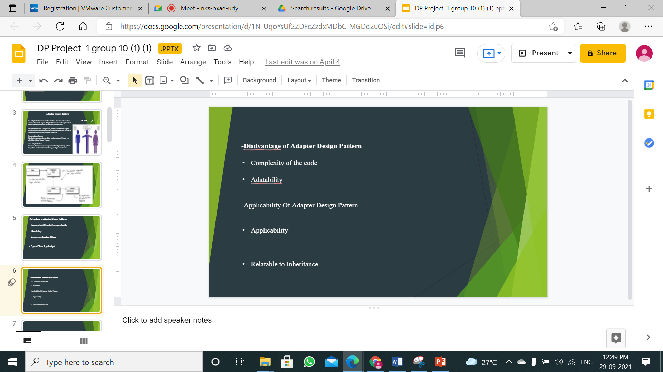

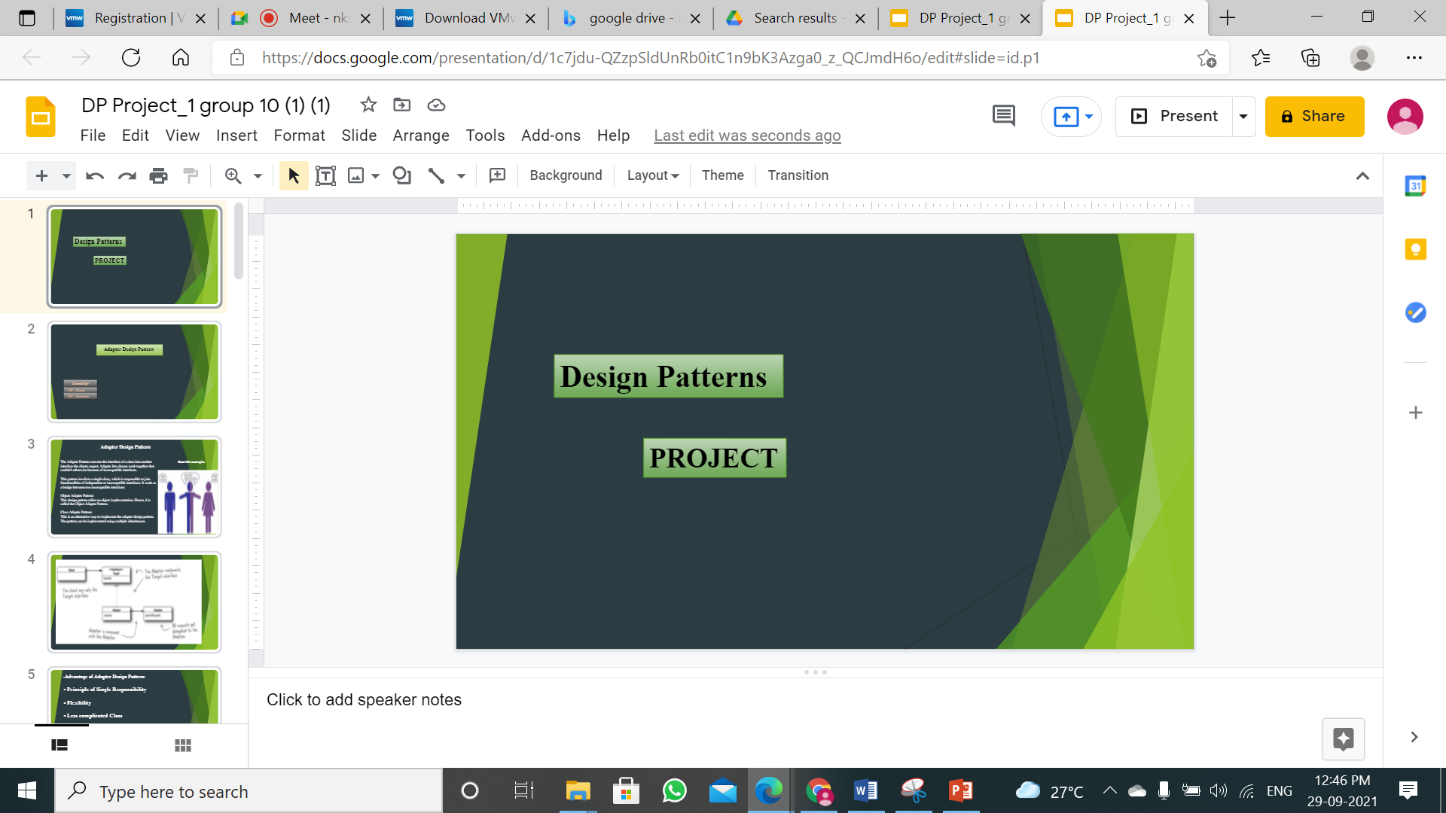

**Practical 4**

**Aim: To demonstrate PaaS with Google App Engine.**

**Theroy:**

Step 1: Create account

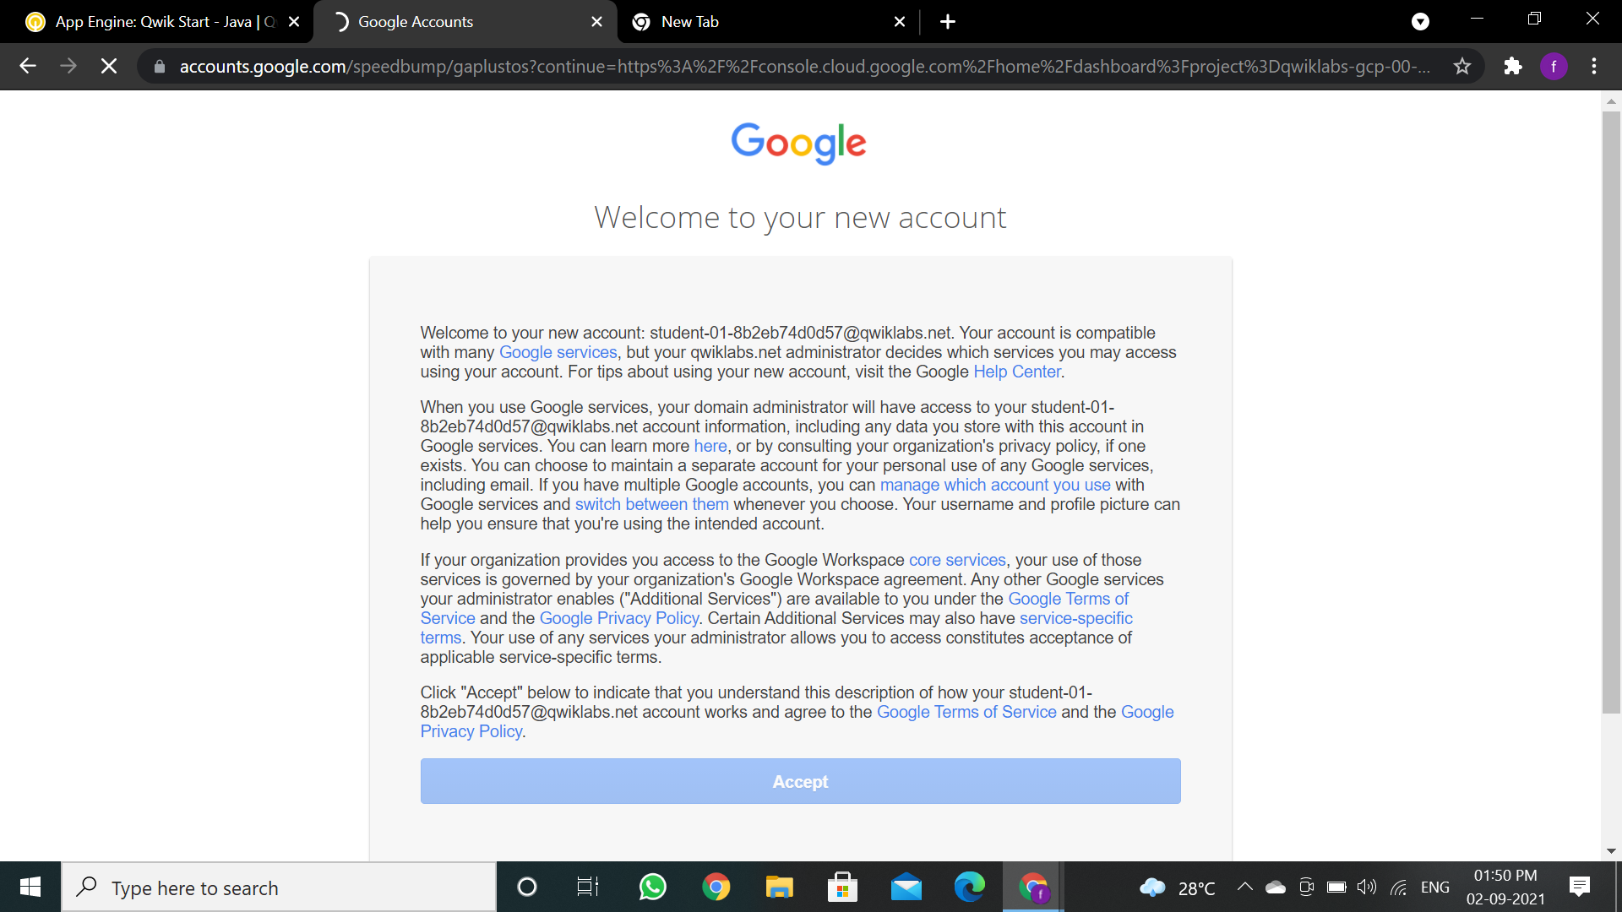

Click the **Start Lab** button. If you need to pay for the lab, a pop-up opens for you to select your payment method. On the left is a panel populated with the temporary credentials that you must use for this lab.

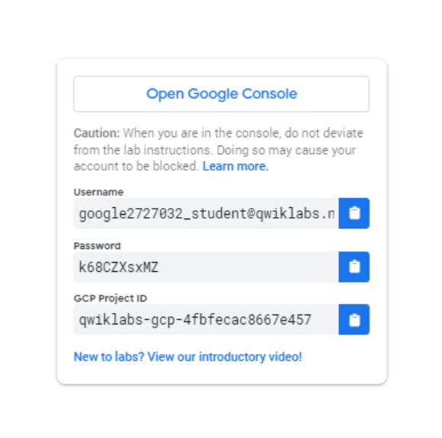

Copy the username, and then click **Open Google Console**. The lab spins up resources, and then opens another tab that shows the **Sign in** page.

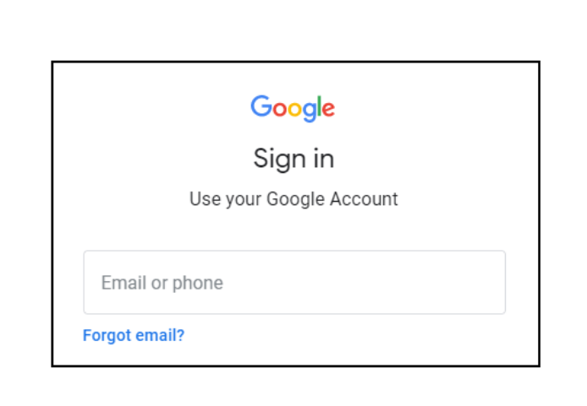

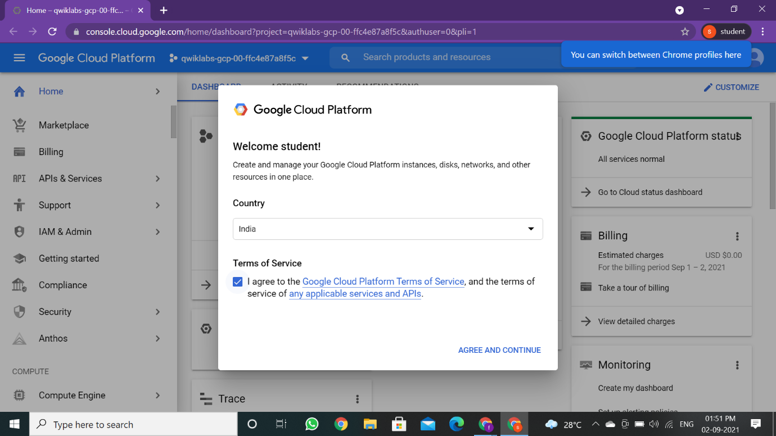

In the **Sign in** page, paste the username that you copied from the Connection Details panel. Then copy and paste the password.

### **Activate Cloud Shell**

### Cloud Shell is a virtual machine that is loaded with development tools. It offers a persistent 5GB home directory and runs on the Google Cloud. Cloud Shell provides command-line access to your Google Cloud resources.

In the Cloud Console, in the top right toolbar, click the **Activate Cloud Shell** button.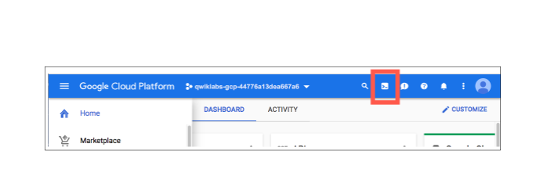Click **Continue**.

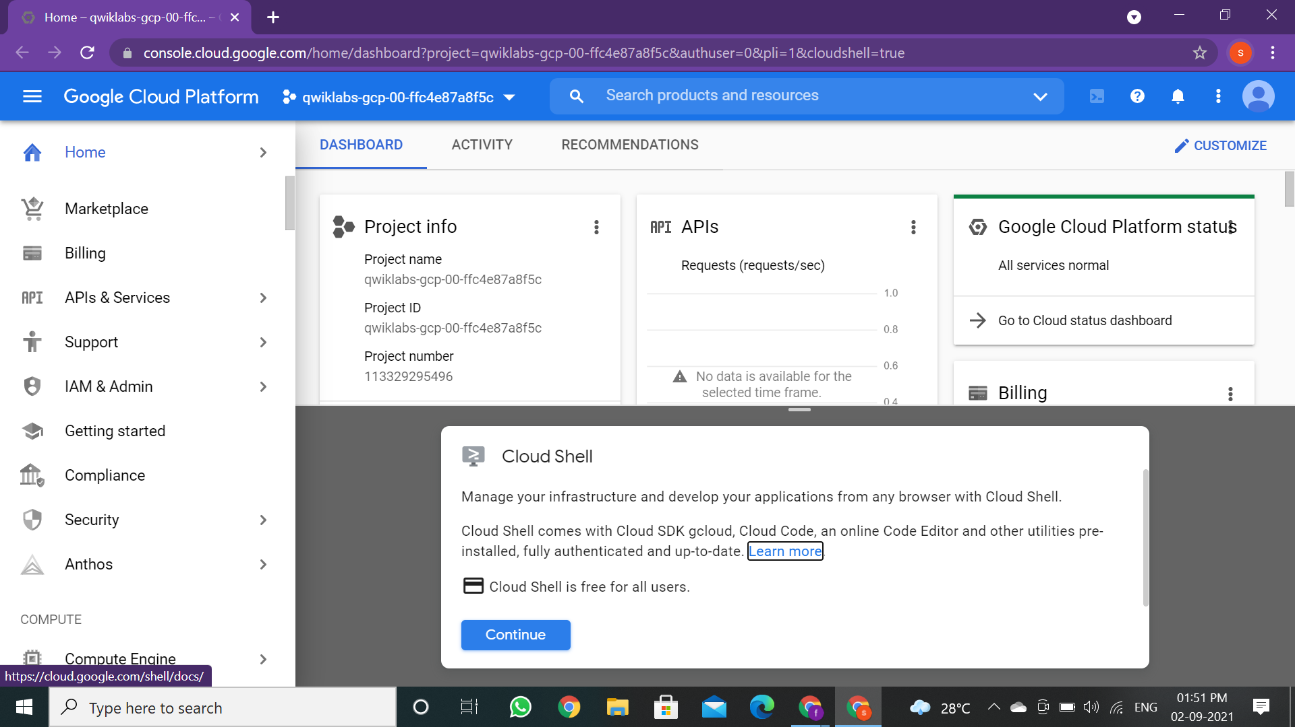

It takes a few moments to provision and connect to the environment. When you are connected, you are already authenticated, and the project is set to your PROJECT_ID. For example:

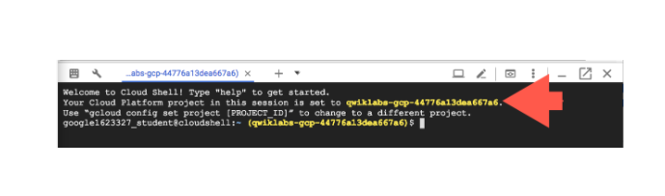

gcloud is the command-line tool for Google Cloud. It comes pre-installed on Cloud Shell and supports tab-completion.

You can list the active account name with this command:

**gcloud auth list**

**gcloud config list project**

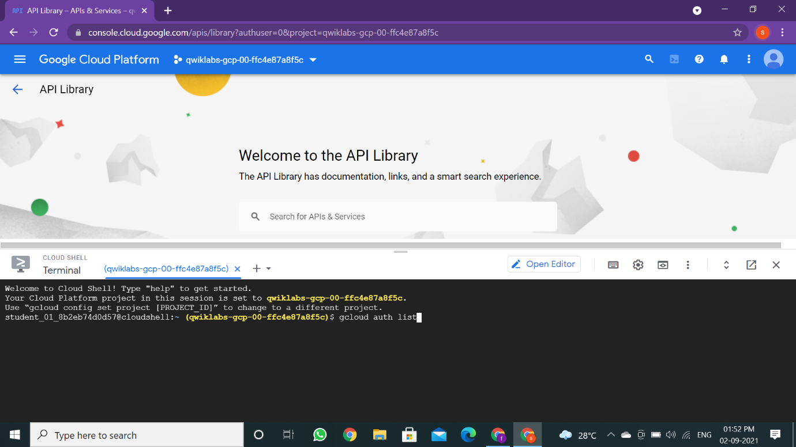

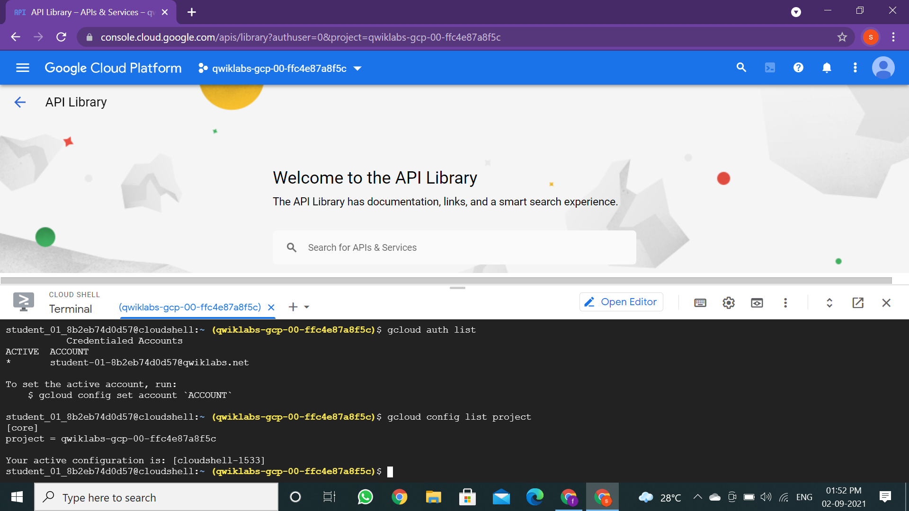

**Enable Google App Engine Admin API**

The App Engine Admin API enables developers to provision and manage their App Engine Applications.

1. In the left-hand menu click on **APIs & Services** > **Library**.

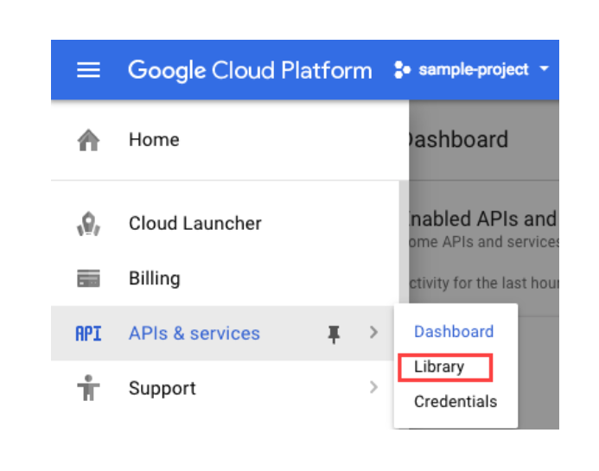

1. Type "App Engine Admin API" in the search box.
2. Click **App Engine Admin API**.

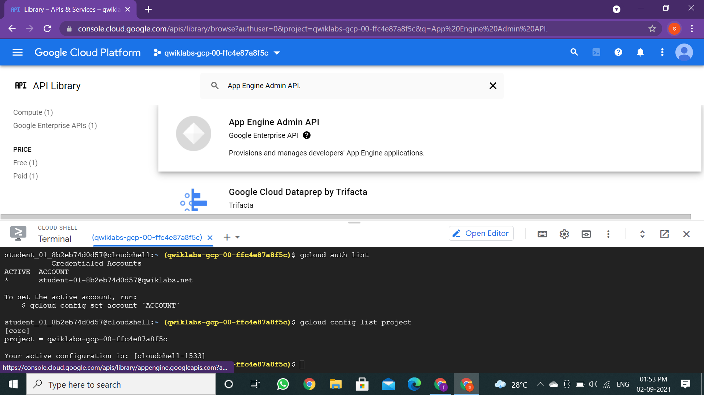

1. Click **Enable** if it isn't already set. Your page should now resemble the following:

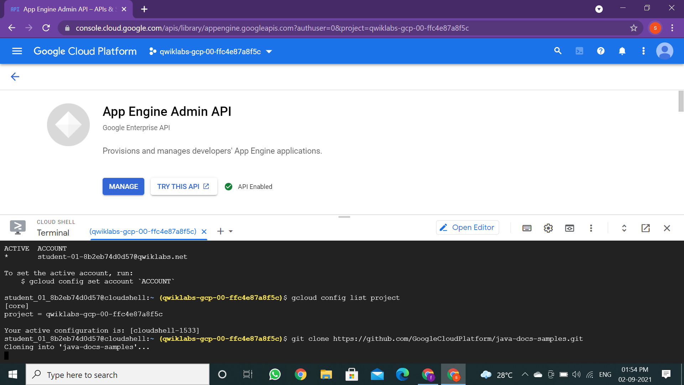

**Download the Hello World app**

1. Open a Cloud Shell session and run the following command to clone the Hello World sample app repository:

**git clone https://github.com/GoogleCloudPlatform/java-docs-samples.git**

1. Then go to the directory that contains the sample code:

**cd java-docs-samples/appengine-java8/helloworld**

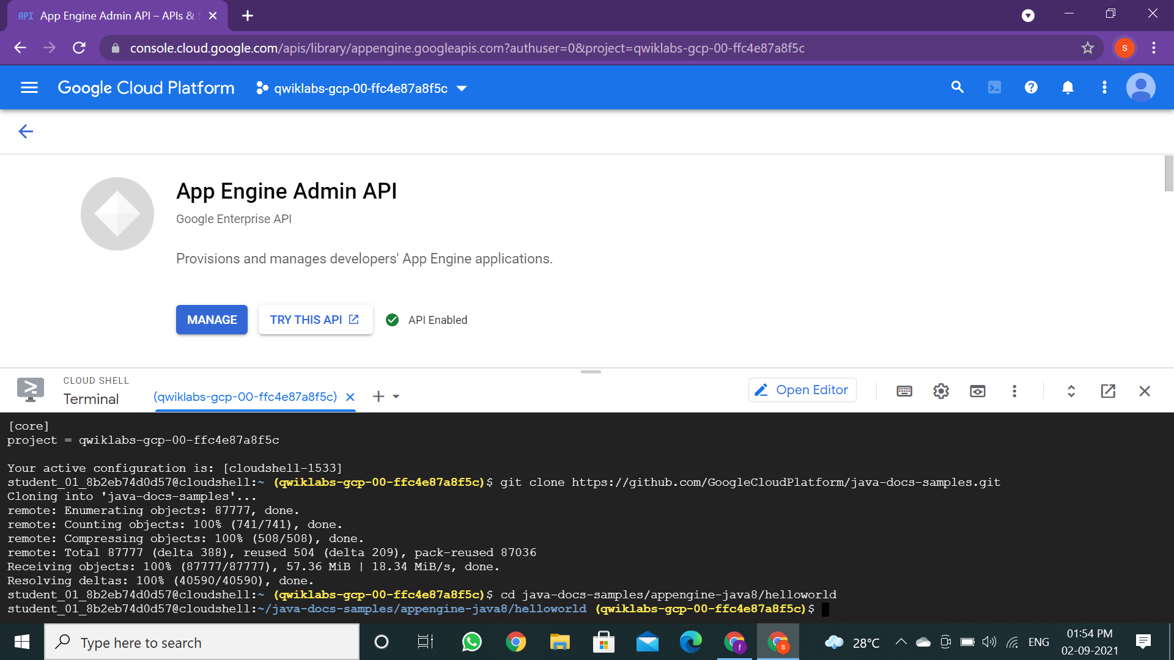

**Test the application using the development server**

To get the development server running, you'll download Maven to manage compiling your app and starting the development server.

1. Run the following commands to configure your Maven environment:

**mvn clean**

**mvn package**

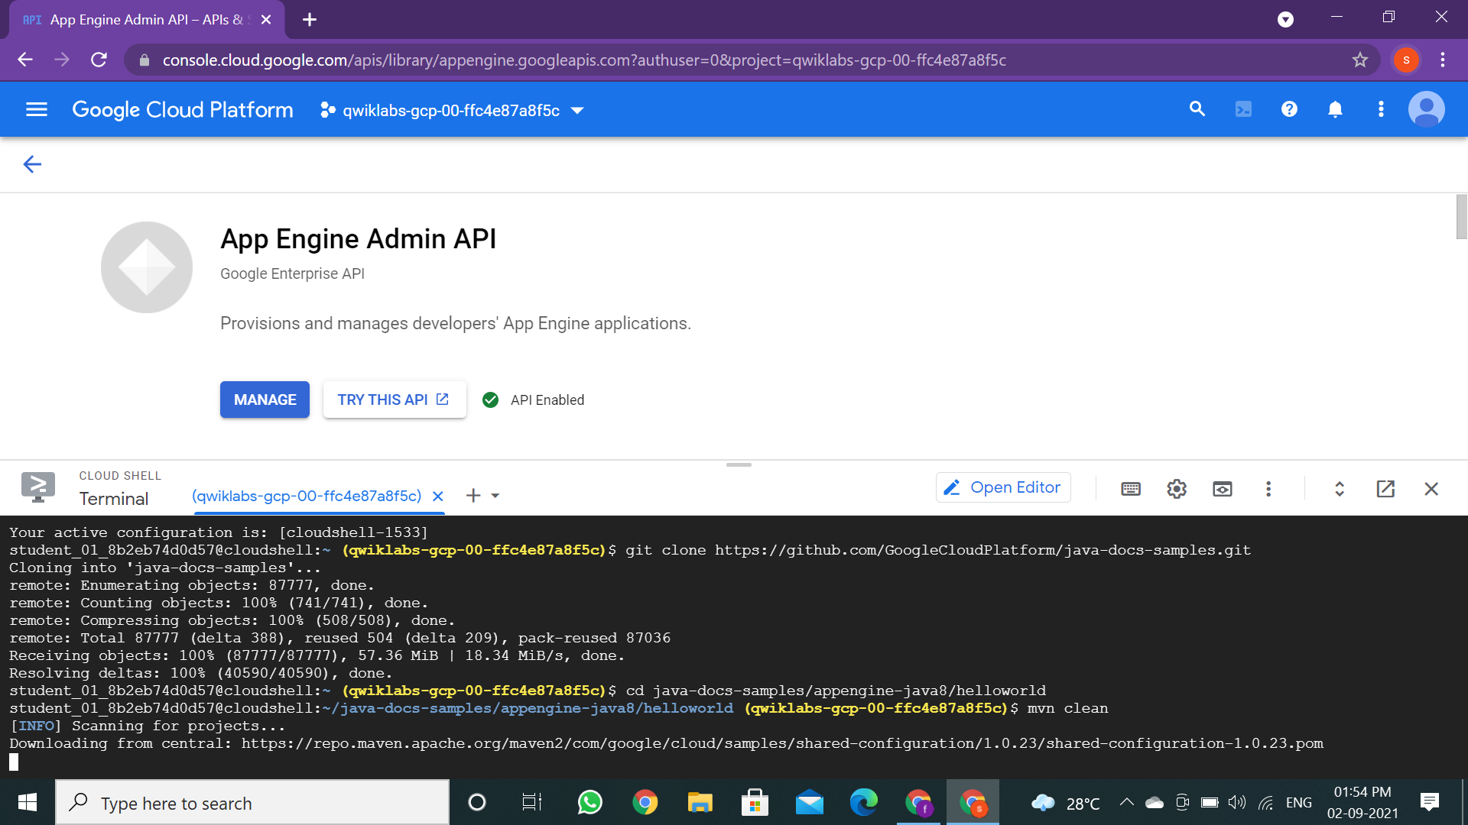

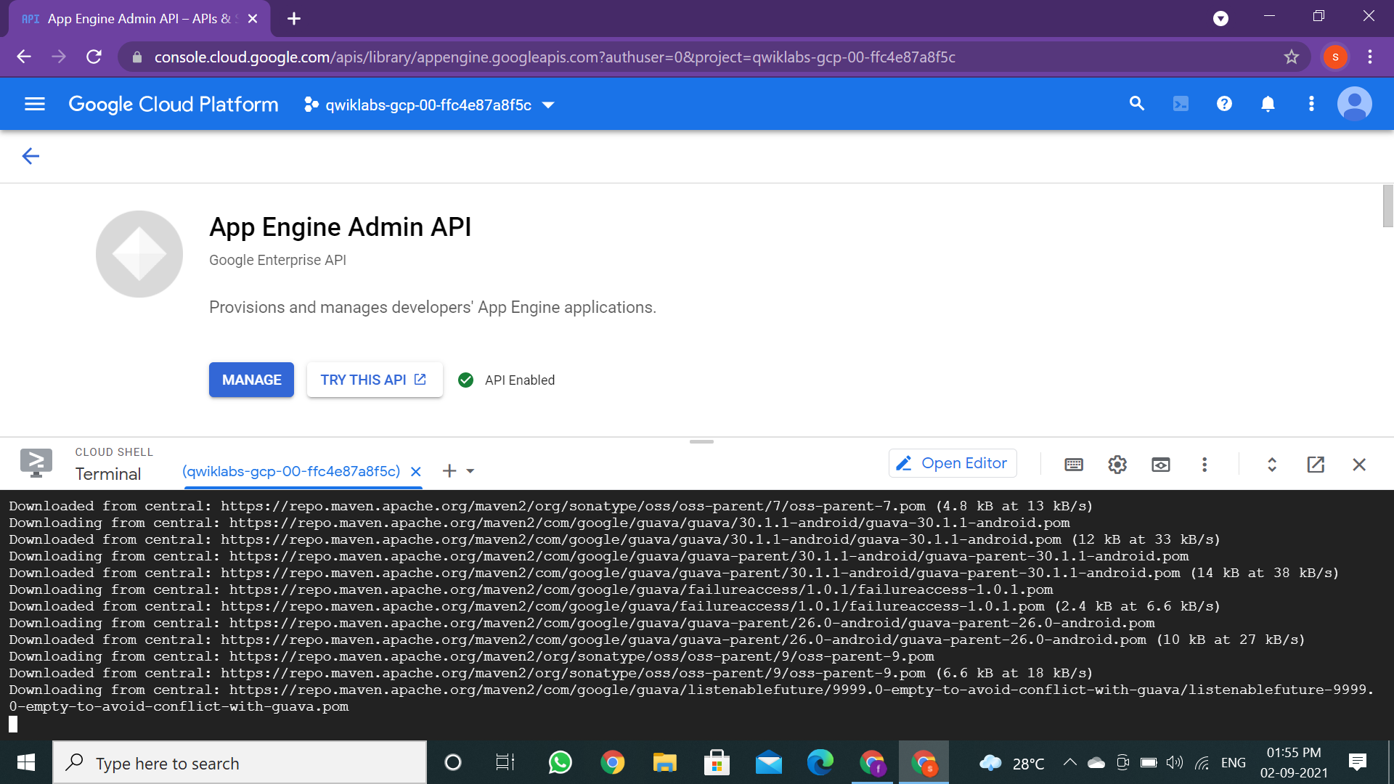

1. Enter the following Maven command to download and install Maven and run the app:

**mvn appengine:run**

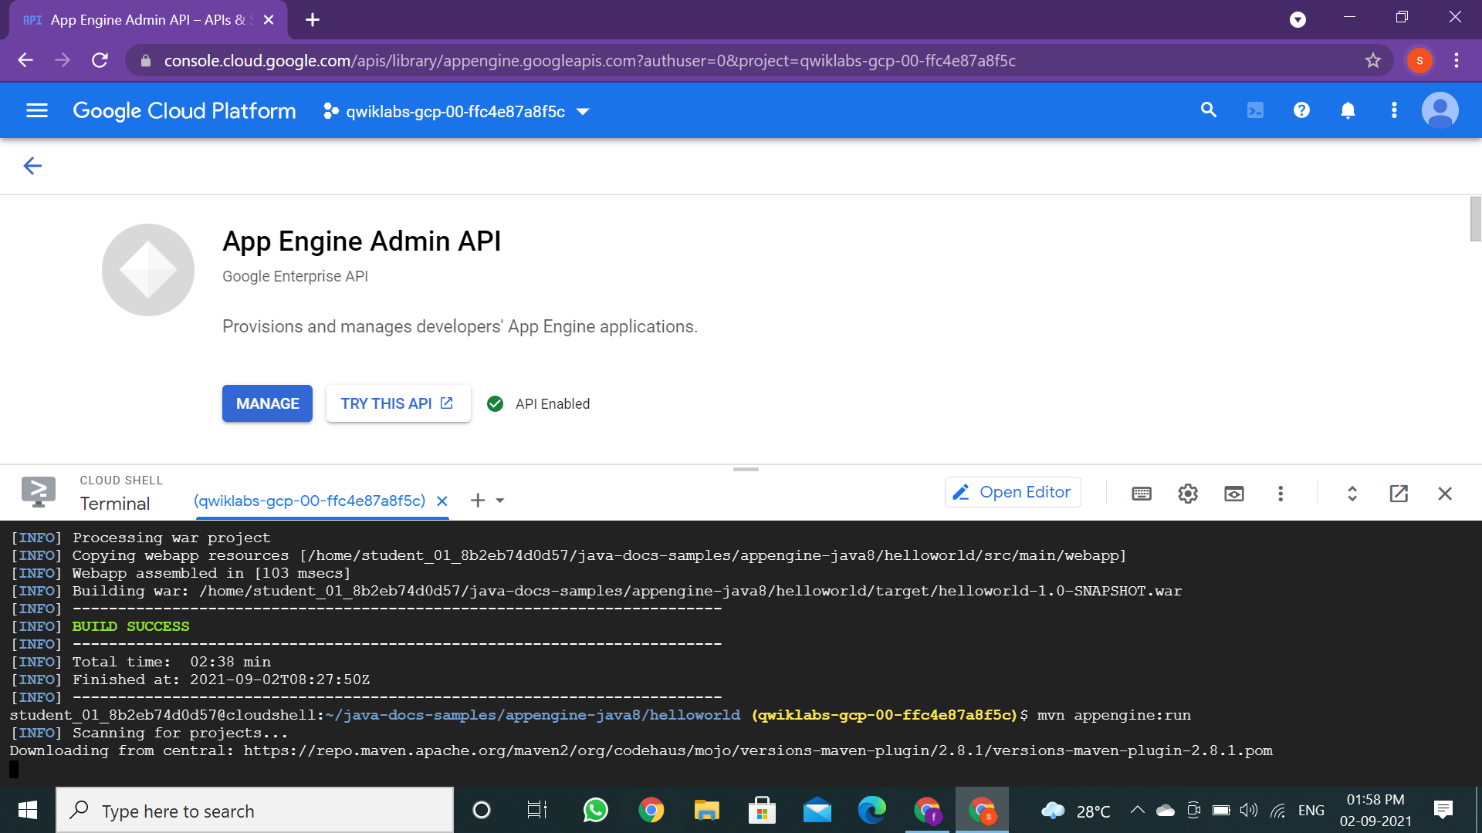

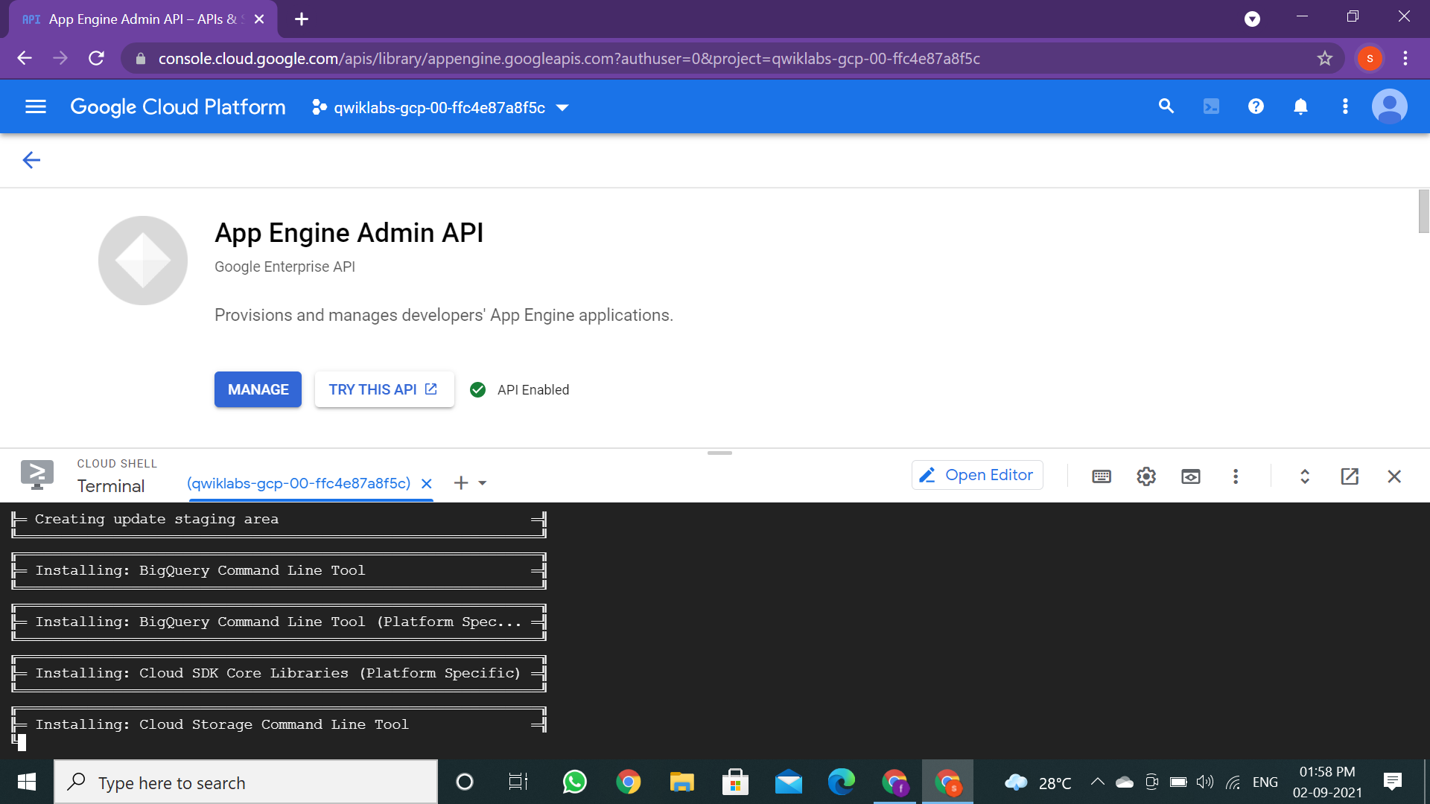

The development server is listening for requests on port 8080 when you see the following last line of output:

1. View the app by clicking the **Web preview** button > **Preview on port 8080**:

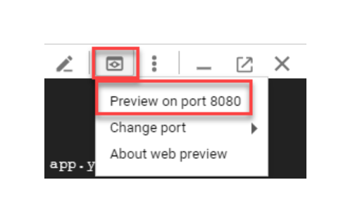

page should resemble the following:

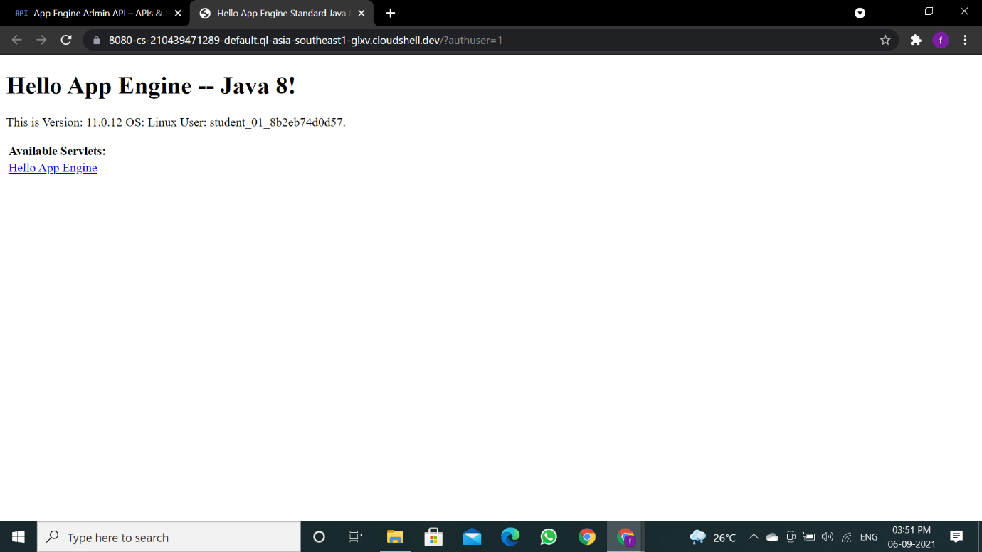

**Deploy your app**

Now you'll create an application on an App Engine with the following command

**gcloud app create**

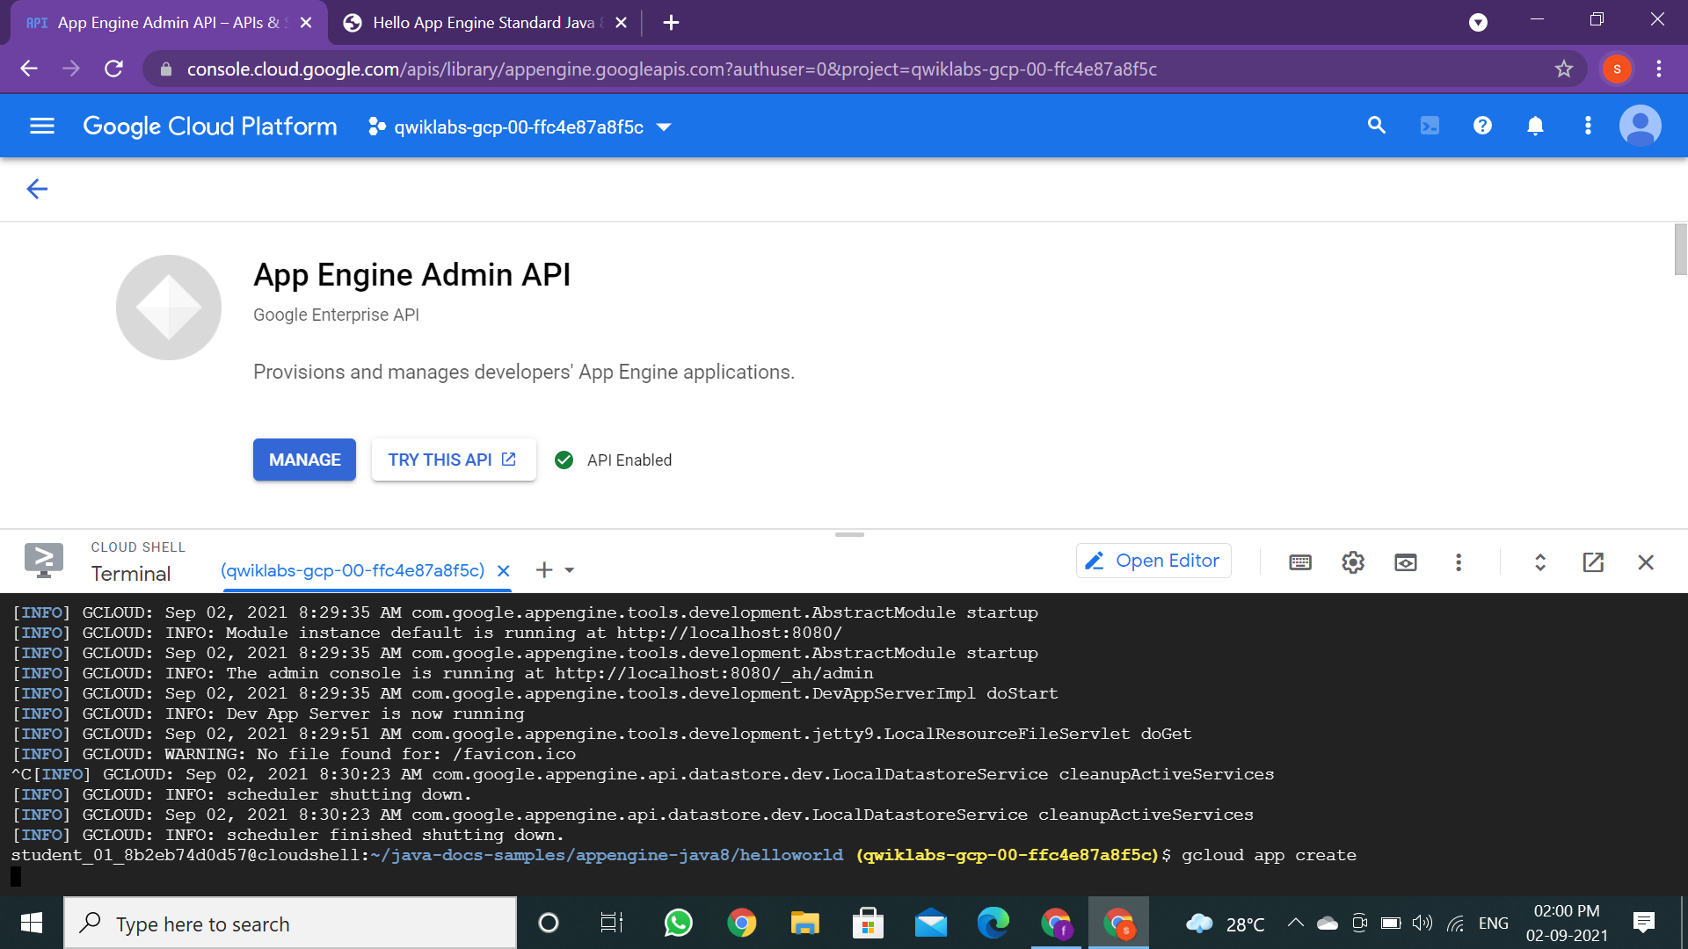

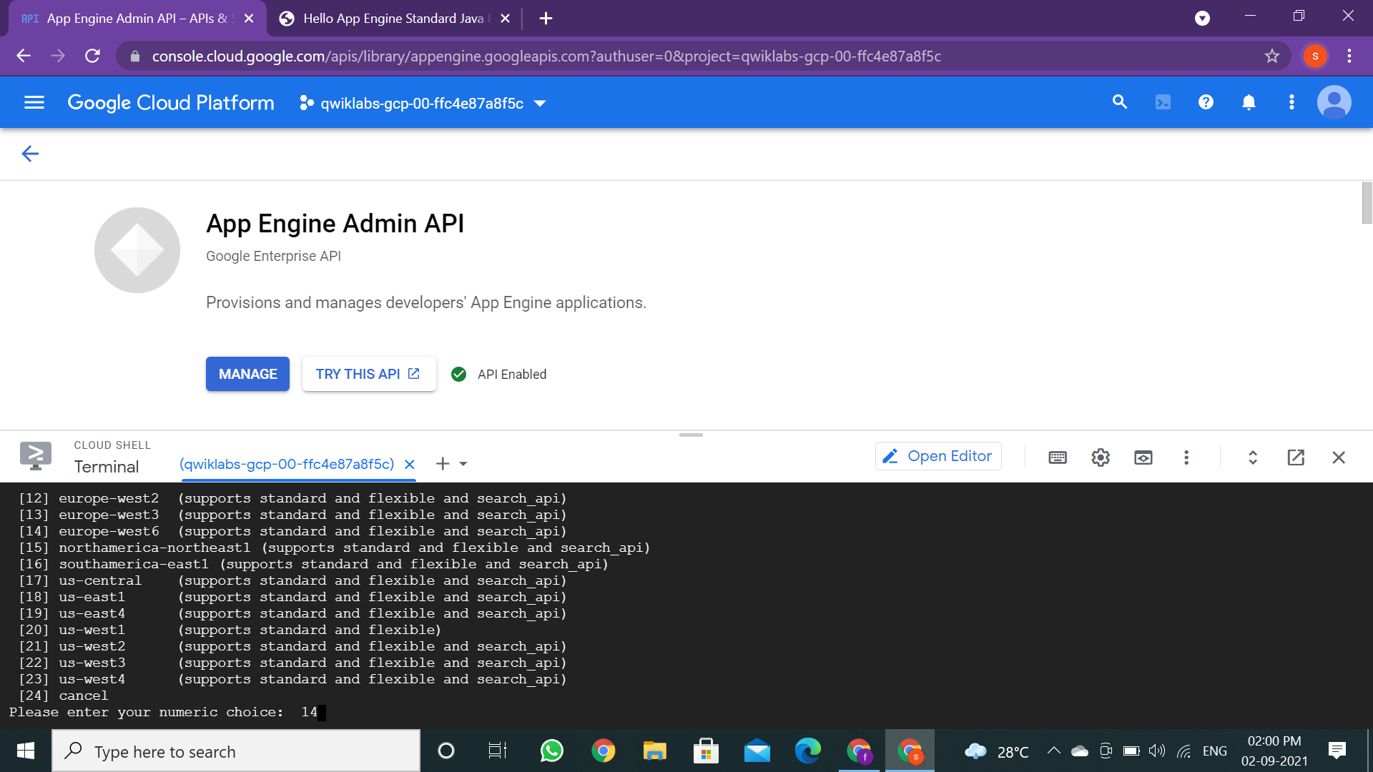

1. Open the pom.xml file with the following command:

**nano pom.xml**

1. Key down towards the bottom of the page until you find this section:

<version>2.2.0</version>

<configuration>

<!-- can be set w/ -DprojectId=myProjectId on command line -->

<projectId>**myProjectId**</projectId>

<!-- set the GAE version or use "GCLOUD_CONFIG" for an autogenerated GAE version -->

<version>GCLOUD_CONFIG</version>

</configuration>

1. Change myProjectId to your Qwiklabs Project ID. Ensure this section resembles the following before moving on:

<configuration>

<!-- can be set w/ -DprojectId=myProjectId on command line -->

<projectId>**qwiklabs-gcp-02-47242f3ecbf9**</projectId>

<!-- set the GAE version or use "GCLOUD_CONFIG" for an autogenerated GAE version -->

<version>GCLOUD_CONFIG</version>

</configuration>

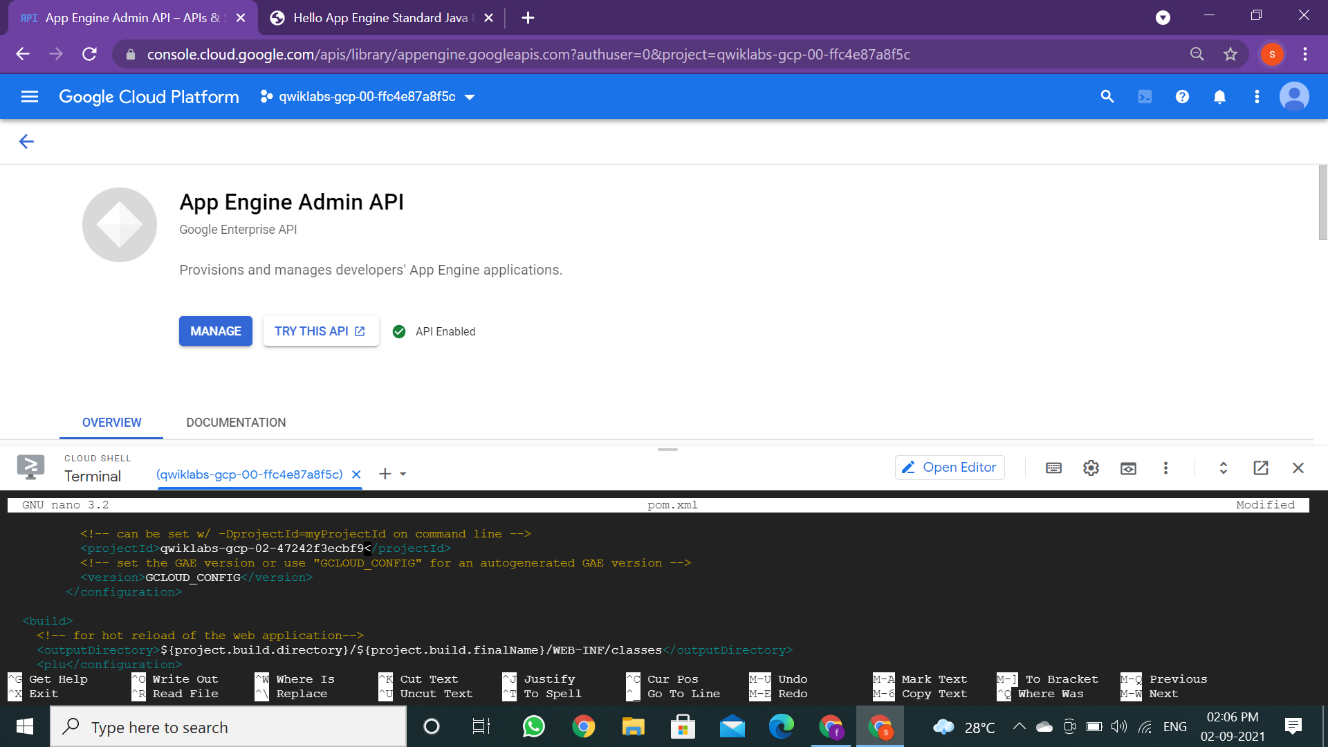

1. Now exit nano and save the file with **CTRL** + **X** --> **Y** --> **Enter**.
2. **DO NOT** use the gcloud app deploy command as stated in the output to deploy your app. Instead, run the following command to deploy your application:

**mvn package appengine:deploy**

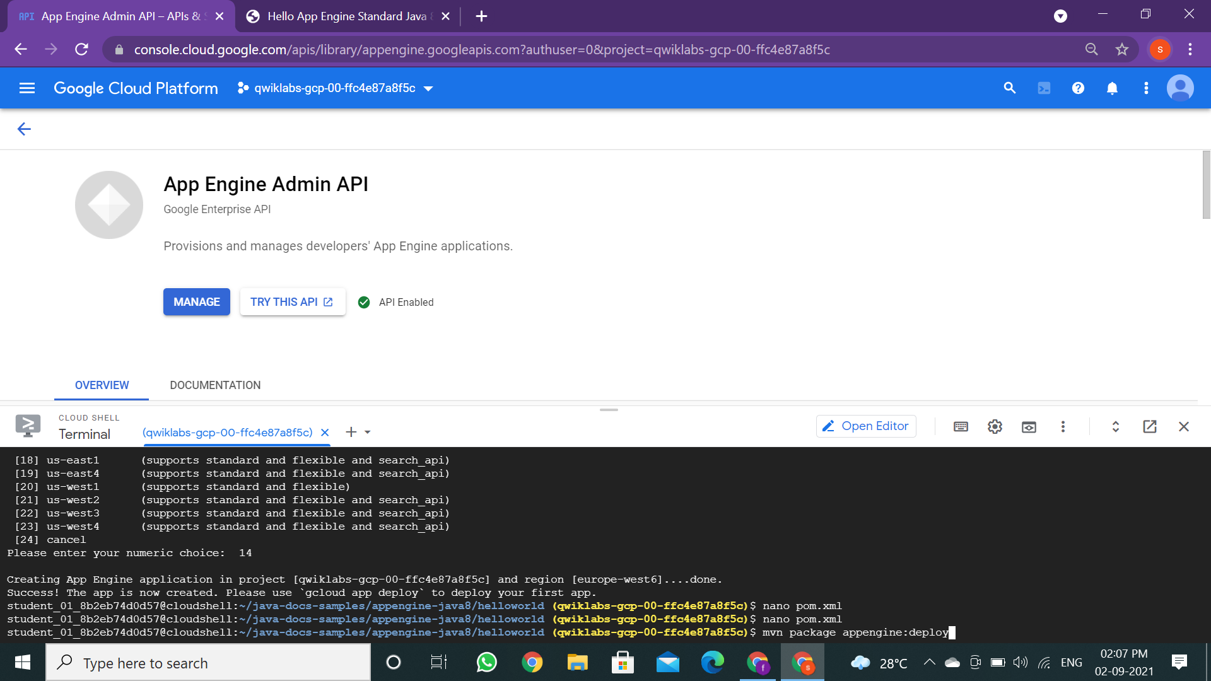

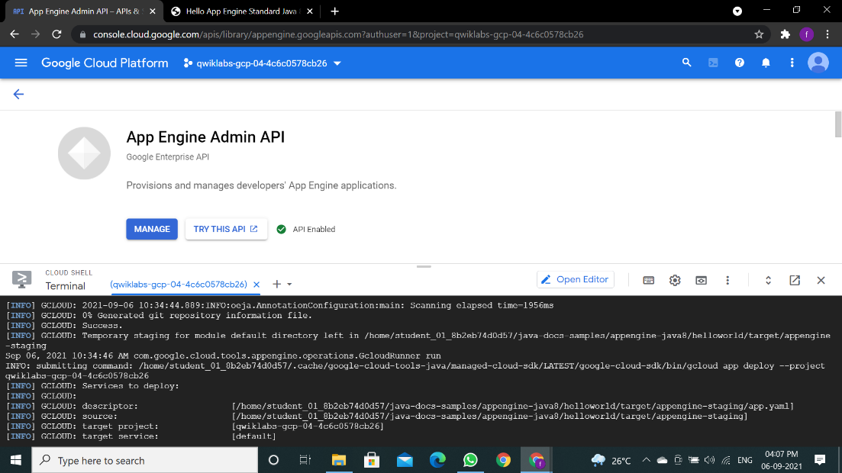

To launch your browser, enter the following command then click on the link it provides.

**gcloud app browse**

Example output; your link will be different:

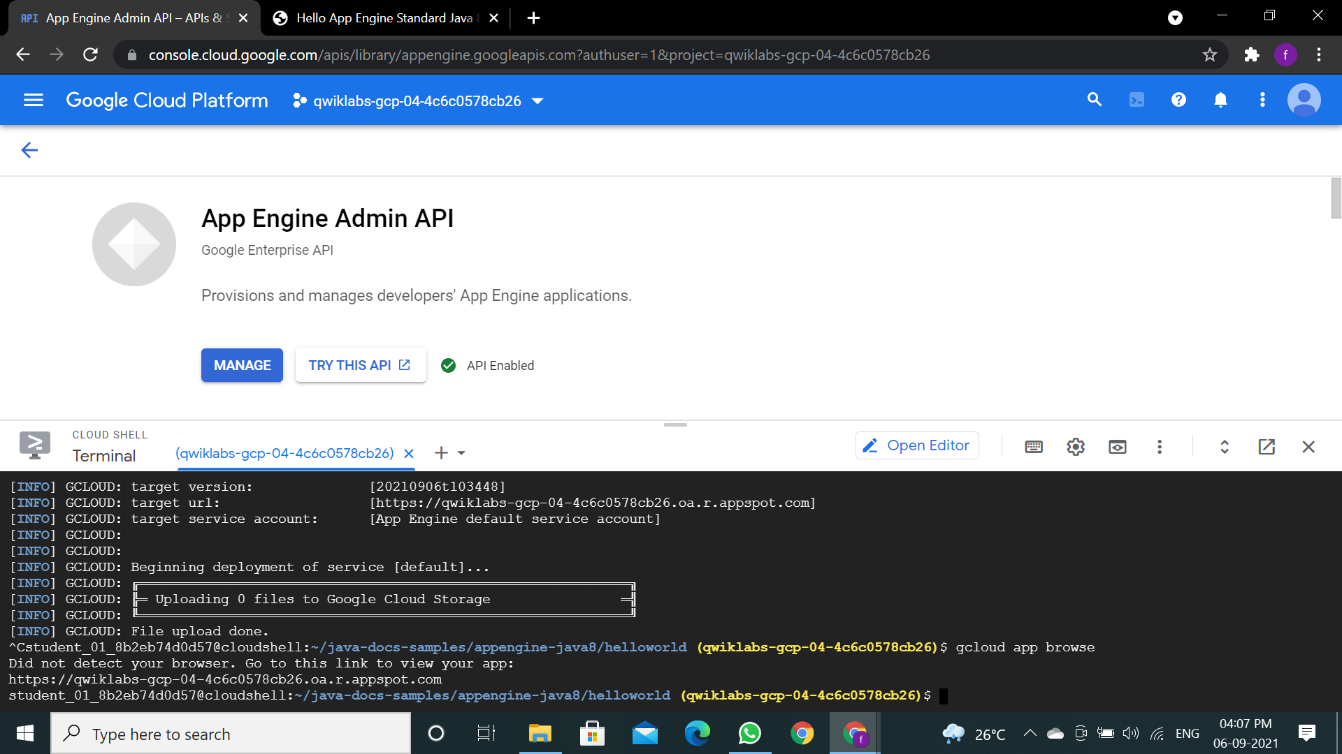

Your application is deployed and you can read the short message in your browser:

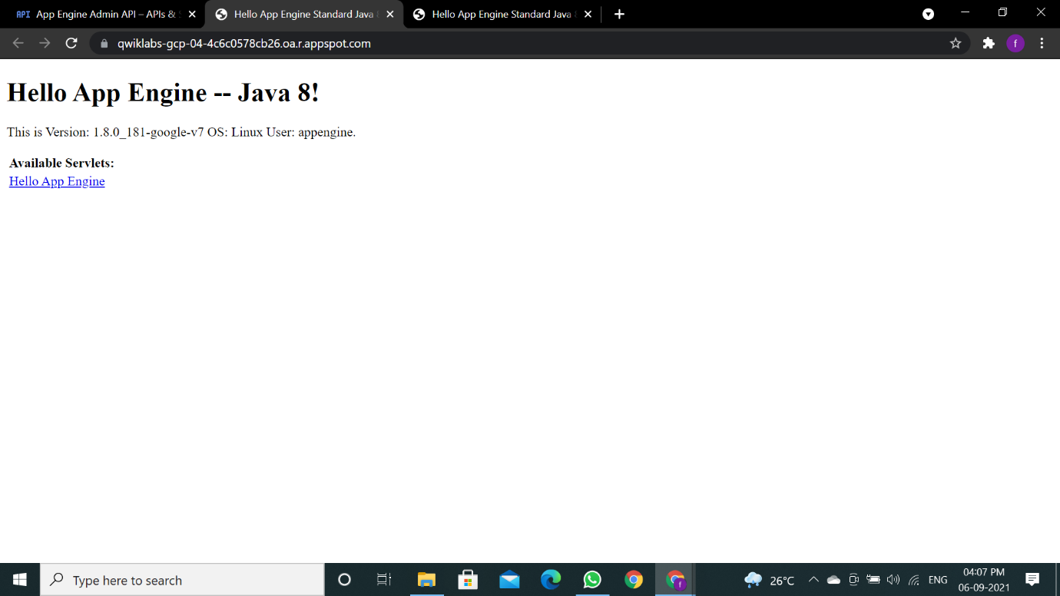

Click **Check my progress** to verify the objective.

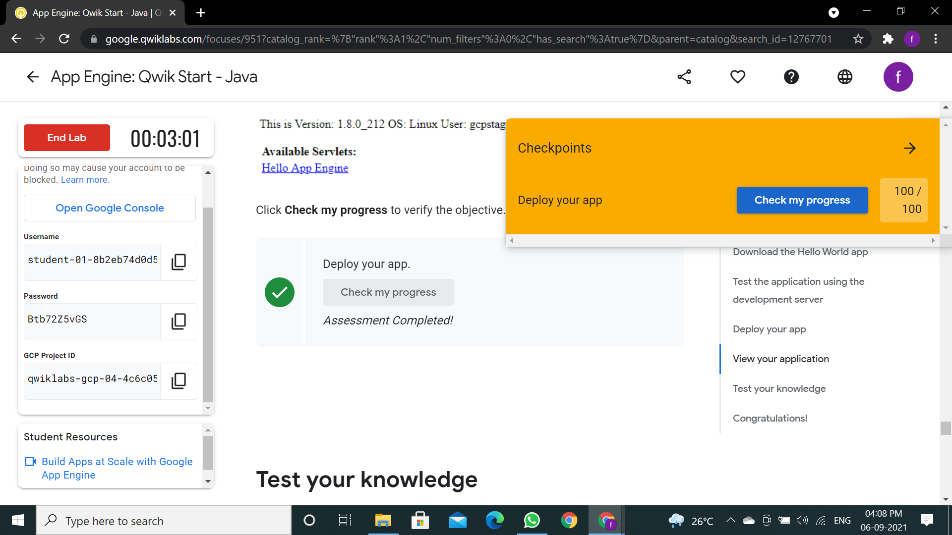

**Practical 5**

**Aim: To implement Infrastructure as a service using OwnCloud.**

Concept:

Step1:DownloadtheOwnCloudXServerfromthelink(Itonlyworkswith64bit system).

<https://owncloud.com/download/>

Here I’ve demonstrated for VirtualBox. So click the Virtual Box button.

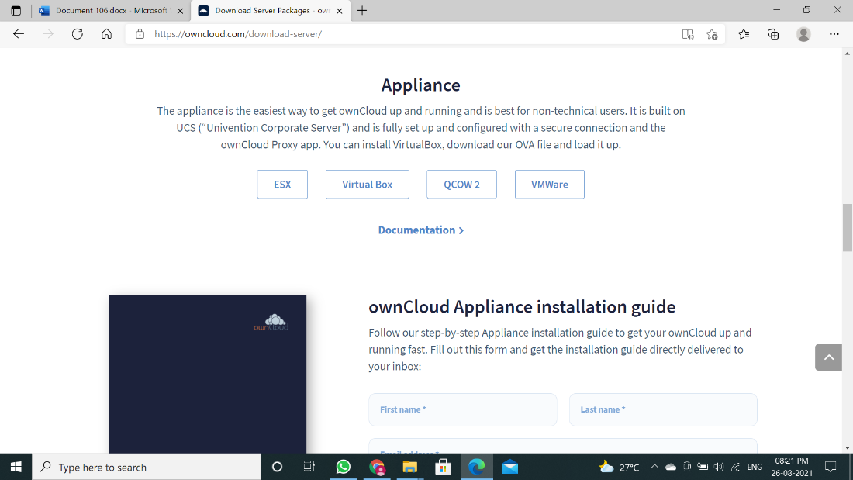

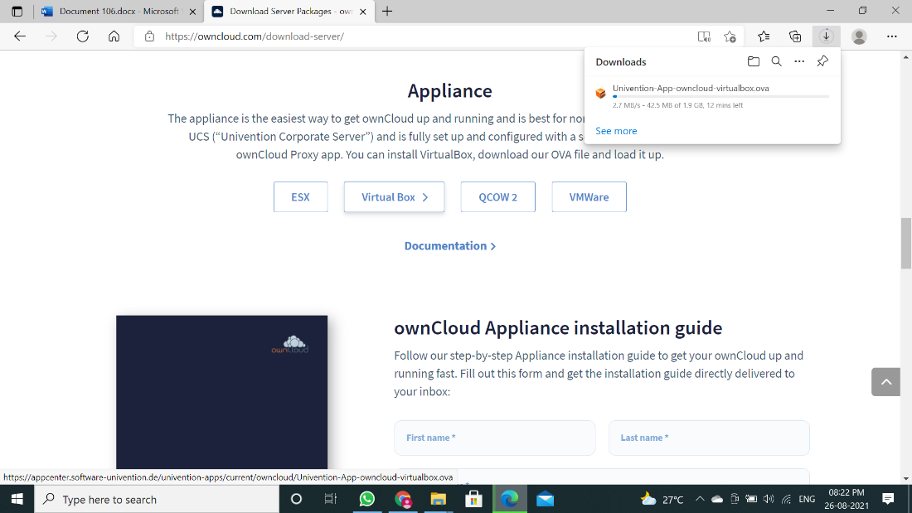

Step 2: Now Double click the application. It will directly take you to the VirtualBox

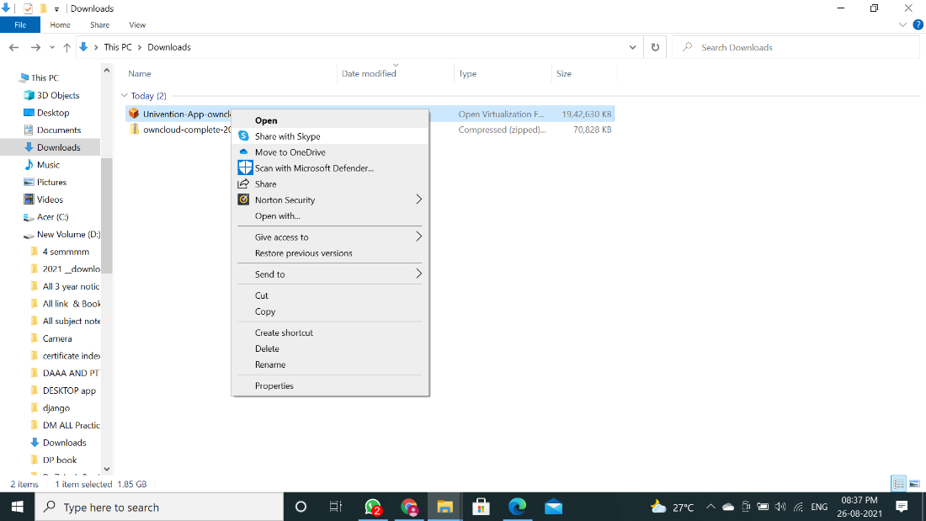

Step 3: Click on Import. Wait till the importing gets finished.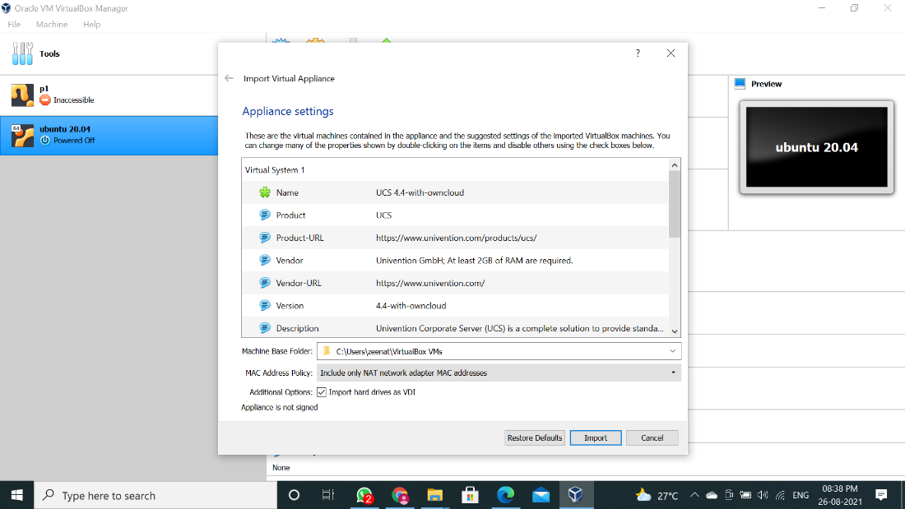

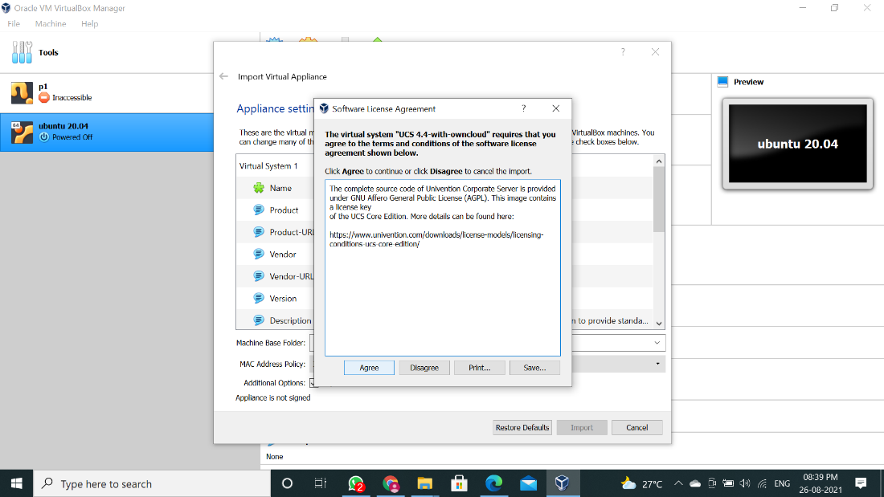

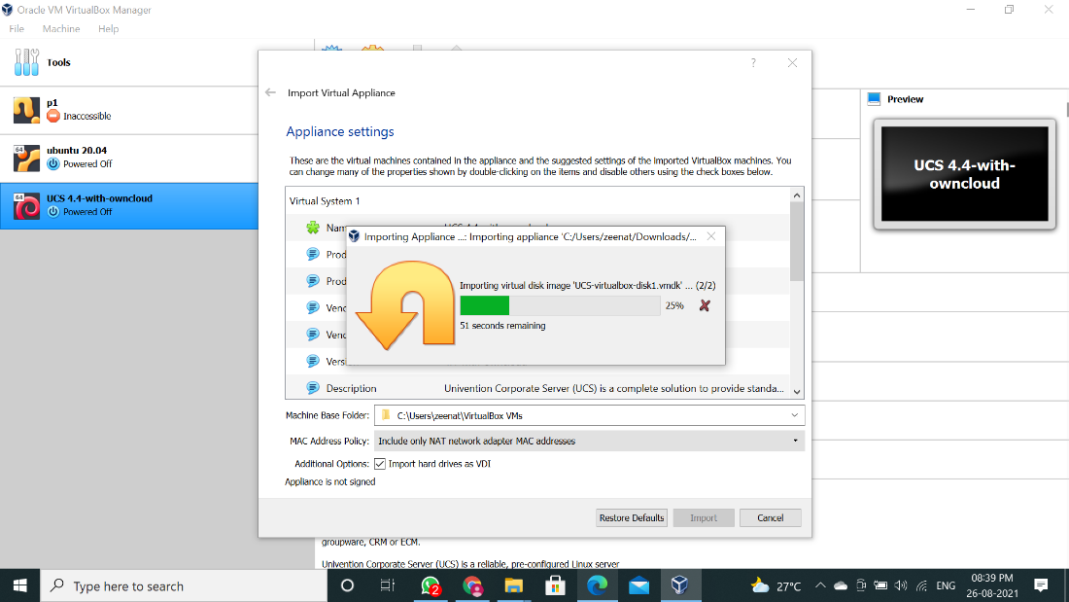

Step 4: Once import is done agree T&C.

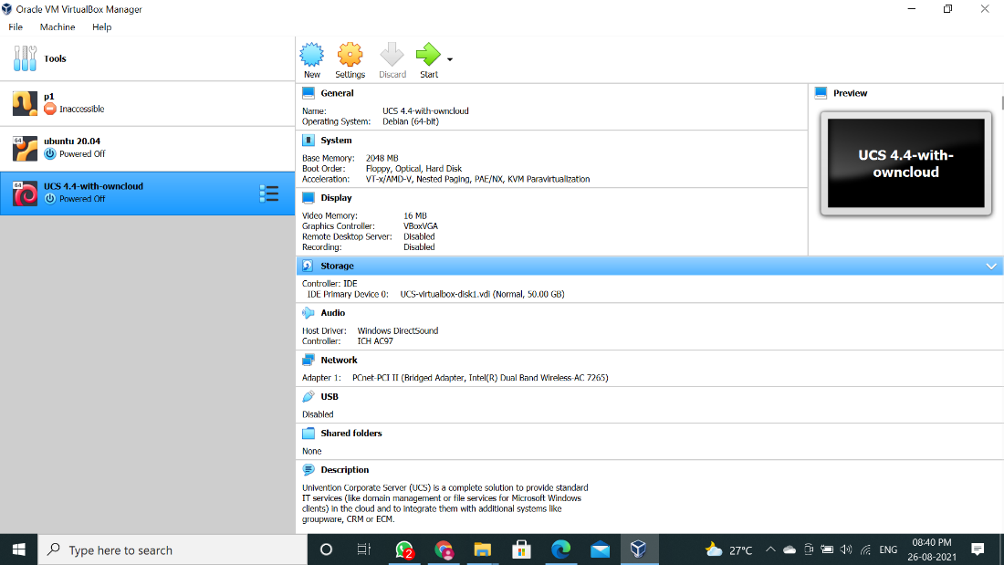

Step 5: Click on "Power on this virtual machine" and following window will appear.

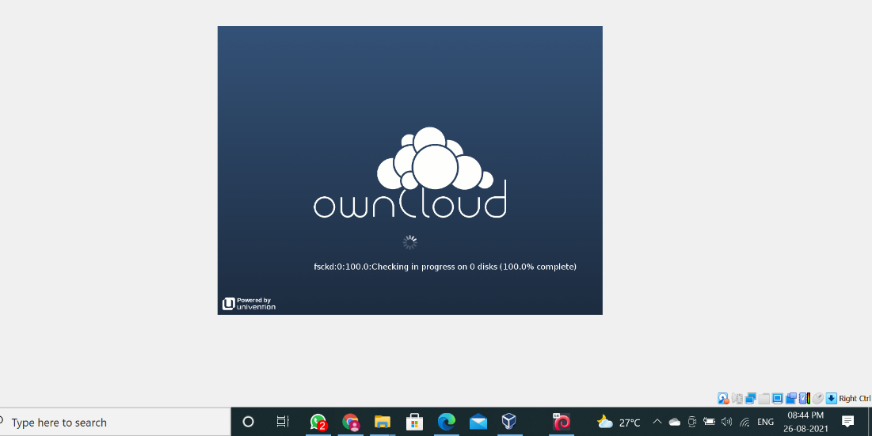

Step 6: On next window it will ask you for your “city”, don’t enter any city name in it and just click “NEXT” (Most important step please don’t enter any city name in it otherwise it will not read keyboard entries).

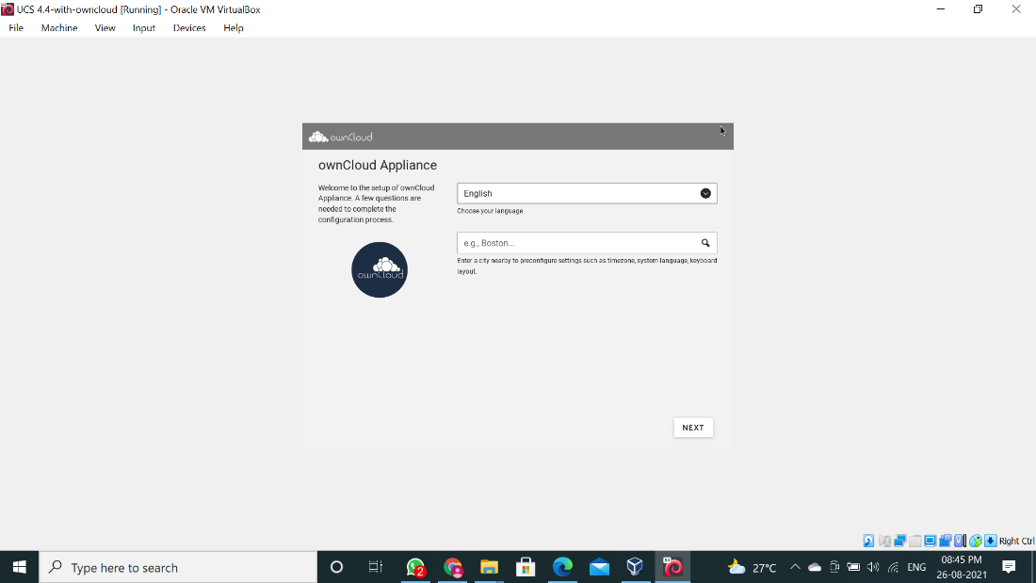

Step 7: Just click “NEXT” on “Localization settings” window.

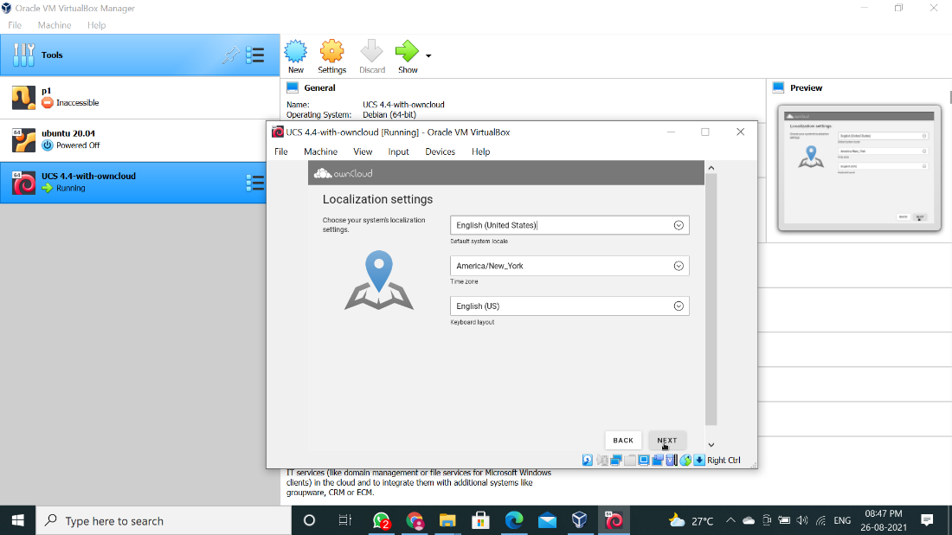

Step 8: It will fetch IP Address, Net Mask and Gateway from DHCP, don’t change anything, also uncheck “Obtain IP address automatically (DHCP)”, mention an “Alternate DNS Server” and just click “NEXT”.

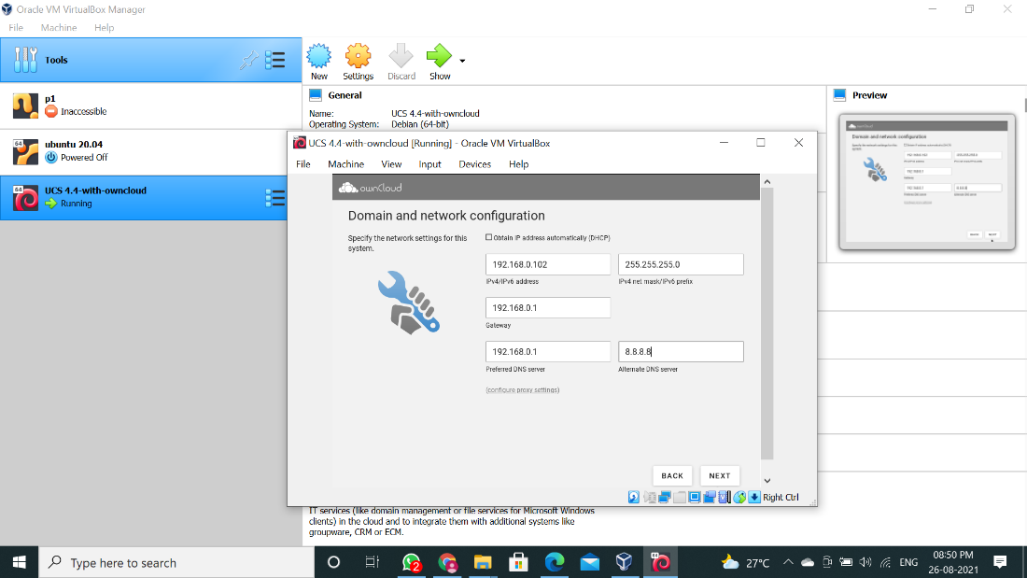

Step 9: In Domain setup click “NEXT”

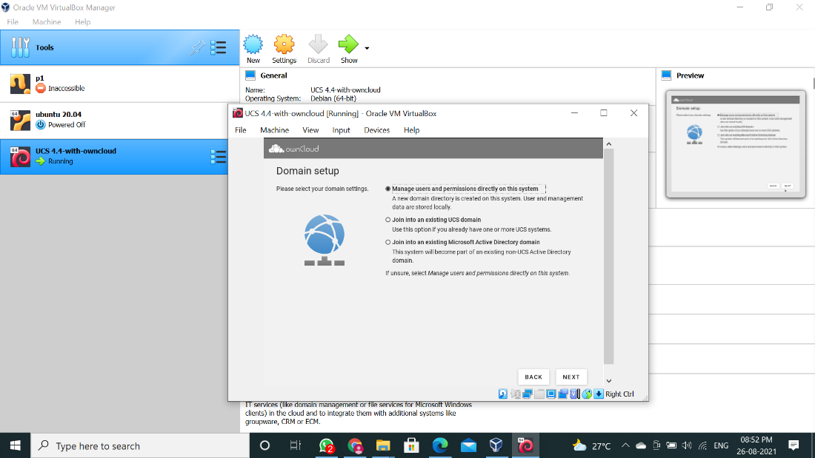

Step 10: Now Account information window will appear, enter details in it. Remember that password we are setting is for “root” and “Administrator”, click on “NEXT

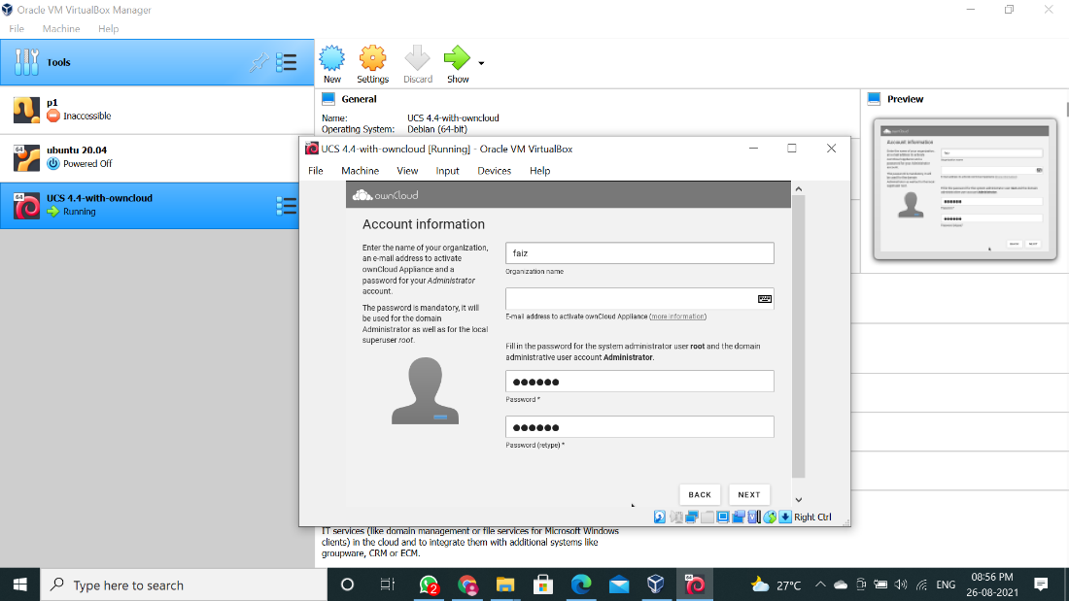

Step 11: On next window it will show you Fully Qualified domain name and LDAP base, click on “NEXT”.

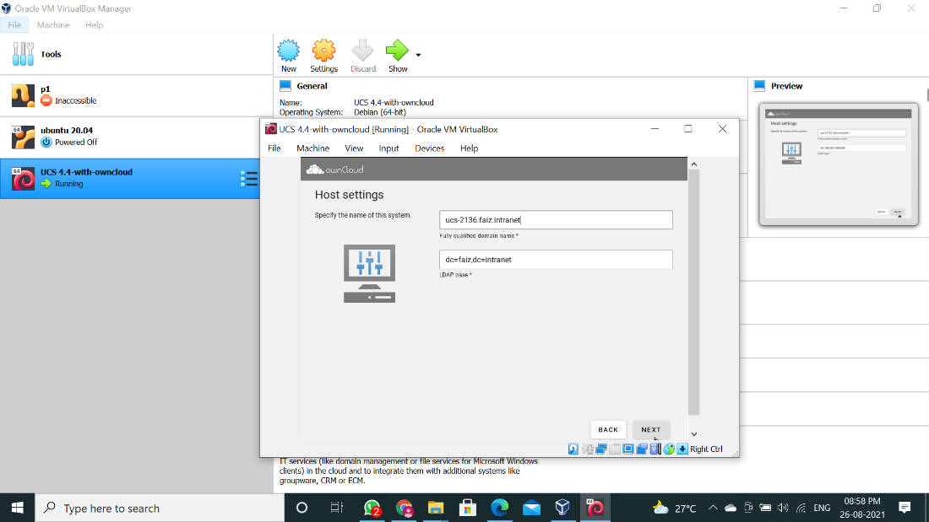

Step 12: Itwillshowtheconfigurationsettingsforowncloudscrolldownalittleandclickon“CONFIGURE SYSTEM”

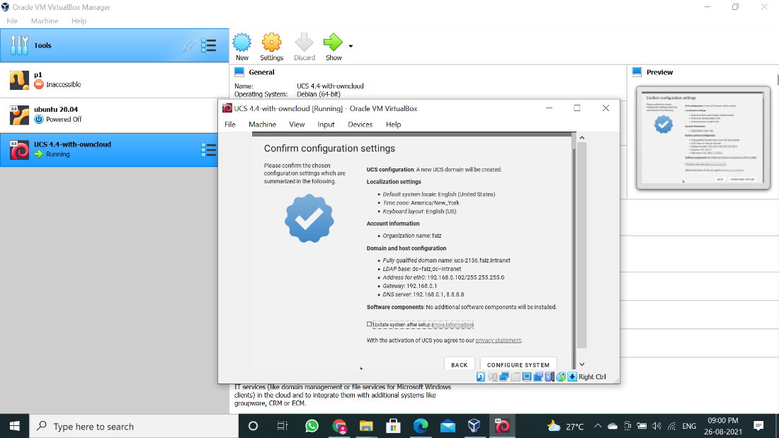

Step 13: It will take time to setup.

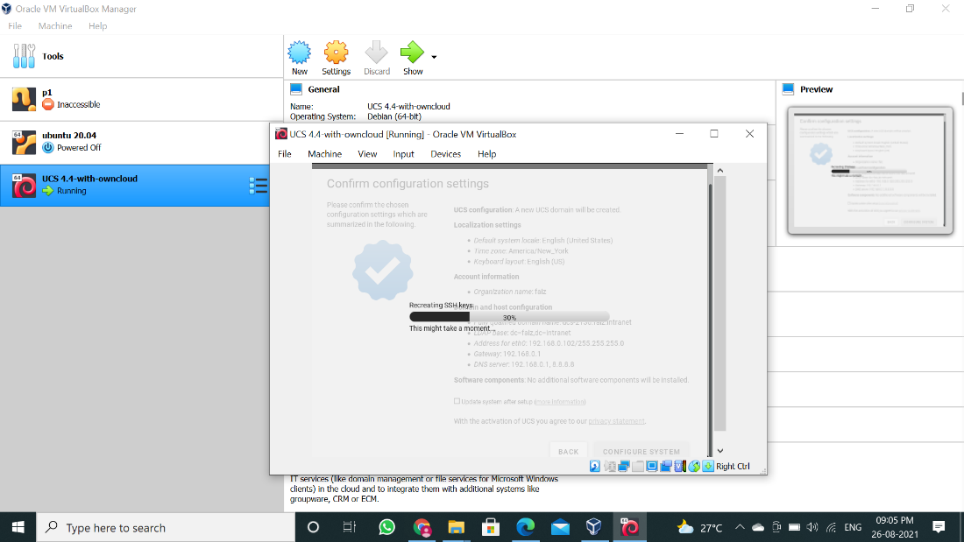

Step 14: The setup is done now click on “FINISH”.

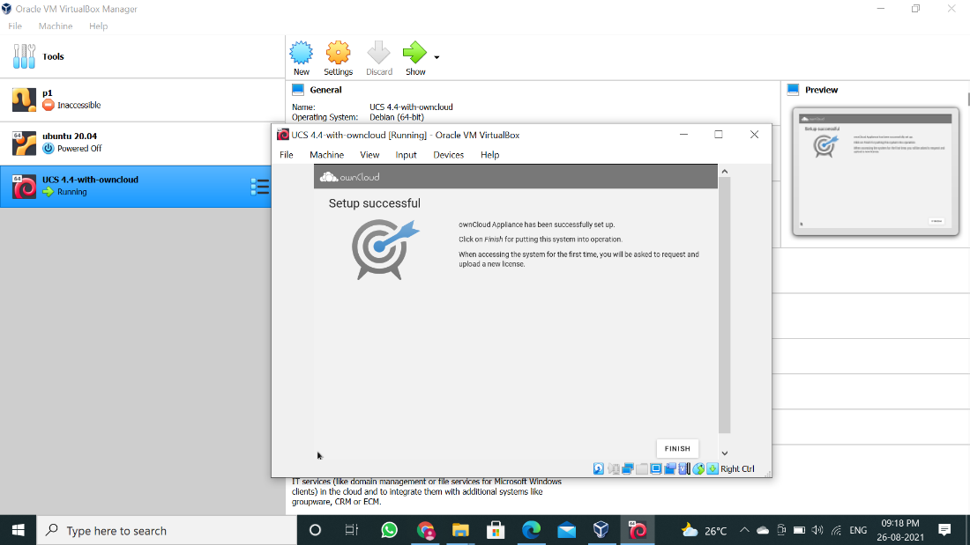

Step 15: Now on next window press any button.

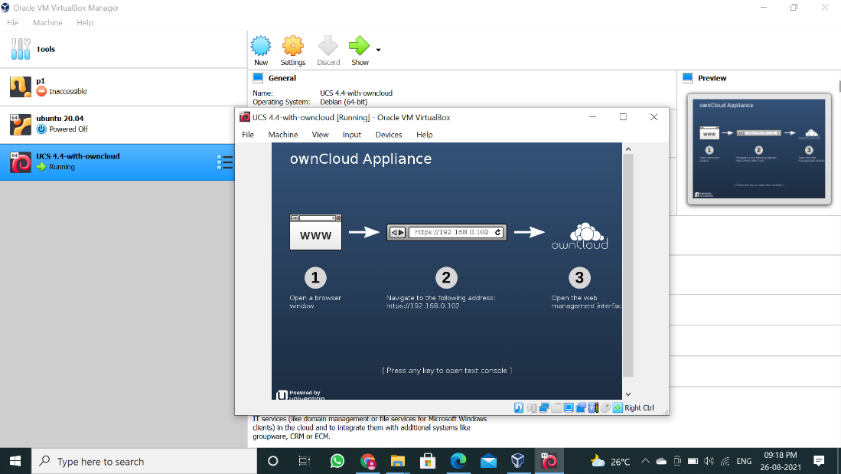

Step 16: Now you can see the IP address on top right-hand side, open the browser and enter system’s IP address in URL bar and press enter.

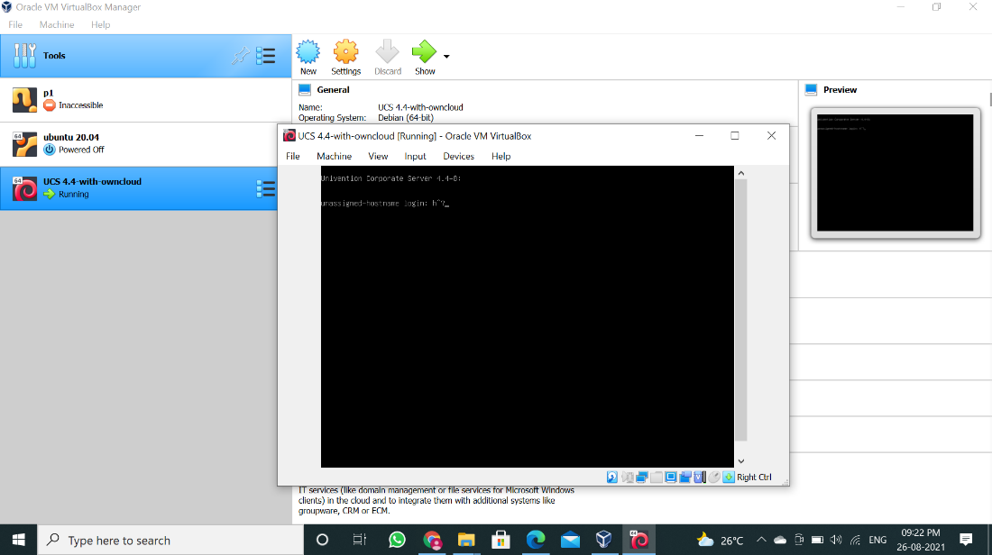

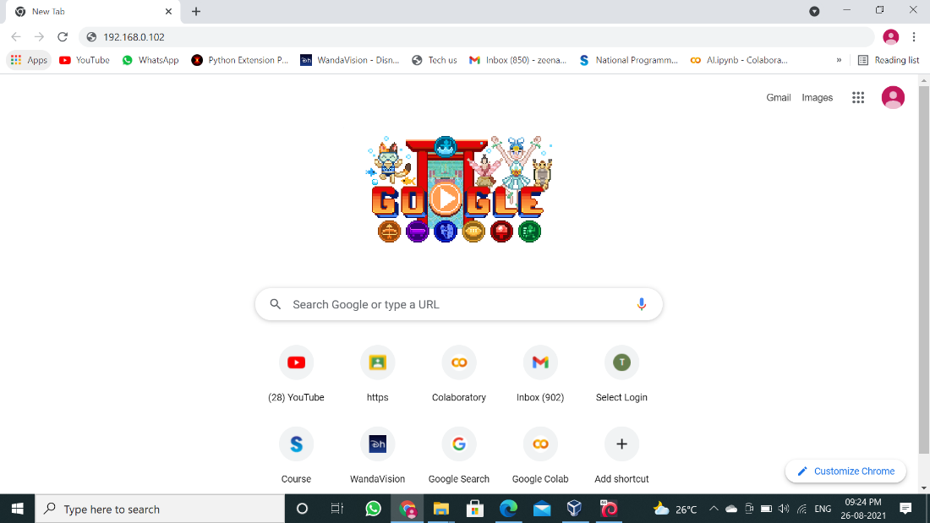

Step 17: It will ask you for Email ID to send license, enter your Email ID and click “REQUEST ACTIVATION”.

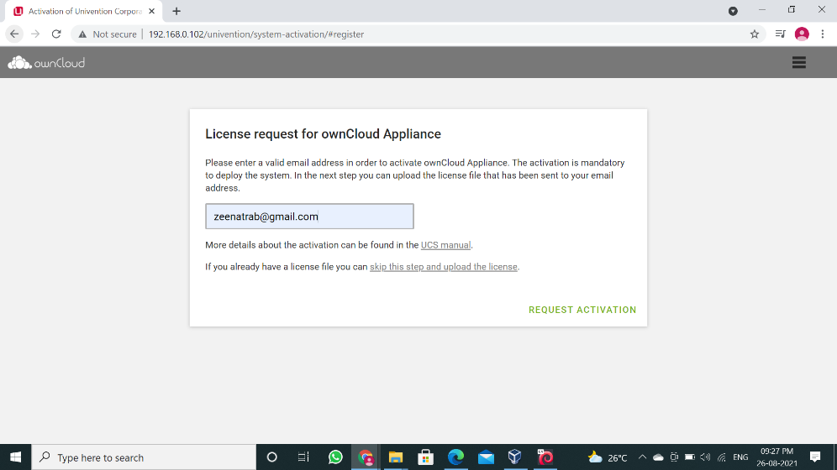

Step 18: Check your mailbox you will receive the license from OwnCloud, download it

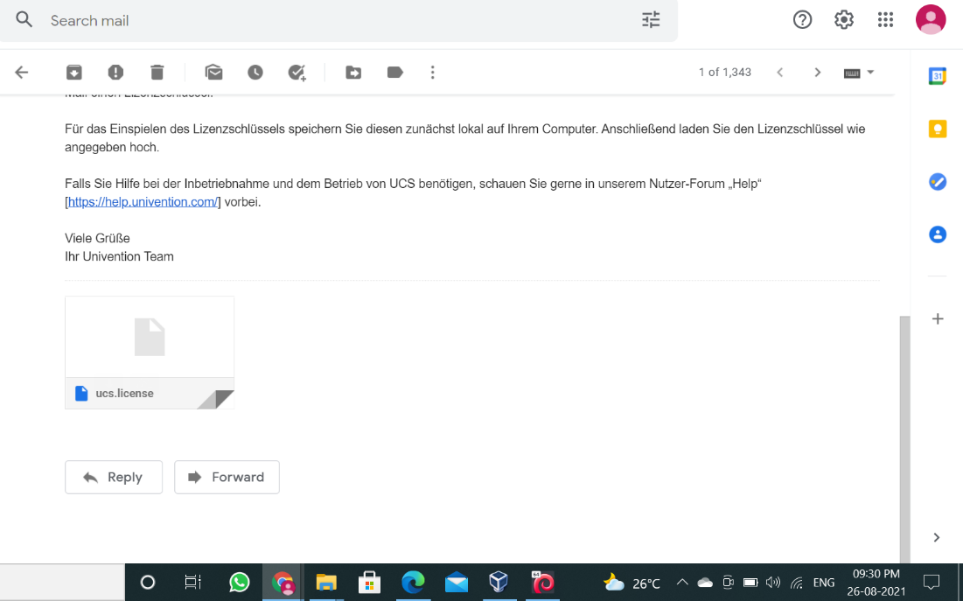

Step 19: Get back to OwnCloud and click on “UPLOAD LICENSE FILE”

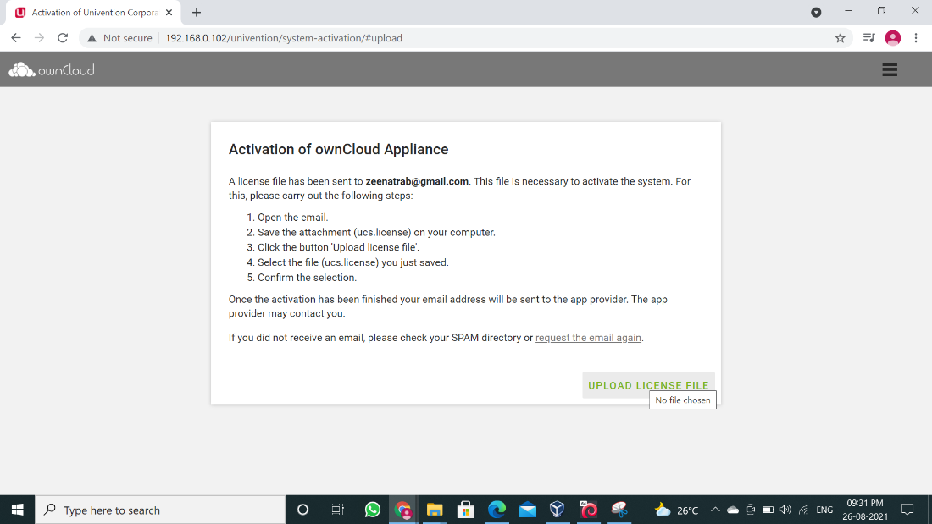

Step 20: Now select the license file and click “Open”.

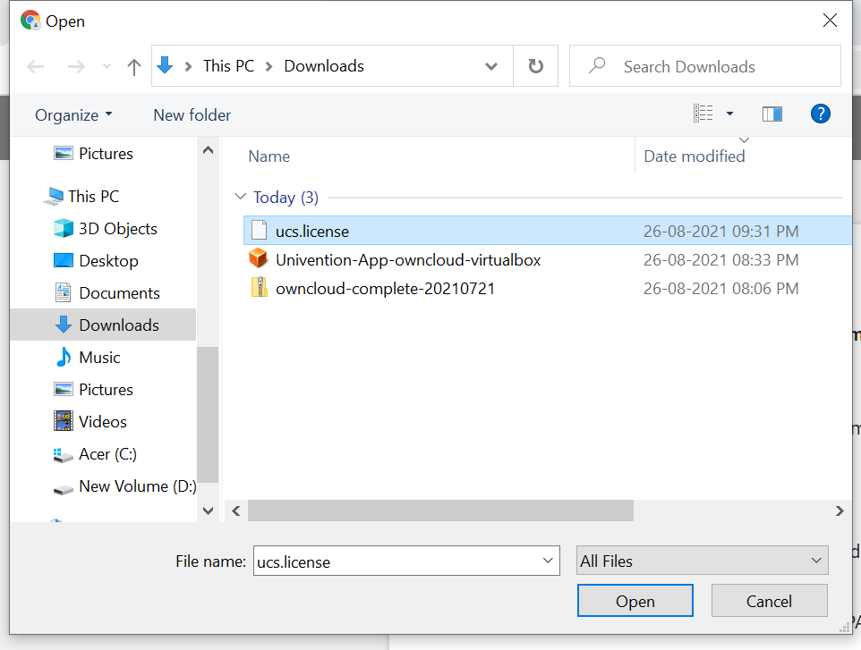

Step 21: On next page click on “FINISH”.

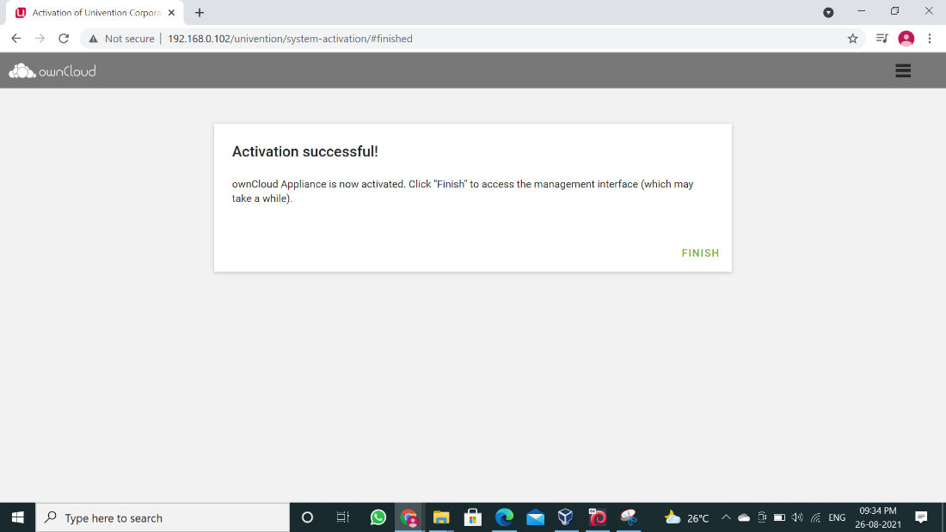

Step 22: We have installed OwnCloud, now just try logging in with “Administrator” as userfor that click on “LOGIN” button.

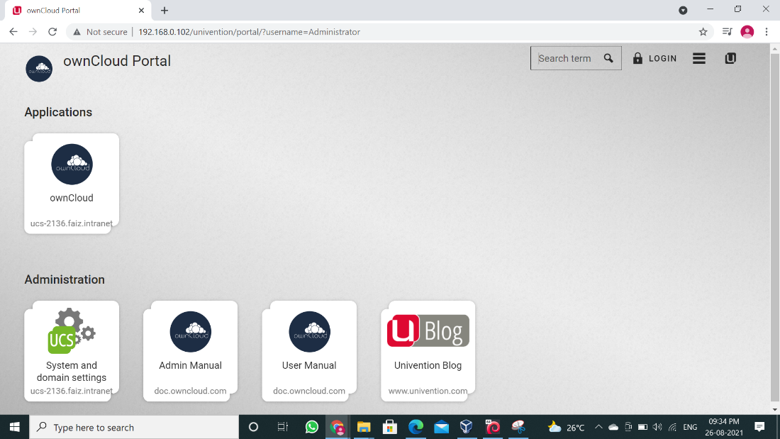

Step 23: Enter “Administrator” as user name and the password which you set during setting up process and click on “LOGIN”.

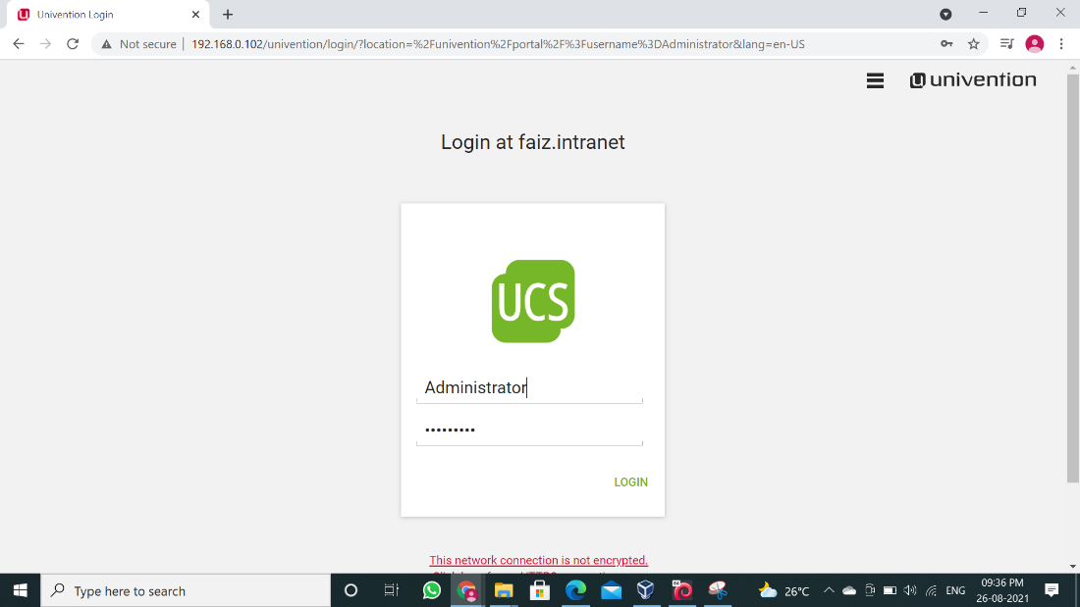

Step 24: After we have logged in successfully, now click on hamburger menu button.

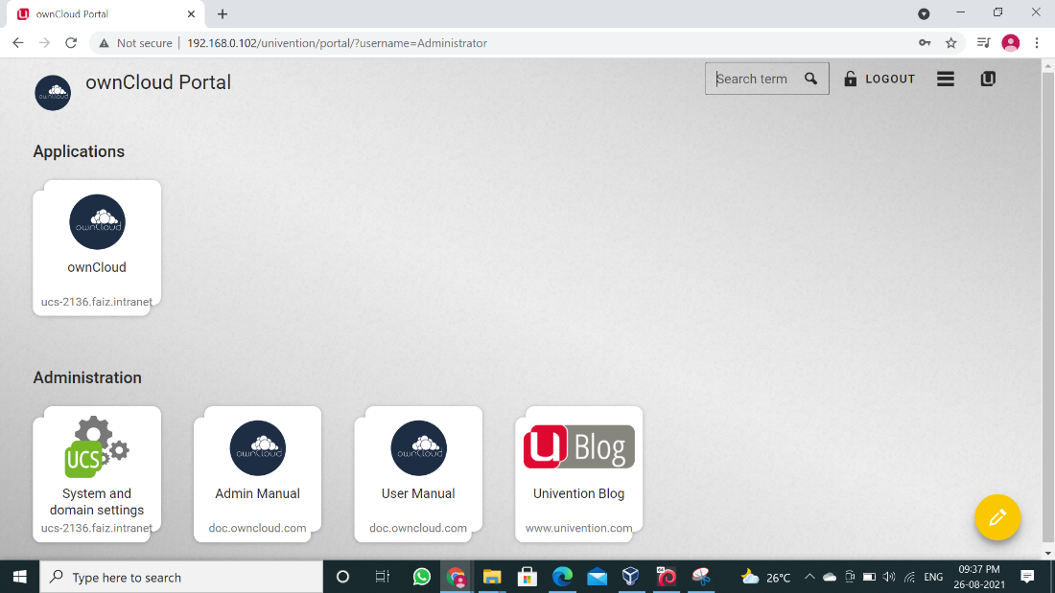

Step 25: Now we successfully completed OwnCloud installation.

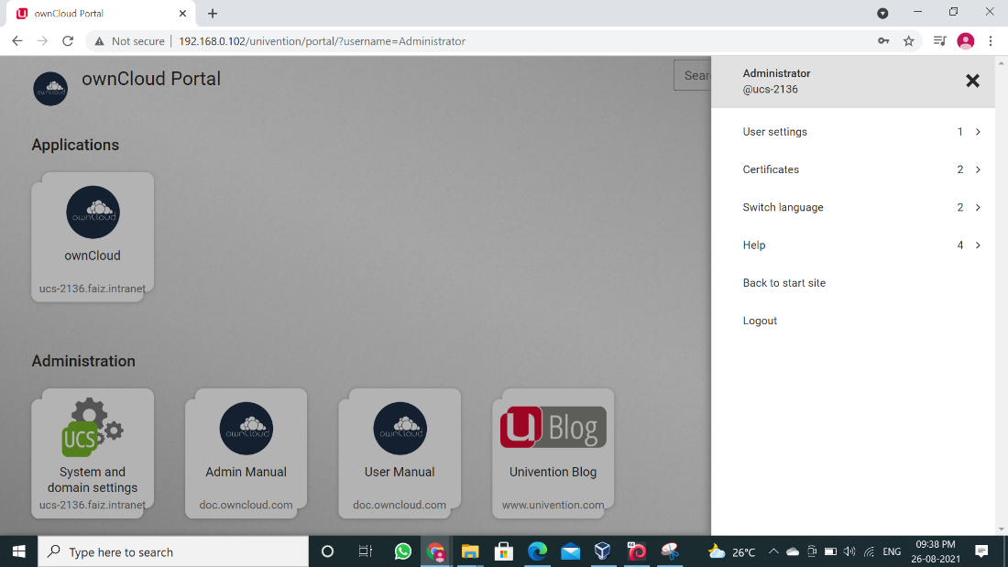

CONCLUSION: We have installed OwnCloud as bare metal hypervisor and implemented it. It provides access to computingresourcesinavirtualenvironment.Withthe helpofInfrastructureasaservicewe can build our own IT platform.

**Practical 6**

**Aim: Understanding Infrastructure as a Service in Open-nebula and**

**Eucalyptus**

**Practical 7**

**Aim: Study and Implementation User Management inCloud**

**OBJECTIVE:** From this experiment the student will be able,

* Is to understand how to create user’s accounts.
* Manage user and group of user’s accounts.
* To explore OwnCloud.

**OUTCOME:** The learner will be able to,

* Installing and using Administrative features of ownCloud Technology
* User Management
* Access same with 2 different credentials

## THEORY:

* OwnCloud is a suite of client–server software for creating and using file hosting services. OwnCloud functionally has similarities to the widely used Dropbox.
* The primary functional difference between ownCloud and Dropbox is that ownCloud does not offer data centre capacity to host stored files.
* The Server Edition of ownCloud is free and open-source, thereby allowing anyone to install and operate it without charge on their own private server.
* OwnCloud supports extensions that allow it to work like Google Drive, with online document editing, calendar and contact synchronization, and more.
* Its openness avoids enforced quotas on storage space or the number of connected clients, instead of having hard limits (for example on storage space or number of users) limits are determined by the physical capabilities of the server.
* On the User management page of your ownCloud Web UI you can:

1. Create new users
2. View all of your users in a single scrolling window
3. Filter users by group
4. See what groups they belong to
5. Edit their full names and passwords
6. See their data storage locations
7. View and set quotas
8. Create and edit their email addresses
9. Send an automatic email notification to new users
10. Delete them with a single click

* Granting Administrator Privileges to a User – OwnCloud has two types of administrators:

1. **Group administrators** – It has the rights to create, edit and delete users in their assigned groups. Group administrators cannot access system settings, or add or modify users in the groups that they are not Group Administrators for. Use the dropdown menus in the Group Admin column to assign group admin privileges.
2. **Super Administrators** – It has full rights on your ownCloud server, and can access and modify all settings. To assign the Super Administrators role to a user, simply add them to the admin group.

## PROCEDURE:

**Step 1:** Open browser and type “localhost/owncloud/” in URL bar and press “enter”.

**Note:** If the user is doing it for first time, it will the user for SignUp. Provide the username and password and finish the setup.

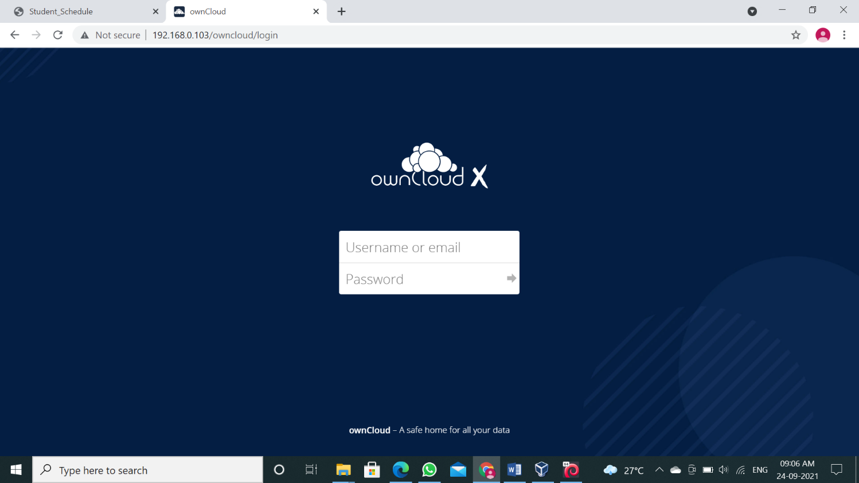

**Step 3:** Enter admin name and password which you have set while creating account and click on

“Log in”.

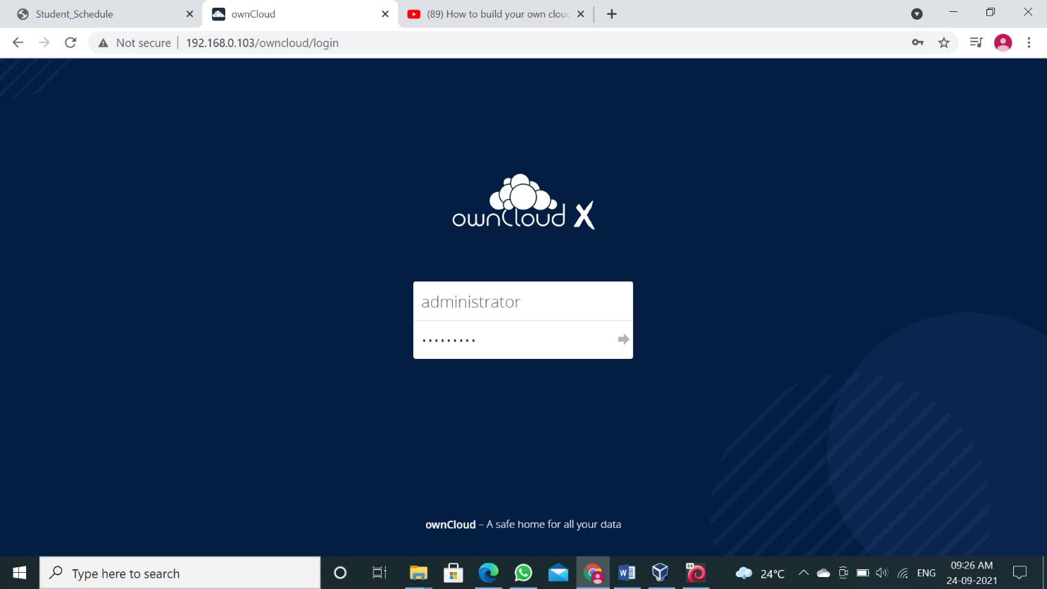

**Step 4:** Following dashboard will get load.

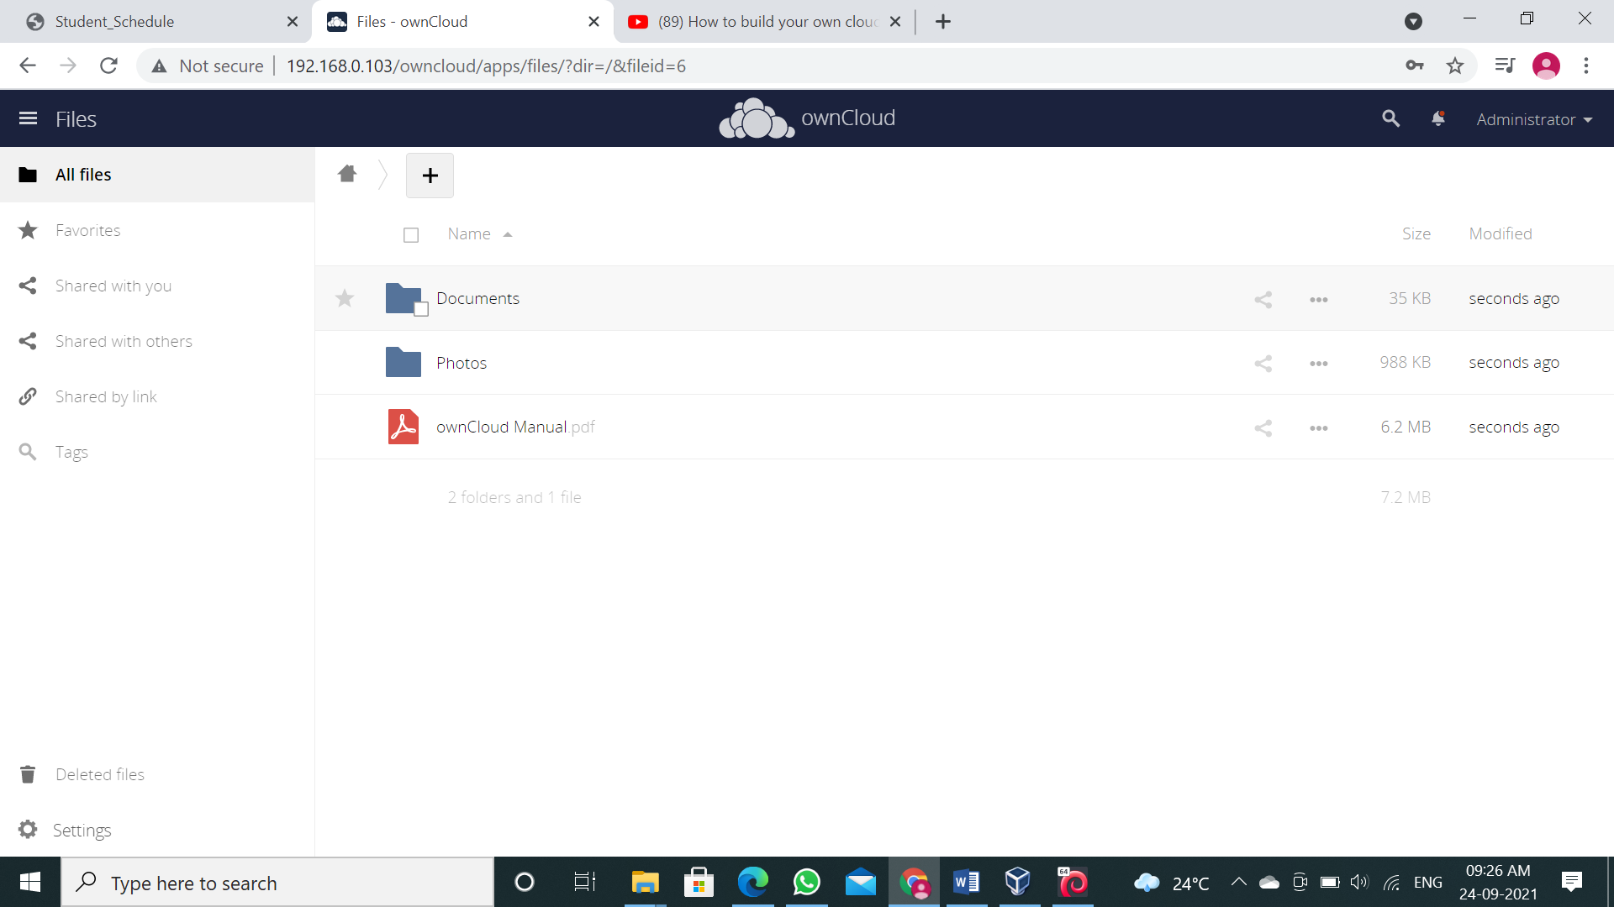

**Step 5:** Now go to “Users”.

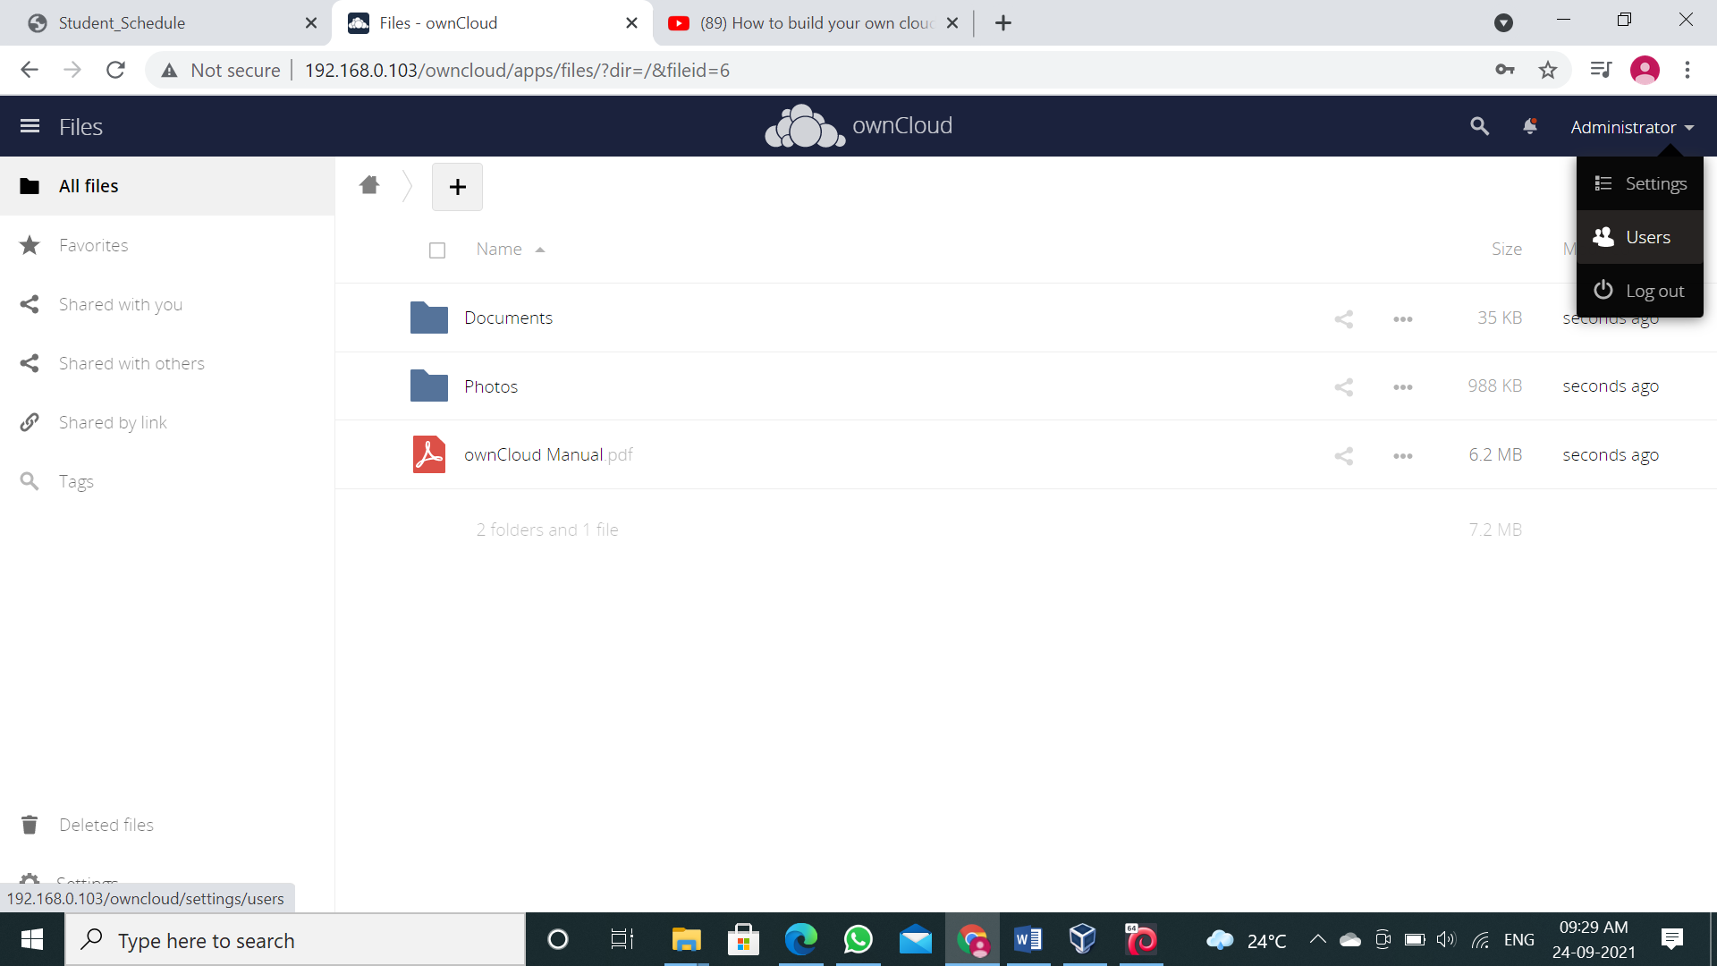

**Step 6:** You can see that there is only user which is admin, which is in Group admin

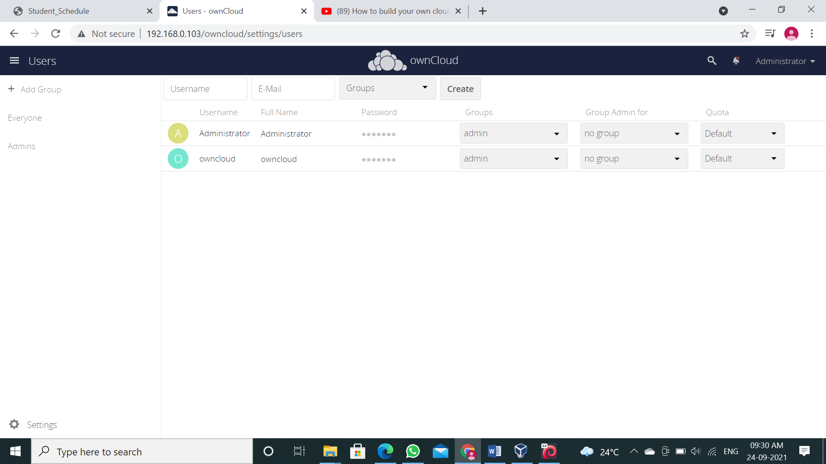

**Step 7:** Now let’s add group, for that go to “Group” > “add group”.

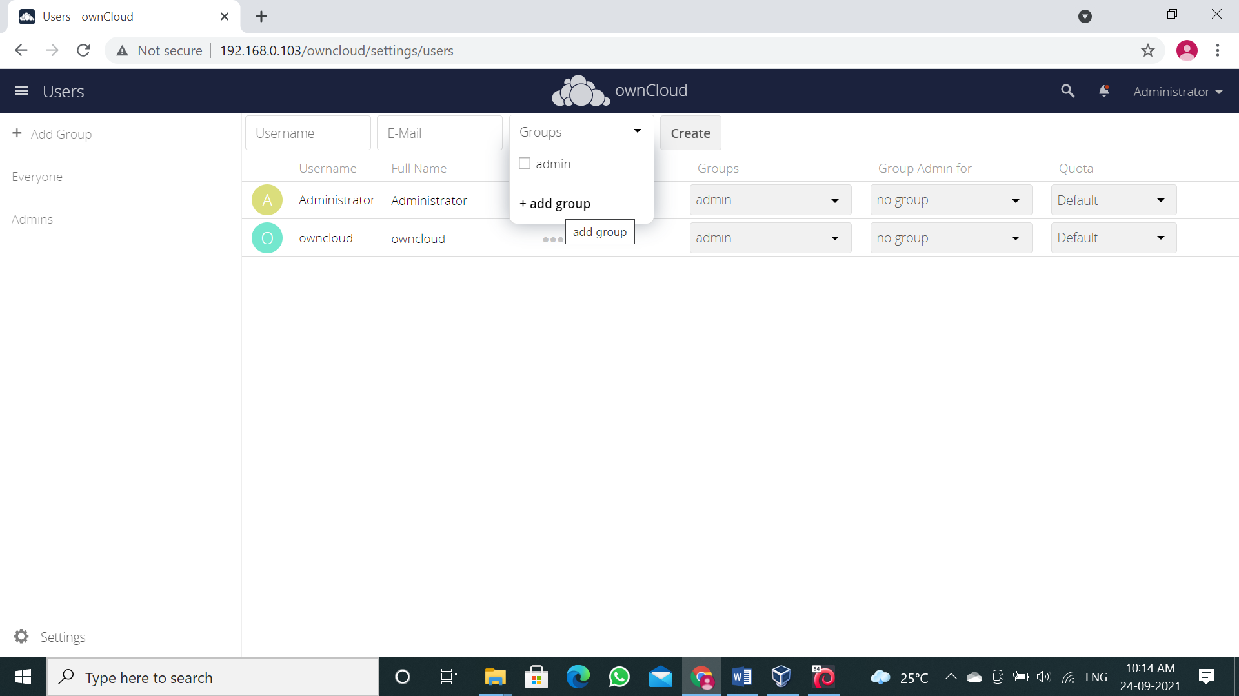

**Step 8:** Enter group name and press “enter”.

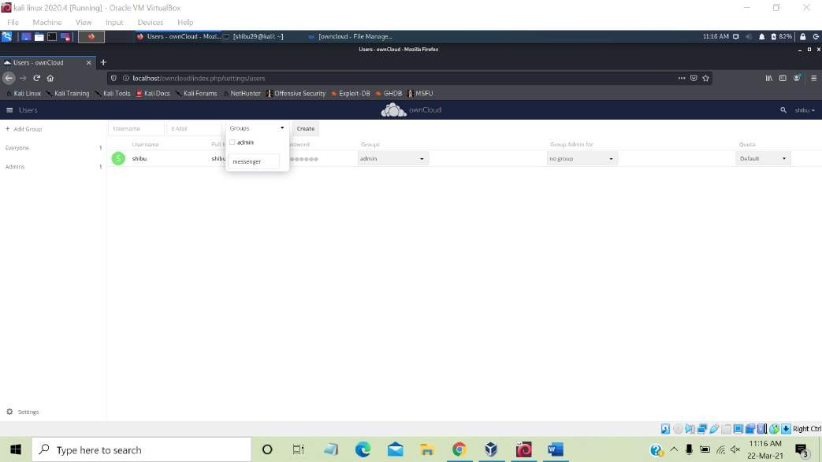

**Step 9:** Our group has been added, now select it.

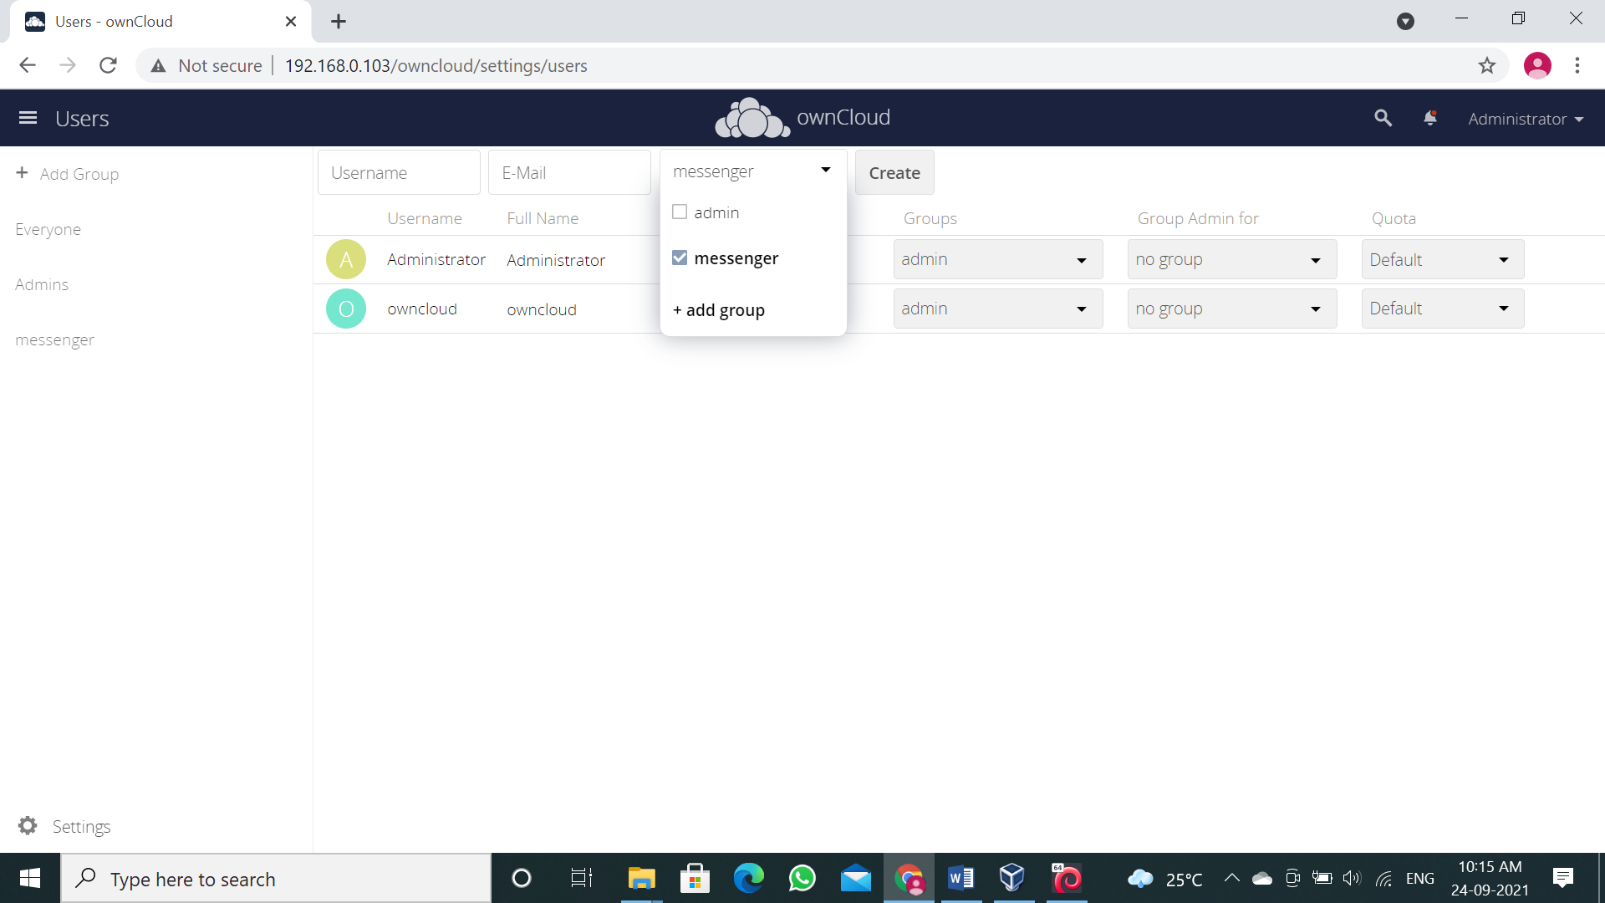

**Step 10:** Now enter “Username” and “E-mail” for the user and click on “Create”.

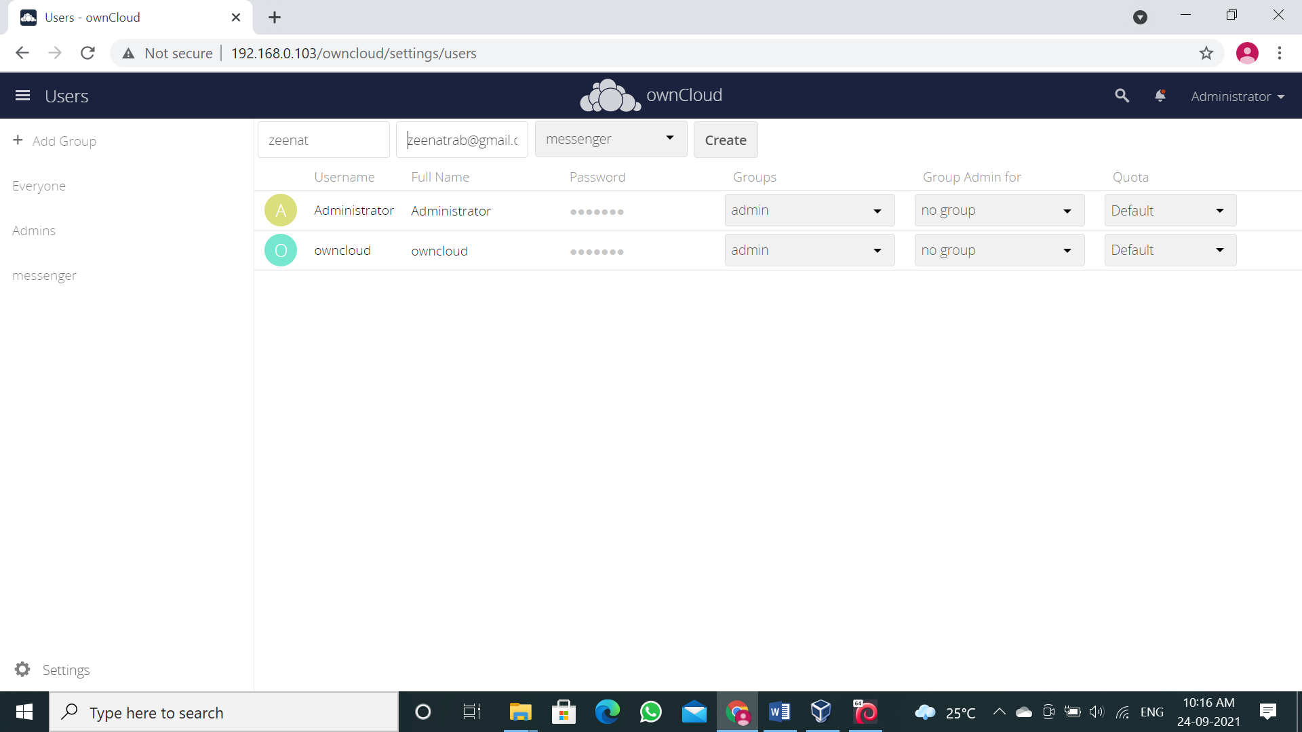

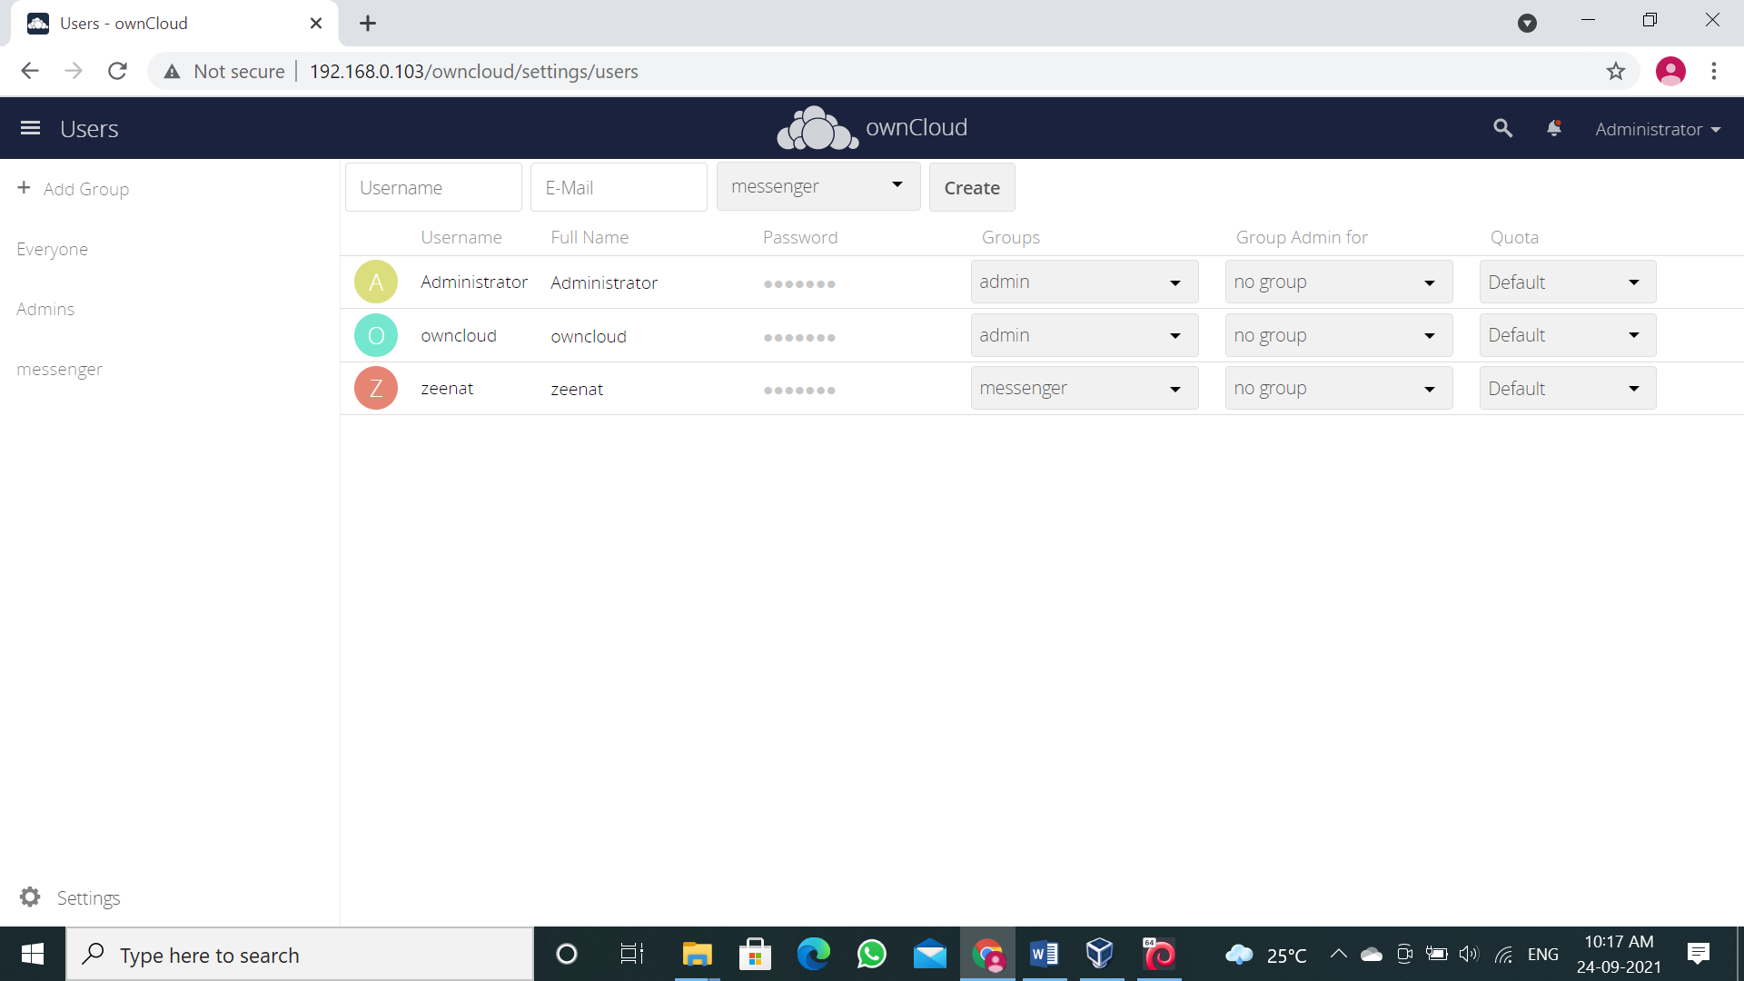

**Step 11:** Our user is been added we can change the storage limit for the new user.

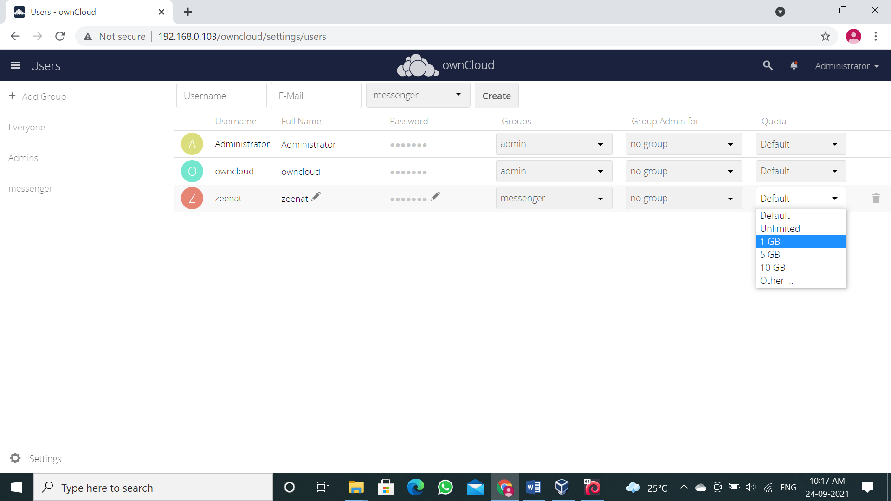

**Step 12:** Let’s add another user but this time in “admin” group

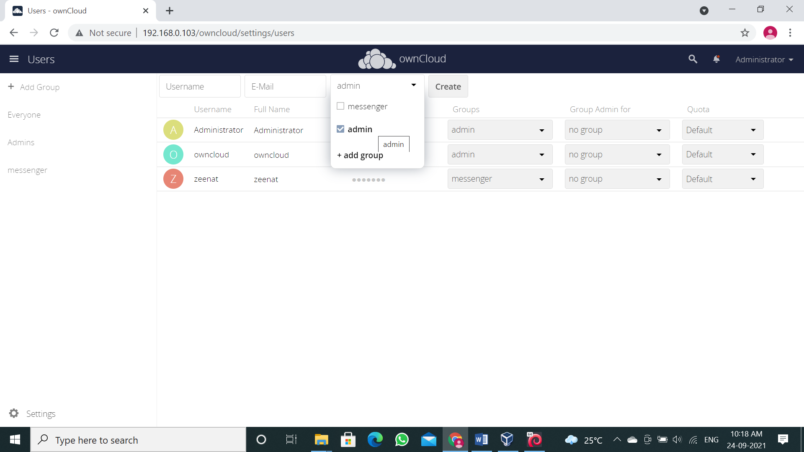 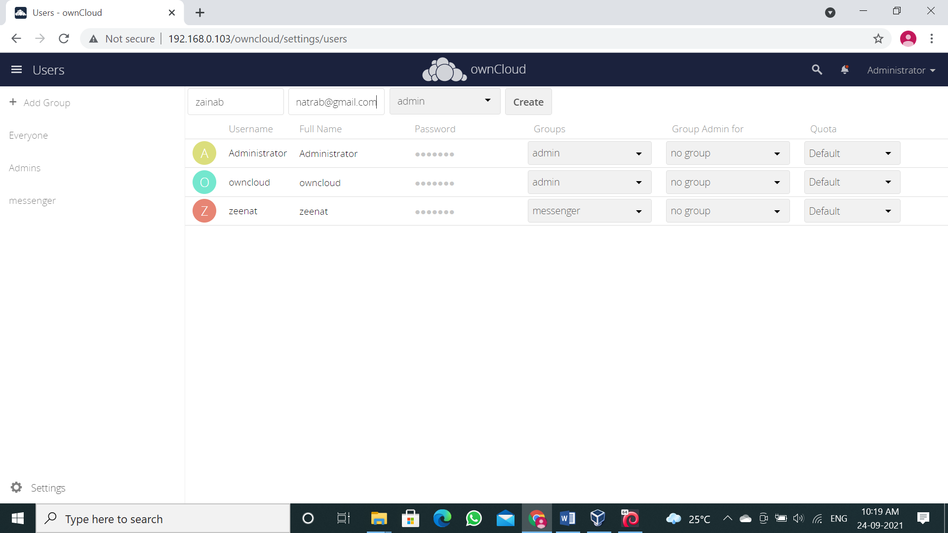

**Step 13:** If it shows “admin, admin” in group just click on it and uncheck one “admin”.

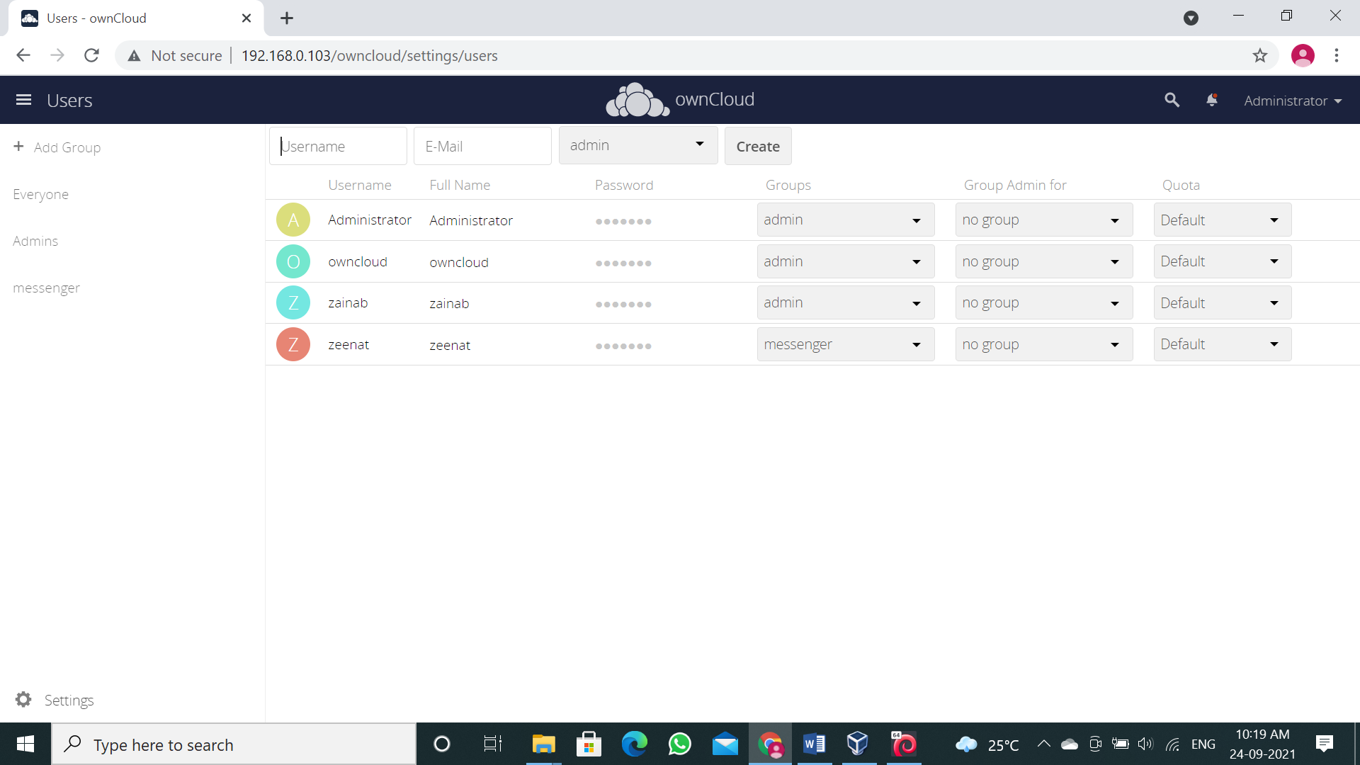

**Note:** Sometimes it fails to register user in “admin” group so please check before logging out.

You can check by refreshing the page.

**Step 14:** Before Logging out from admin account, set new password in the password field.

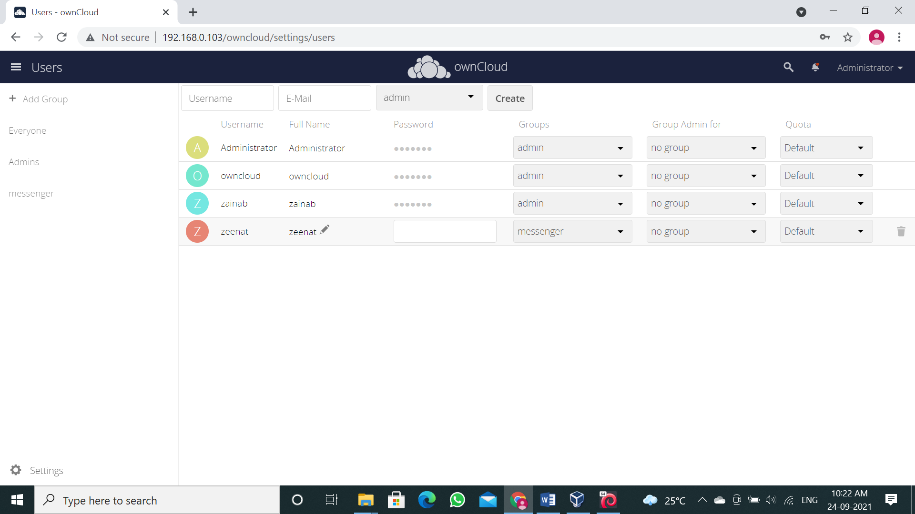

**Step 15:** Now “Log out” from the admin account.

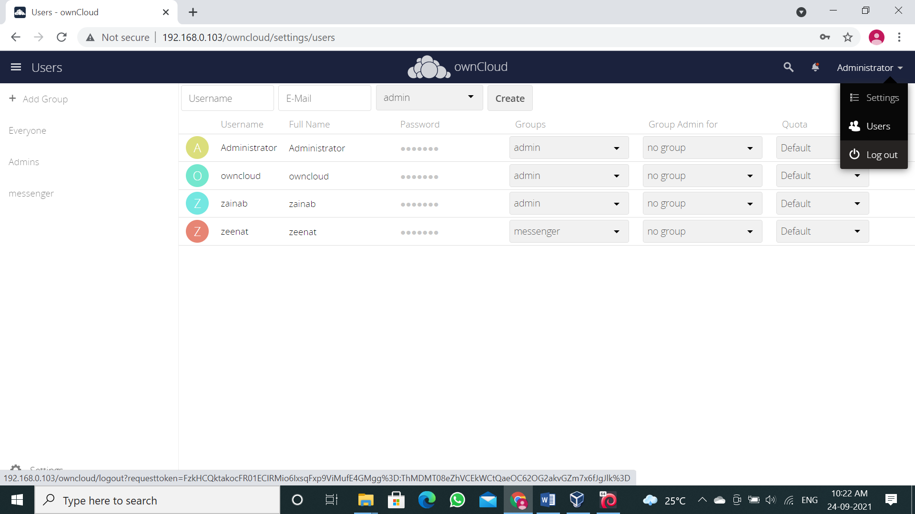

**Step 16:** Try log in with user you just created.

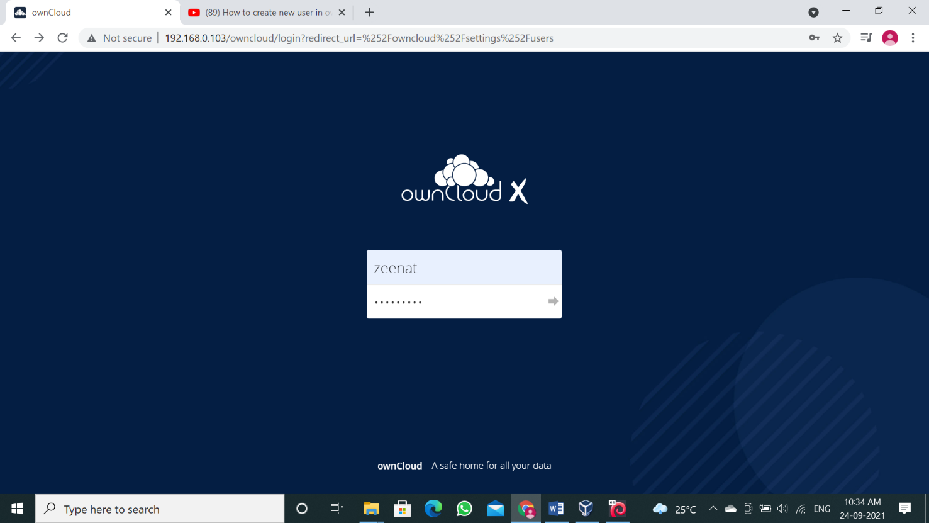

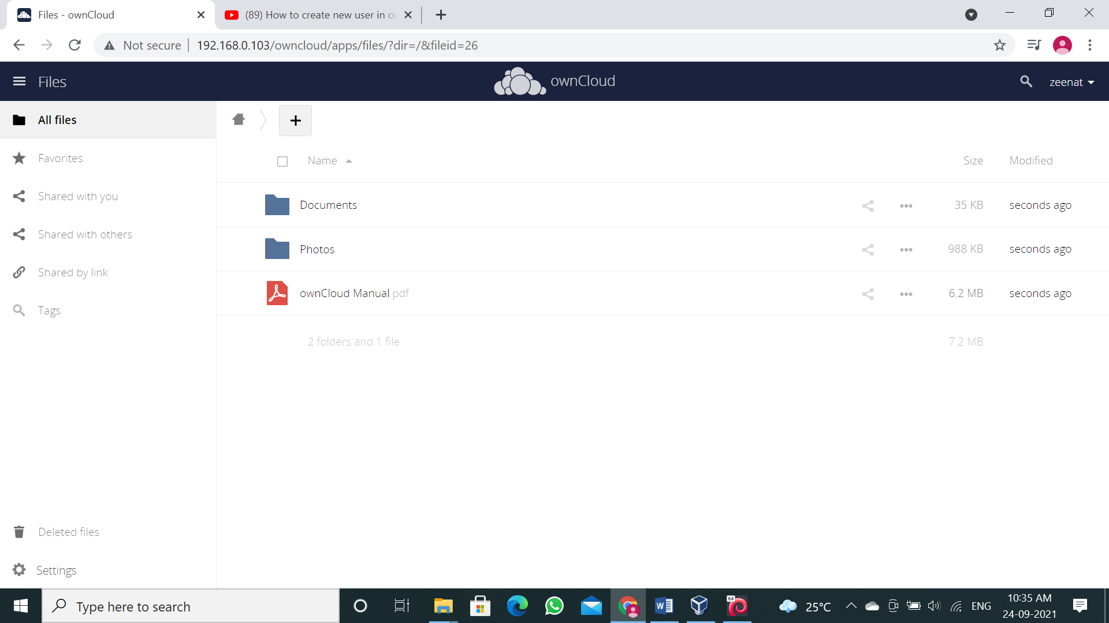

Yes, it has successfully logged in. As you can see this user don’t have any privilege link adding users and creating group because it’s not in “admin” group, now “log out” from the account.

**Step 17:** Now let’s try to log in from the user account who is in “admin” group.

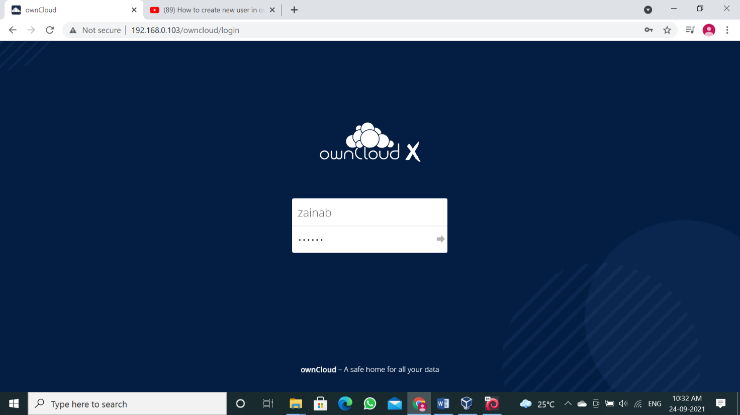

**Step 18:** Enter login details and click on “Log in”.

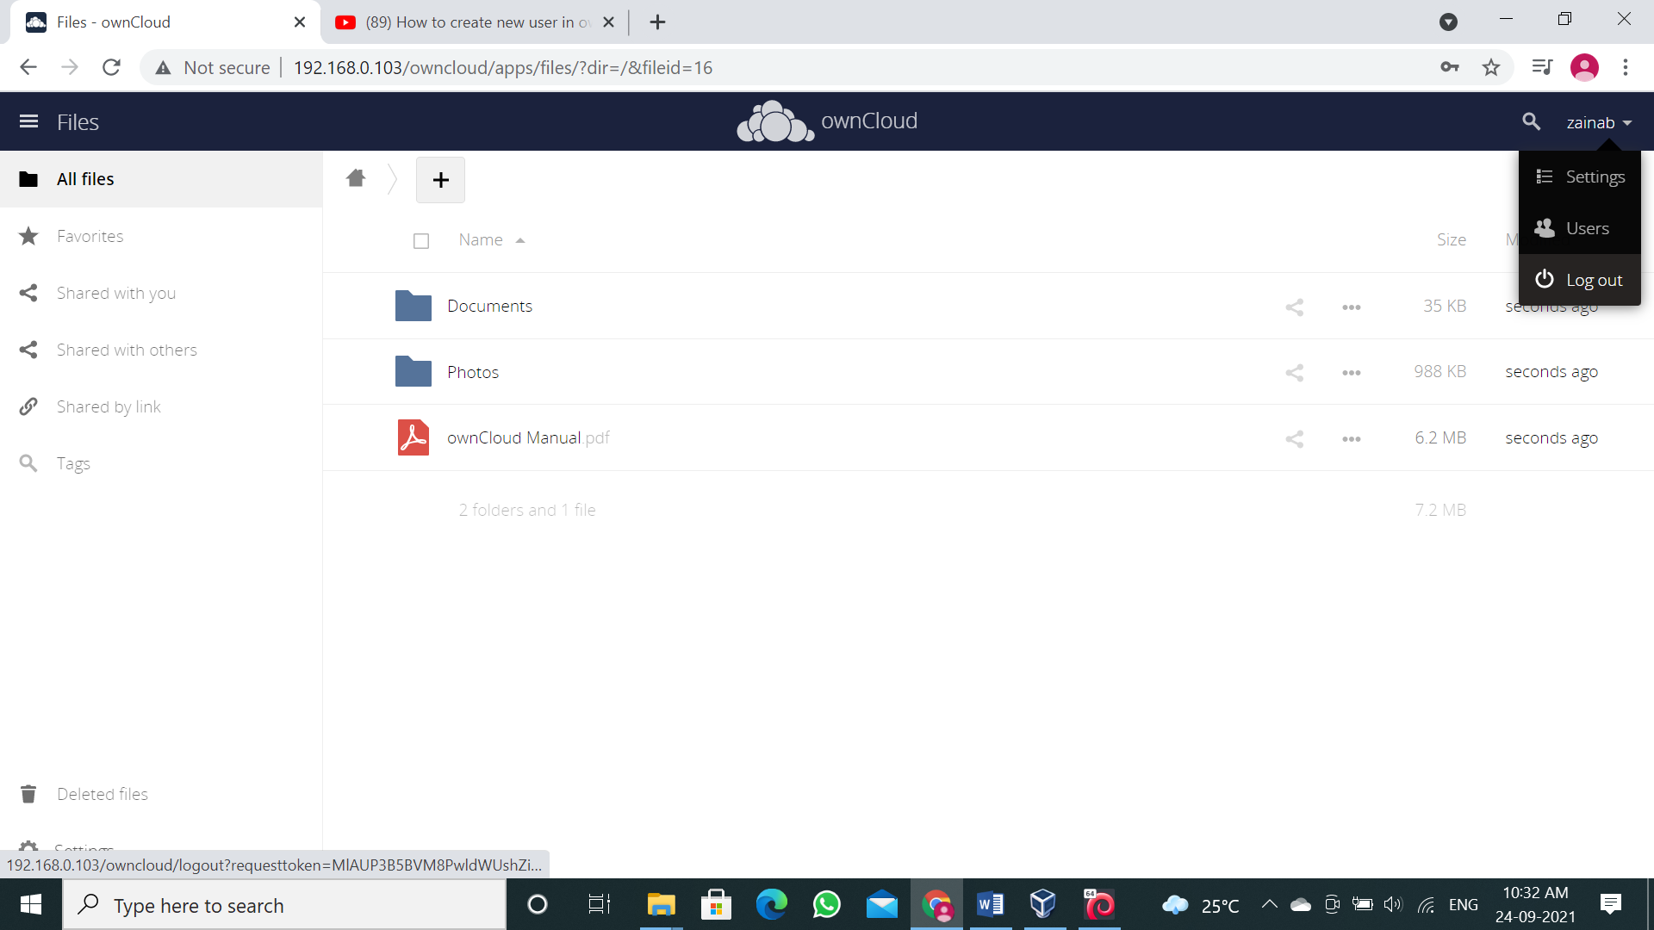

As you can see this user has the privileges of admin because he is in “admin” group.

**Note:** If it doesn’t show the privilege then go to admin account and check if this user group is

“admin” group.

This user has all the rights that admin possess like adding or deleting user

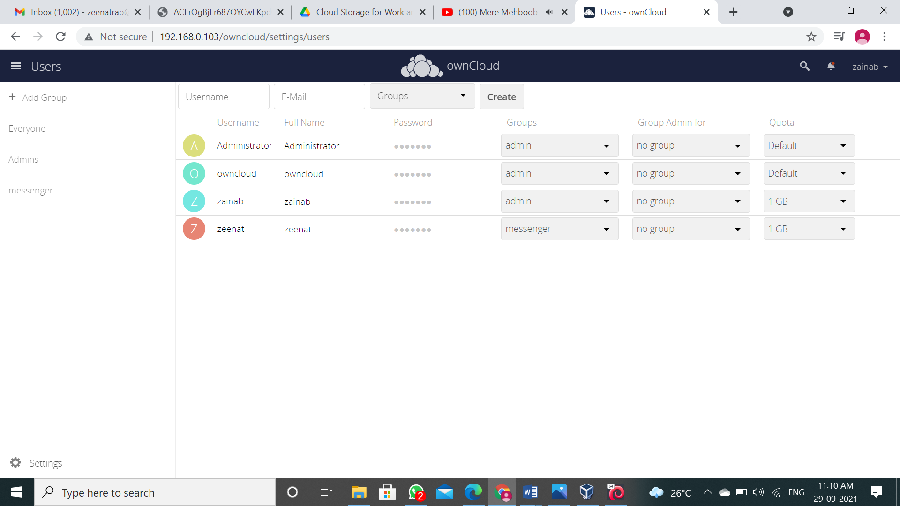

## CONCLUSION:

OwnCloud only stands to grow in popularity as people and enterprises become more concerned about the true security of their data, given the recent leaks we have seen from the NSA and the co-operation of companies such as Google or Apple in sharing user data. With OwnCloud you maintain control of your data and no-one else will be able to access it.

**Practical 8**

**Aim: Study Cloud Security Management.**

**OBJECTIVE:** From this experiment the student will be able,

* To understand the security features of Cloud.
* To learn the technique of application security management and its complexity
* To understand the importance of cloud security management from application point of view

**OUTCOME:** The learner will be able to

* Student can study and implement single-sign-on.
* To use current techniques, skills, and tools necessary for computing practice.
* To match the industry requirements in the domains of Database management, Programming and Networking with the required management skills.

## THEORY:

**Multi-Factor Authentication (MFA) –** Multi Factor Authentication (MFA) is an authentication method that requires the user to provide two or more verification factors to gain access to a resource such as an application, online account, or a VPN. MFA is a core component of a strong identity and access management (IAM) policy.

Rather than just asking for a username and password, MFA requires one or more additional verification factors, which decreases the likelihood of a successful cyber-attack.

**Importance –** The main benefit of MFA is it will enhance your organization's security by requiring your users to identify themselves by more than a username and password. While important, usernames and passwords are vulnerable to brute force attacks and can be stolen by third parties.

Enforcing the use of an MFA factor like a thumbprint or physical hardware key means increased confidence that your organization will stay safe from cyber criminals.

**Working of MFA –** MFA works by requiring additional verification information (factors). One of the most common MFA factors that users encounter are one-time passwords (OTP). OTPs are those 4 – 8 digits codes that you often receive via email, SMS or some sort of mobile app.

With OTPs a new code is generated periodically or each time an authentication request is submitted.

The code is generated based upon a seed value that is assigned to the user when they first register and some other factor which could simply be a counter that is incremented or a time value.

Three Main Types of MFA Authentication Methods

* Things you know (knowledge), such as a password or PIN
* Things you have (possession), such as a badge or smartphone
* Things you are (inherence), such as a biometric like fingerprints or voice recognition

## PROCEDURE:

Click on the link: <https://aws.amazon.com/console/>

**Step 1:** Go to “My Account” > “AWS Management Console”.

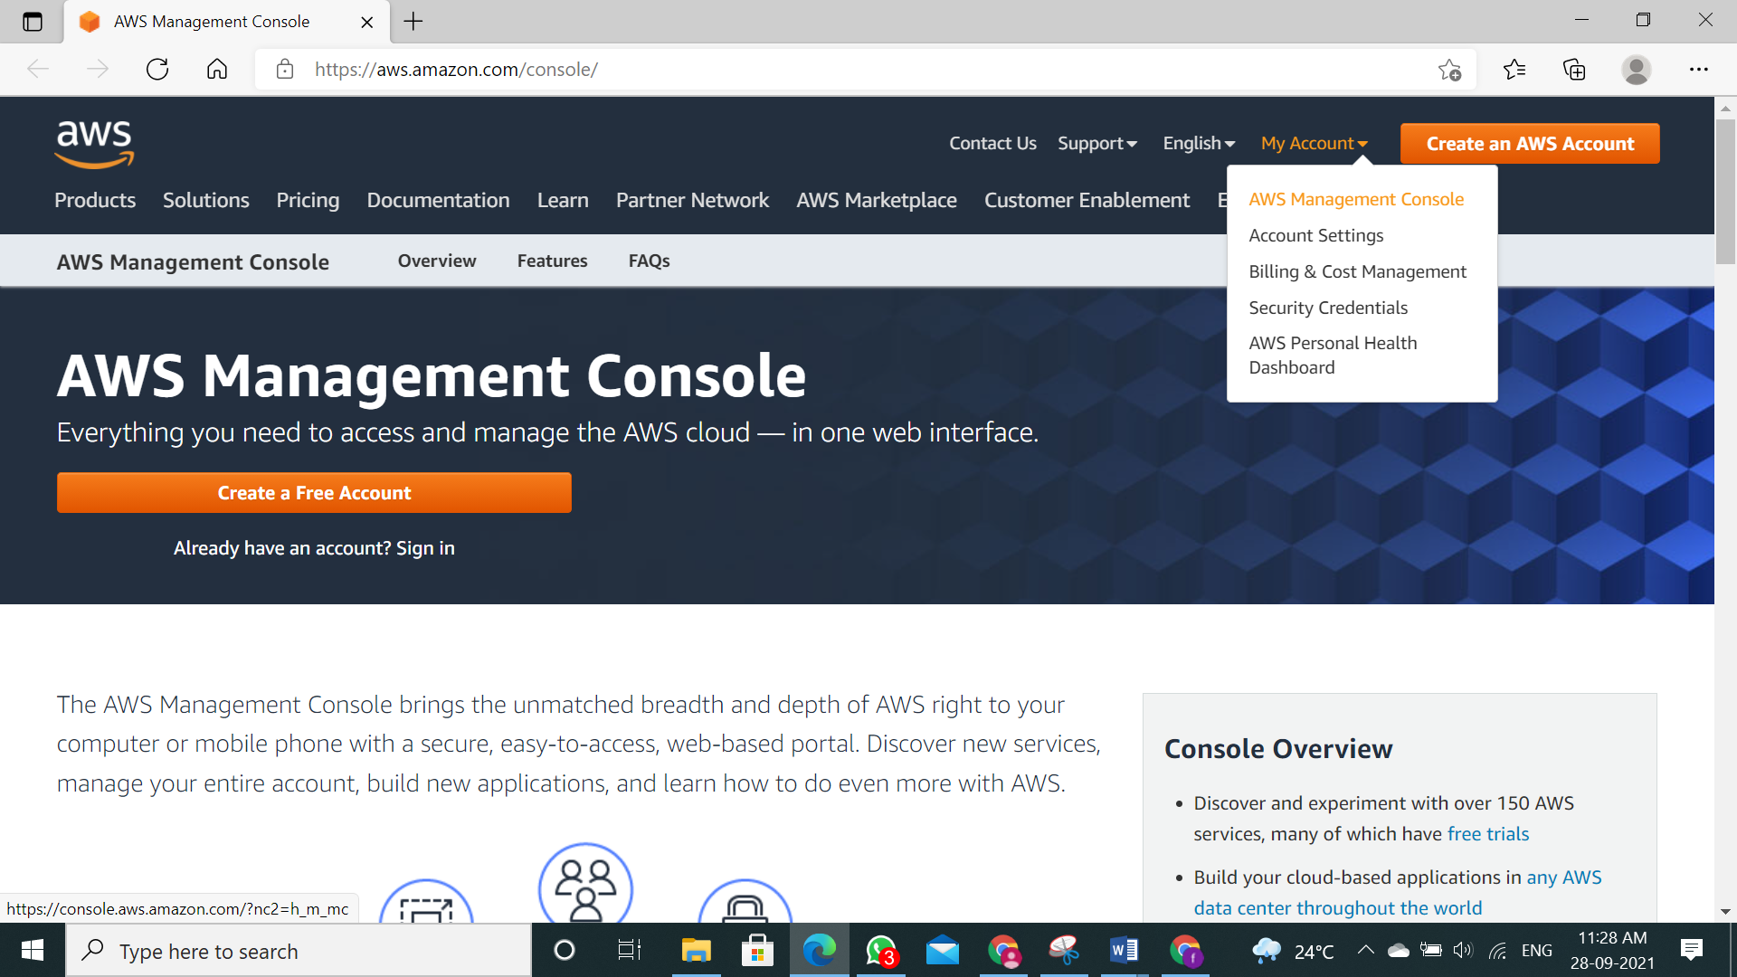

**Step 2:** Just login to your user’s account.

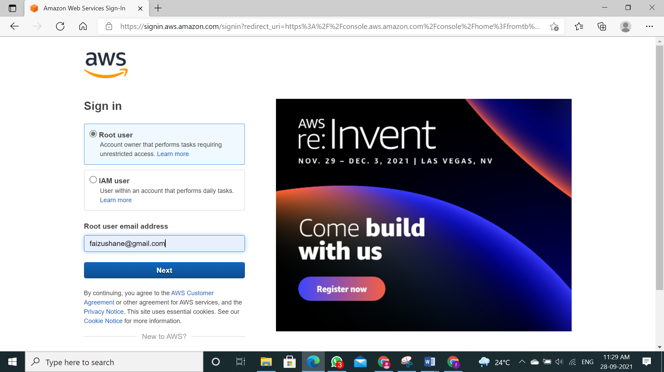

**Step 3:** Click on “Sign In”.

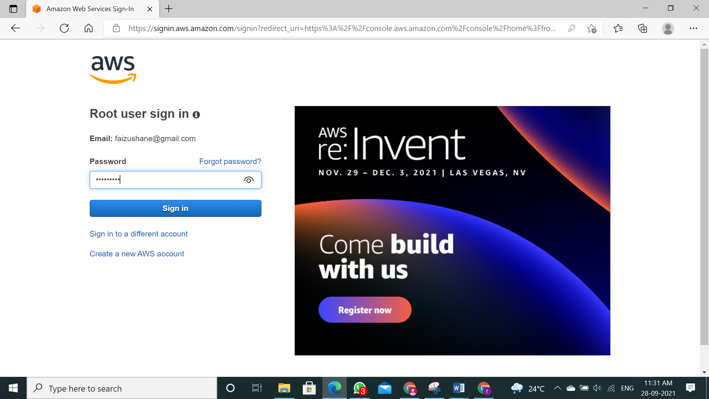

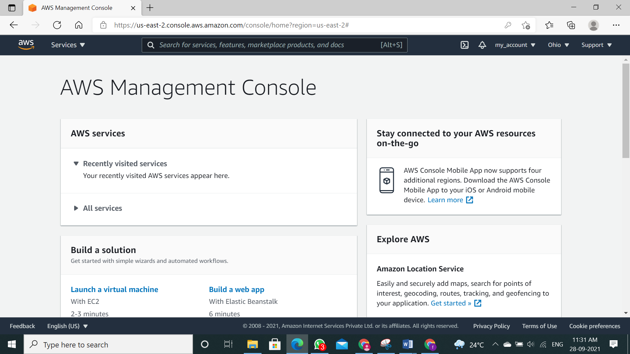

**Step 4:** Once you logged in go to "My security credentials".

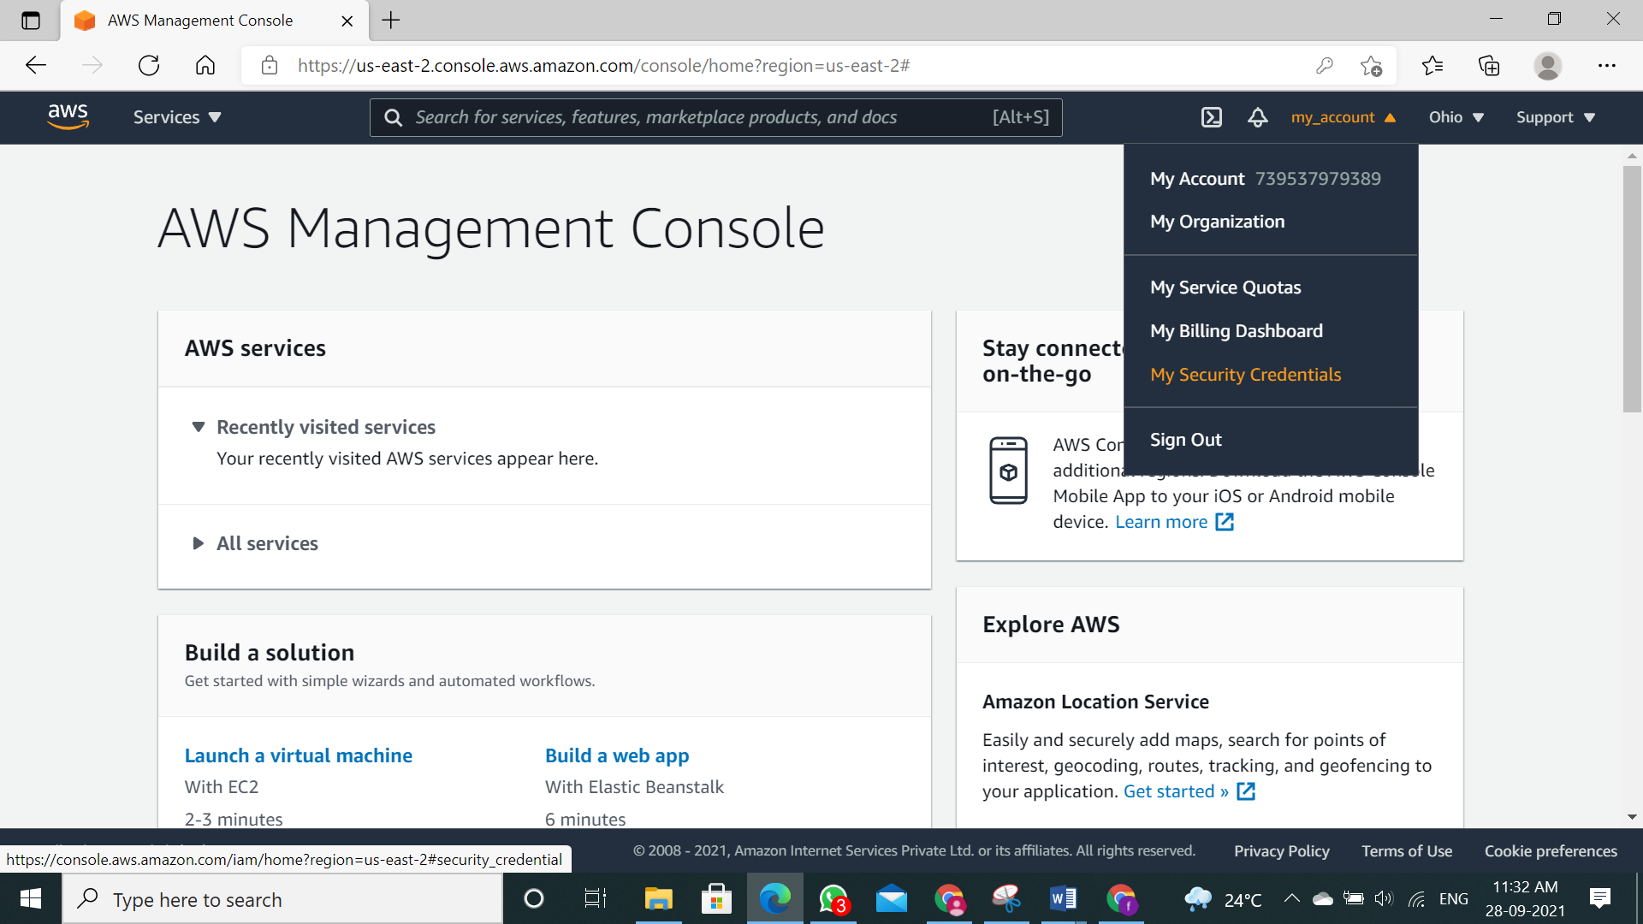

**Step 5:** Scroll down you will find “Multi-factor authentication (MFA)”. Click on “Assign MFA device”

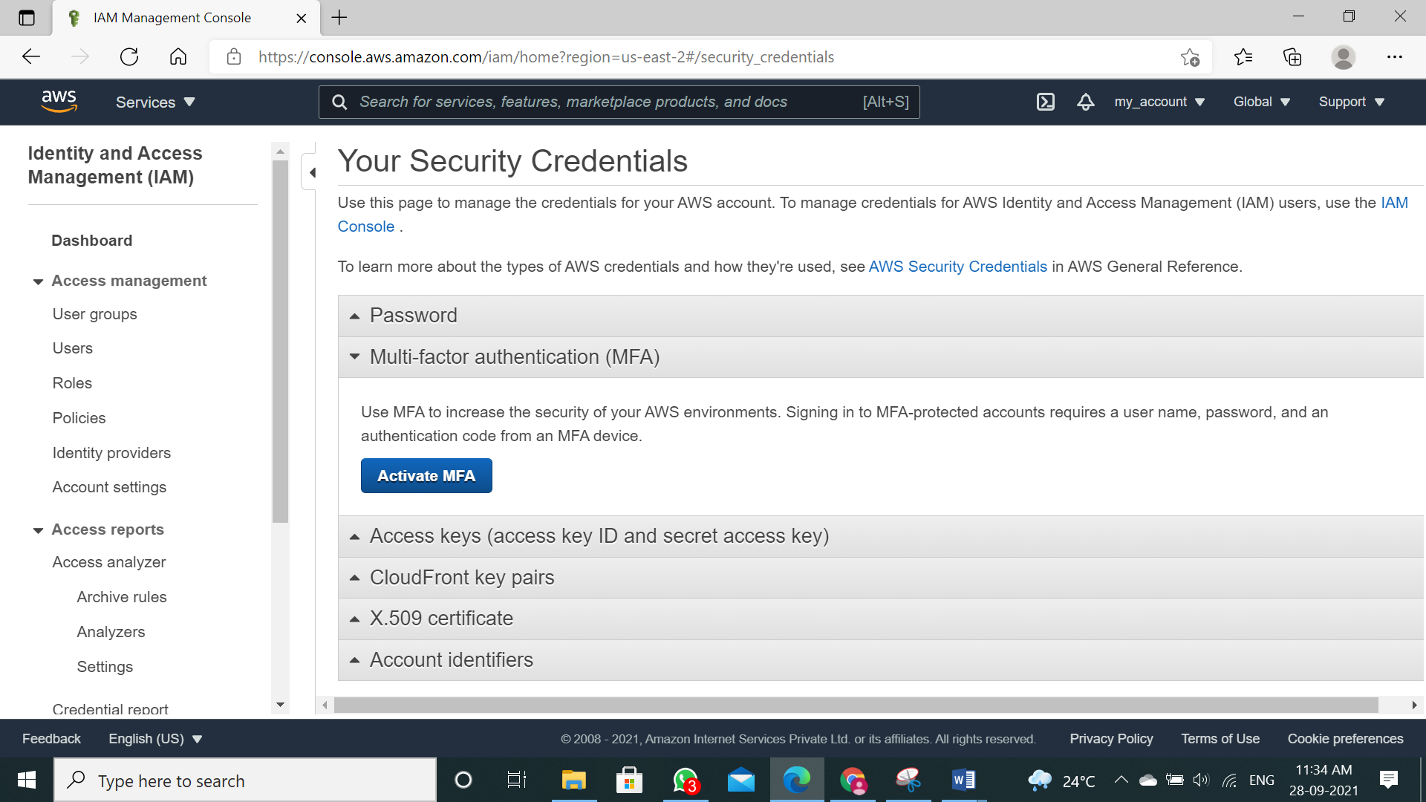

**Step 6:** We will select first option “Virtual MFA device” and click on “Continue”

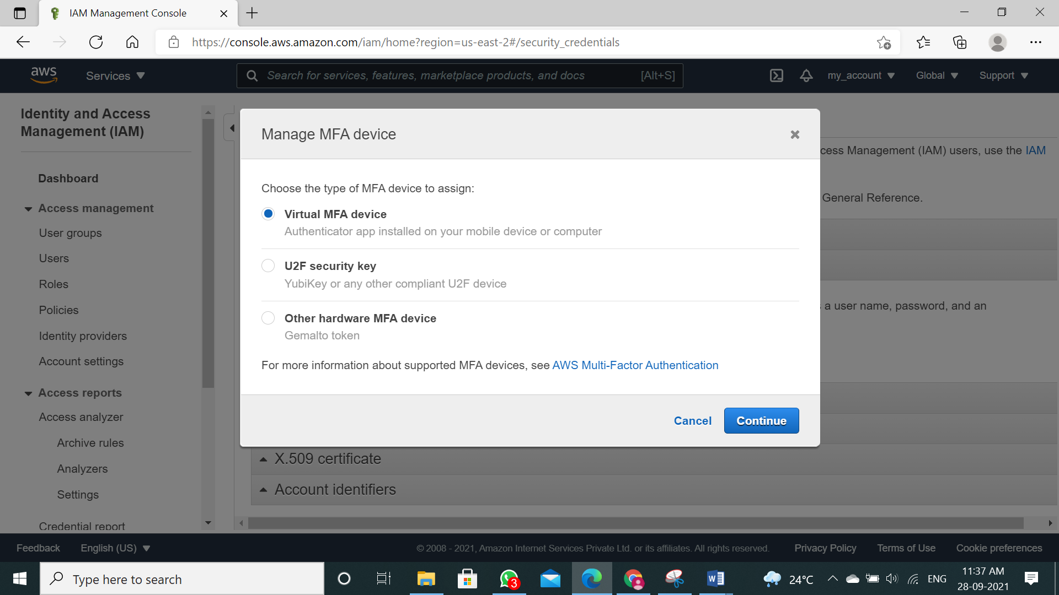

**Step 7:** So, concept is we will use third party app to generate OTP which will help us to authenticate ourselves during logging in. It will add a security layer to our account. Now we have to download “2FA Authenticator (2FAS)” app on our mobile.

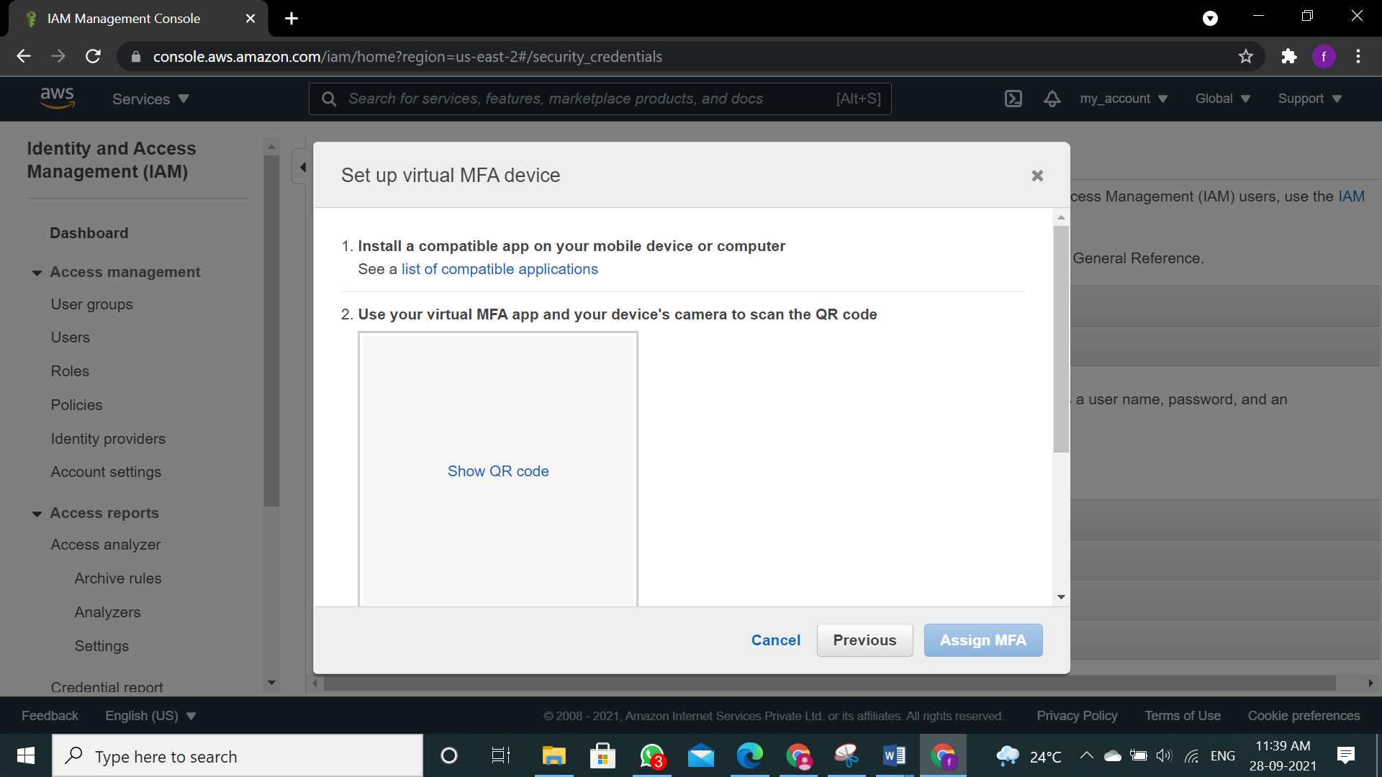

**Step 8:** Click on “Show QR code” to display QR code.

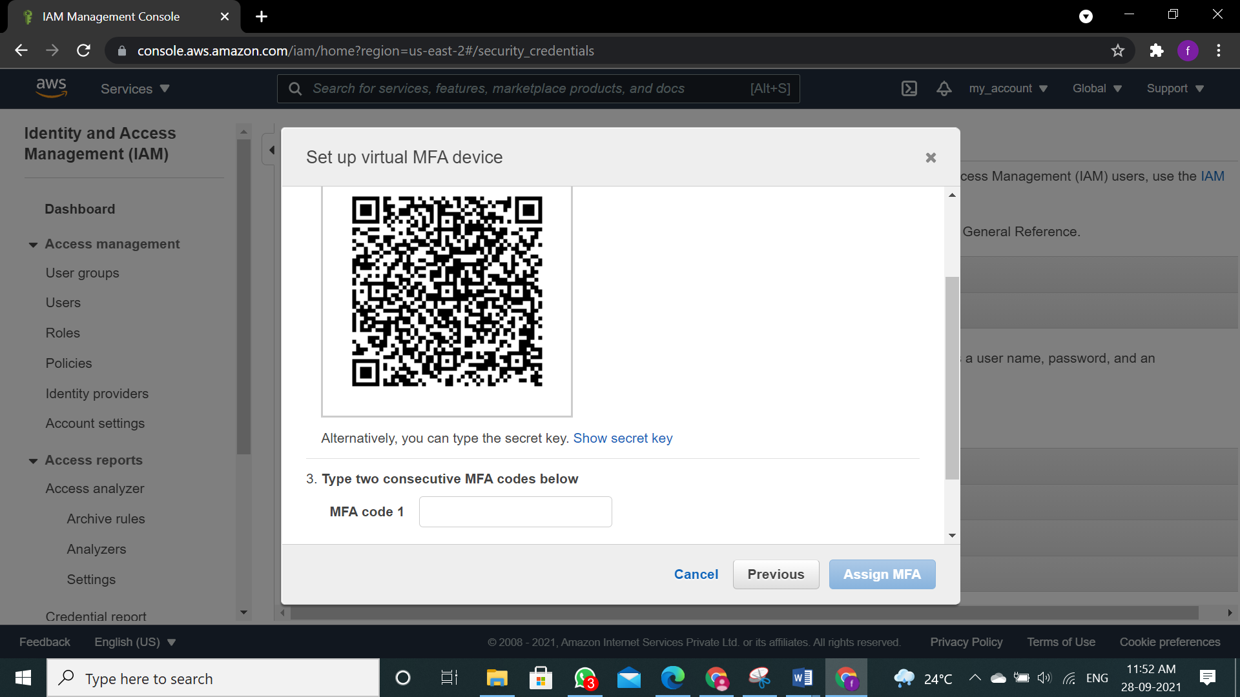

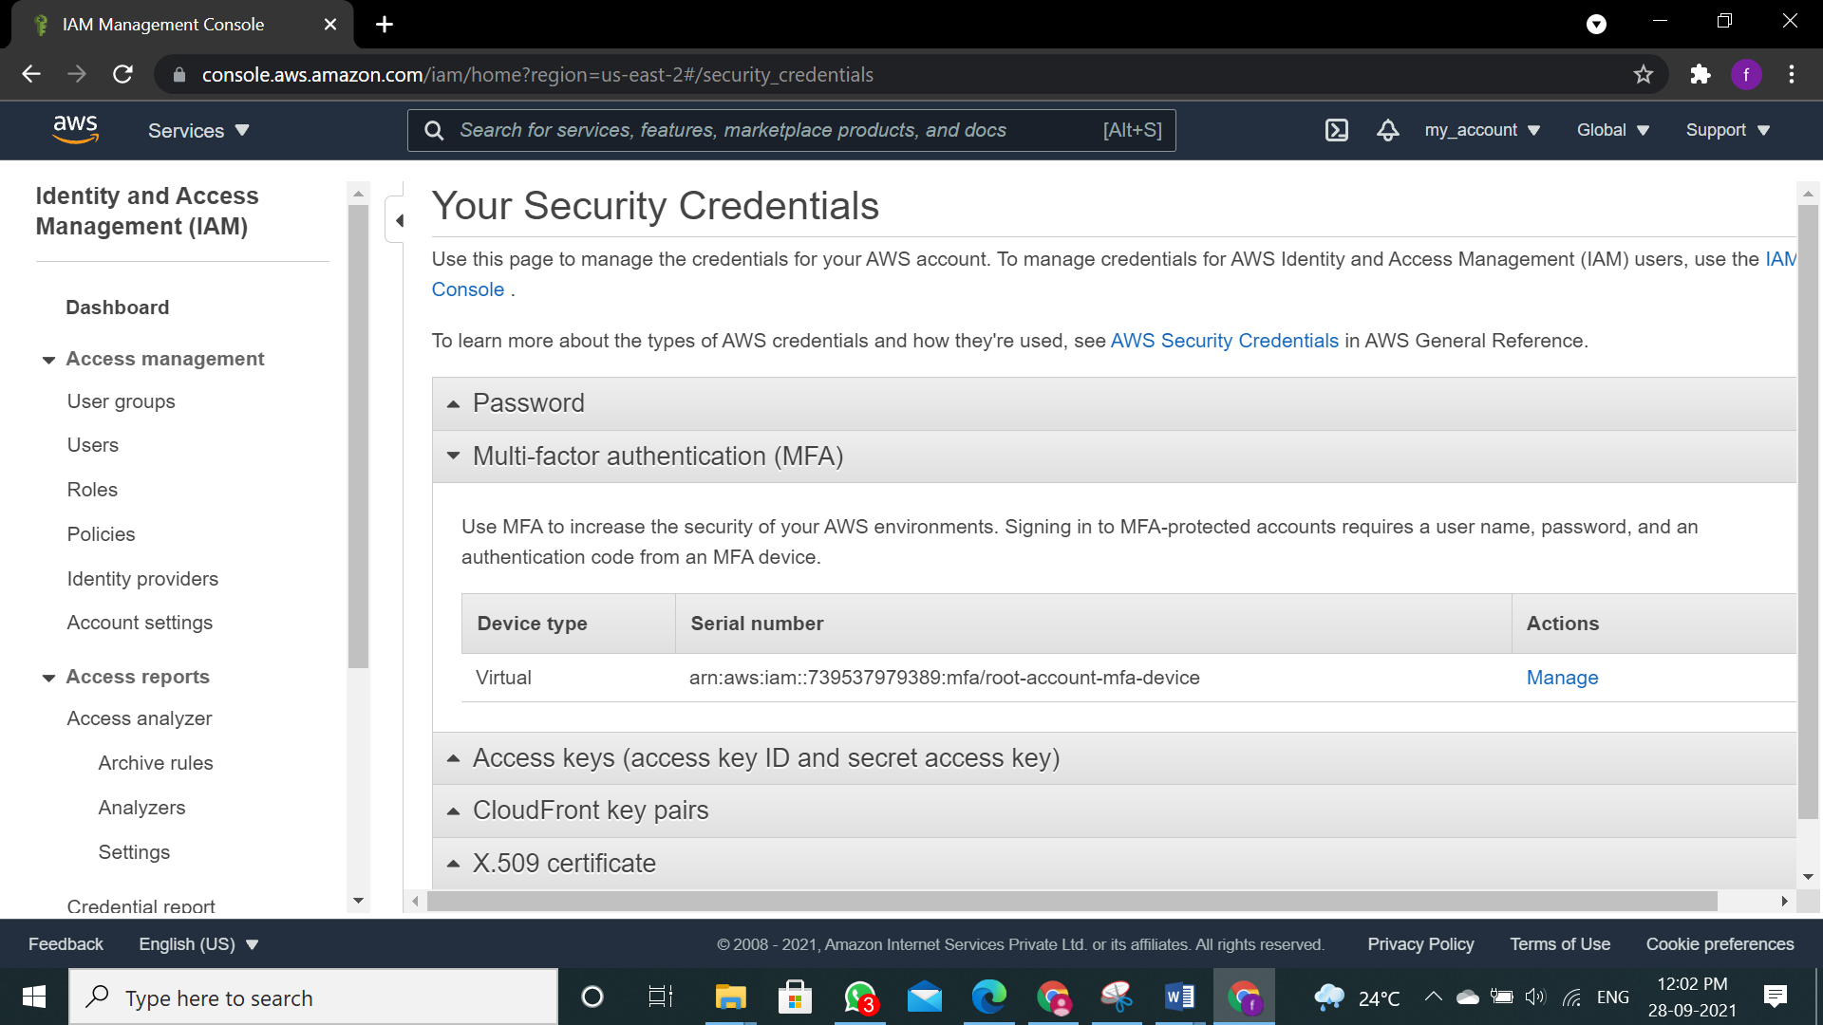

**Step 9:** Open the 2FA Authenticator (2FAS) app click on continue.

**Step 10:** And click on “Scan QR code”.

**Step 11:** First, we have to enter 2 OTP which we will receive on app and click “Assign MFA”.

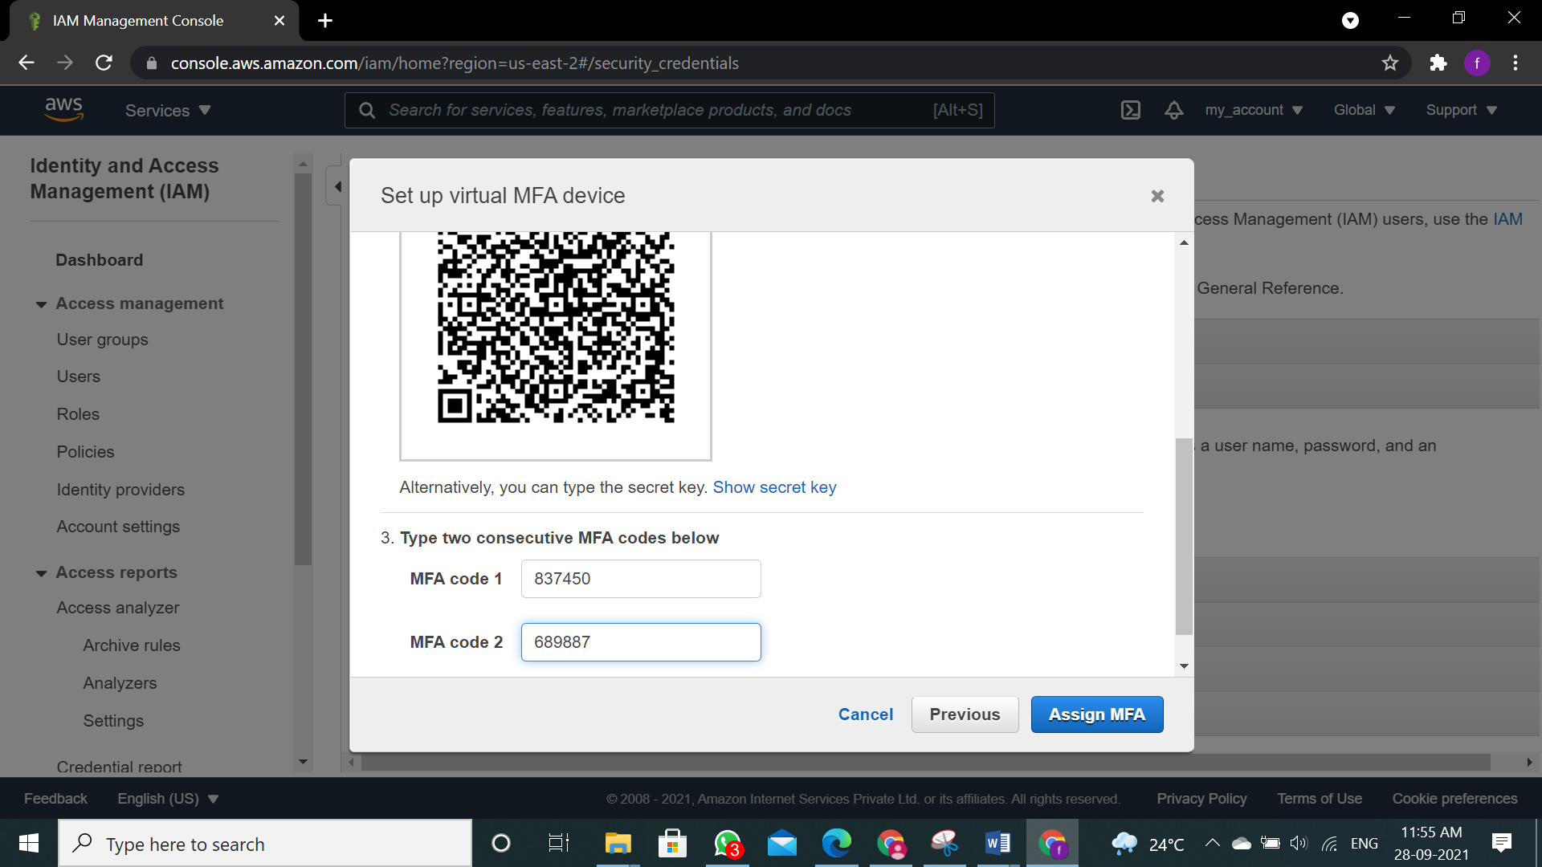

**Step 12:** Click on "Close"

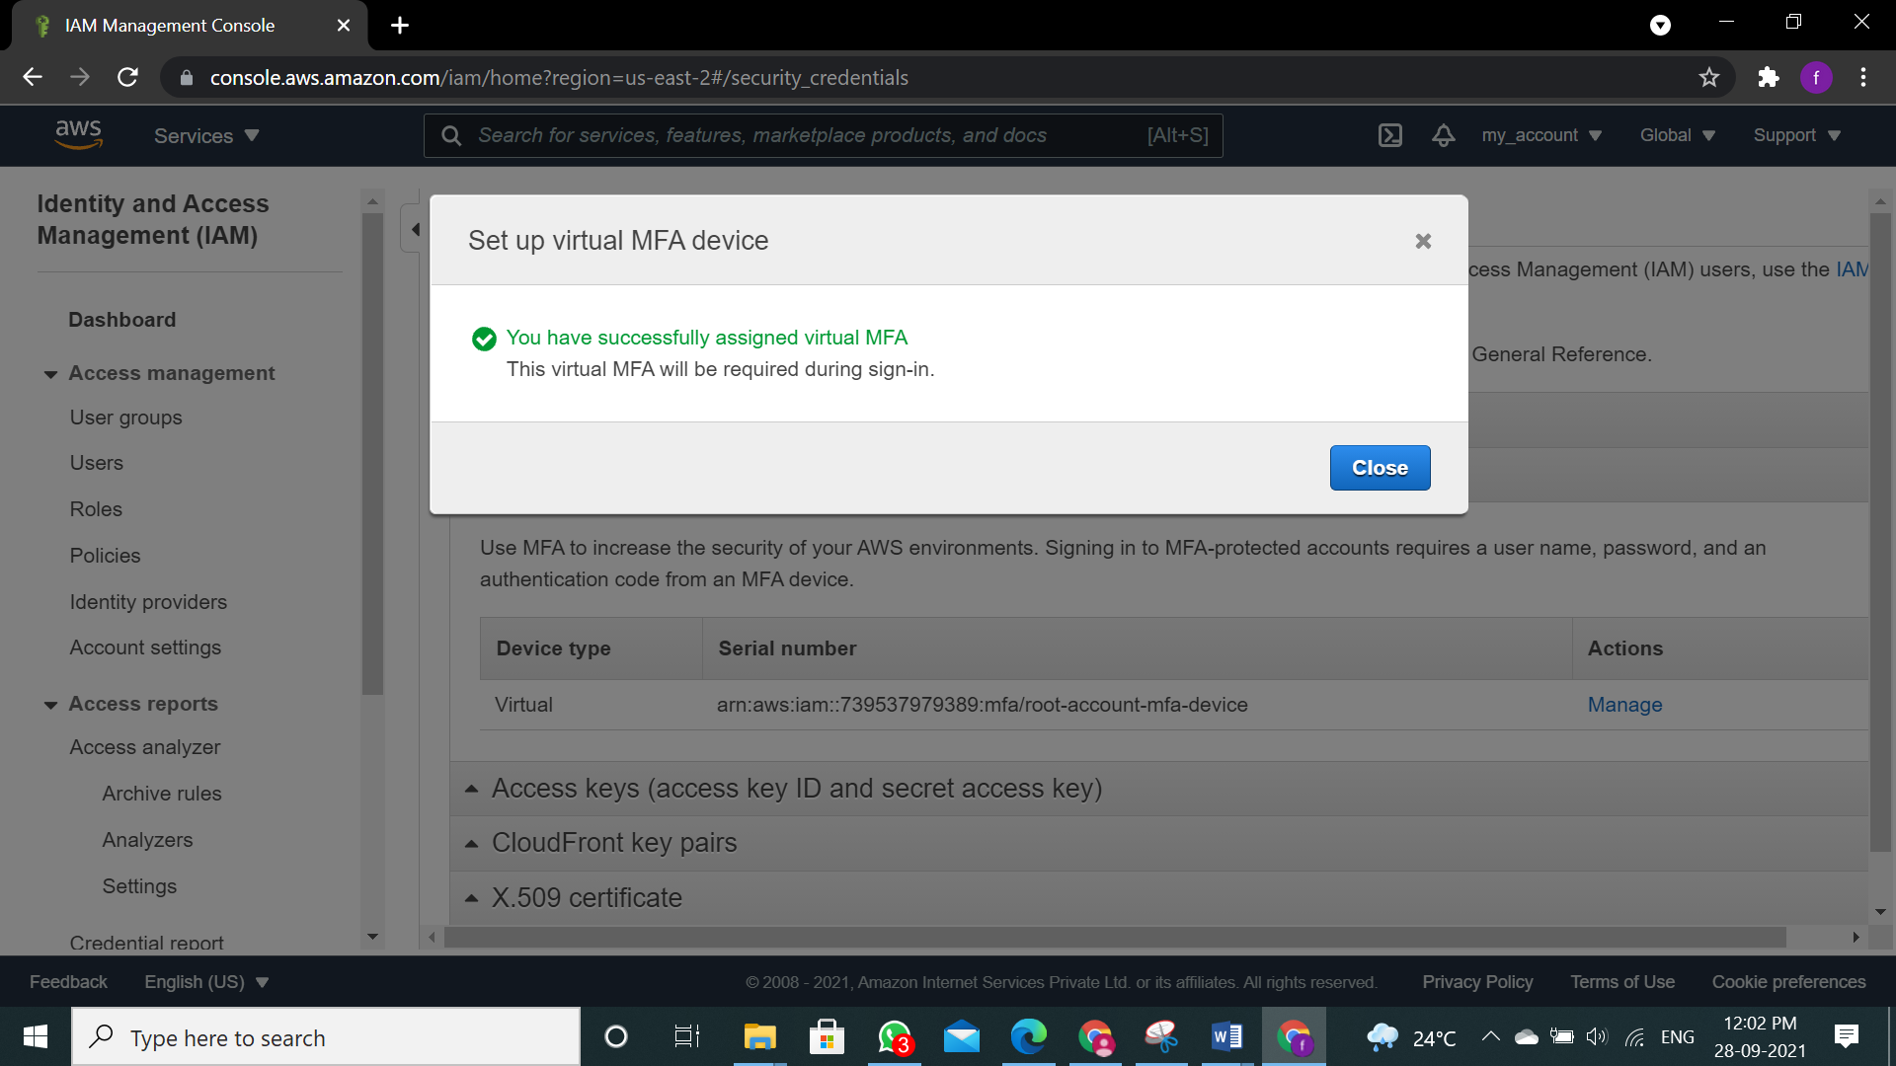

**Step 13:** Log out from the account.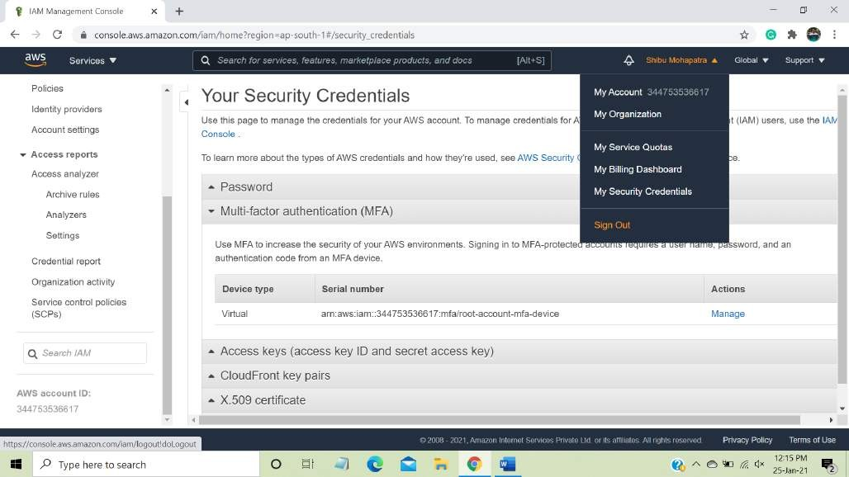

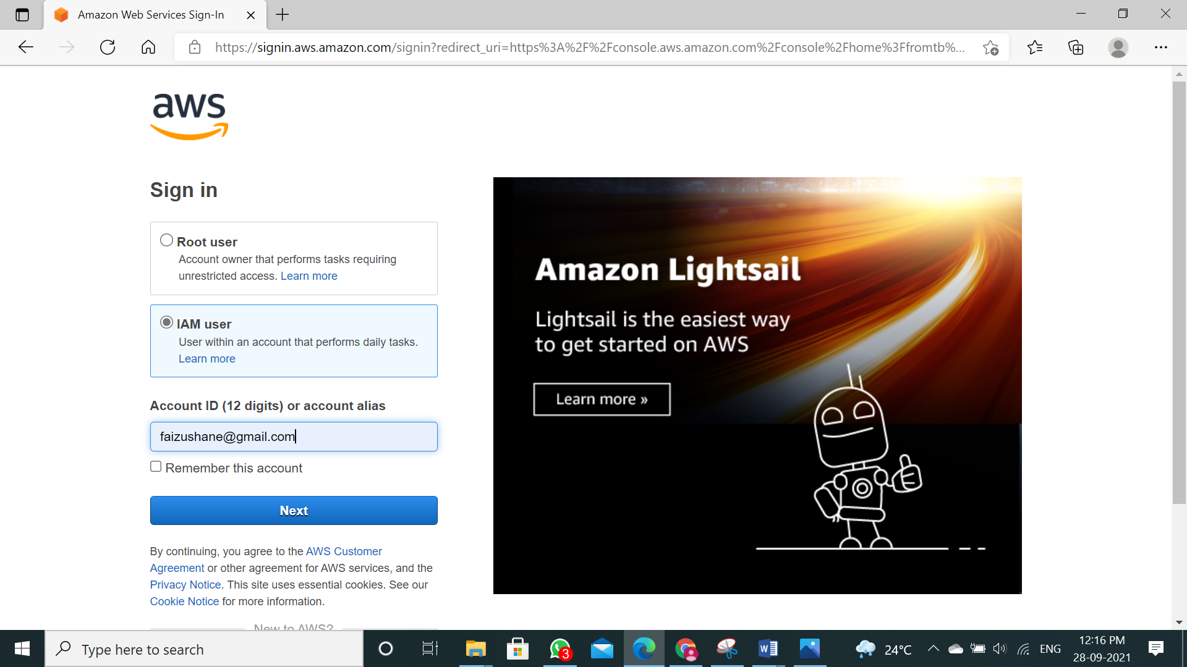

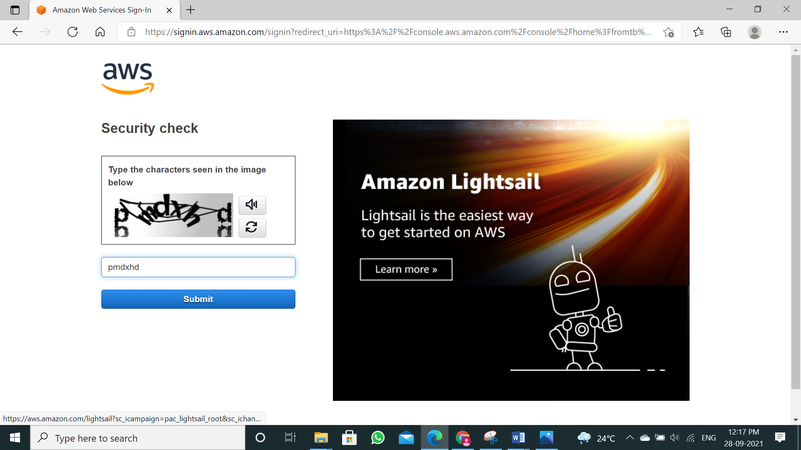

**Step 14:** Now again try to log in to your account

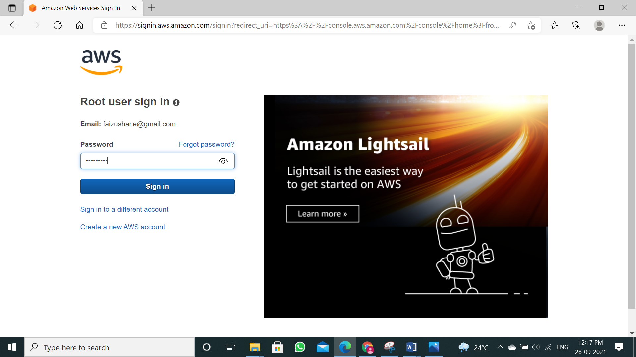

**Step 15:** It will ask for MFA code. You get new code after every 30 seconds, just enter the valid

MFA code and click on “Submit” to login.

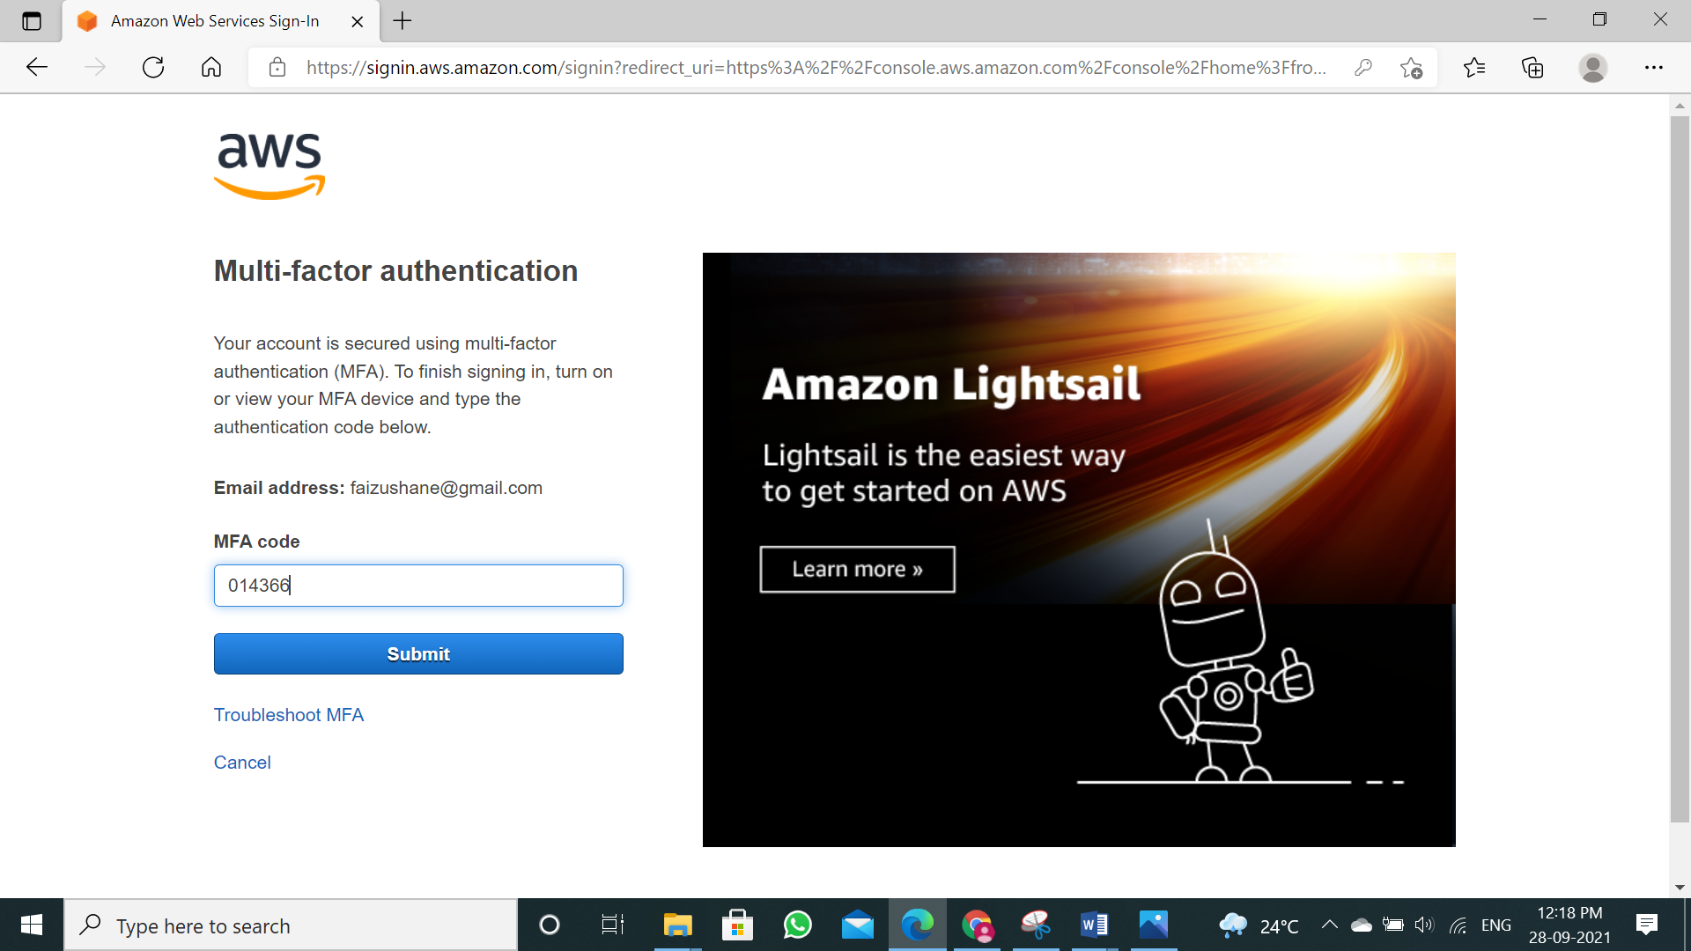

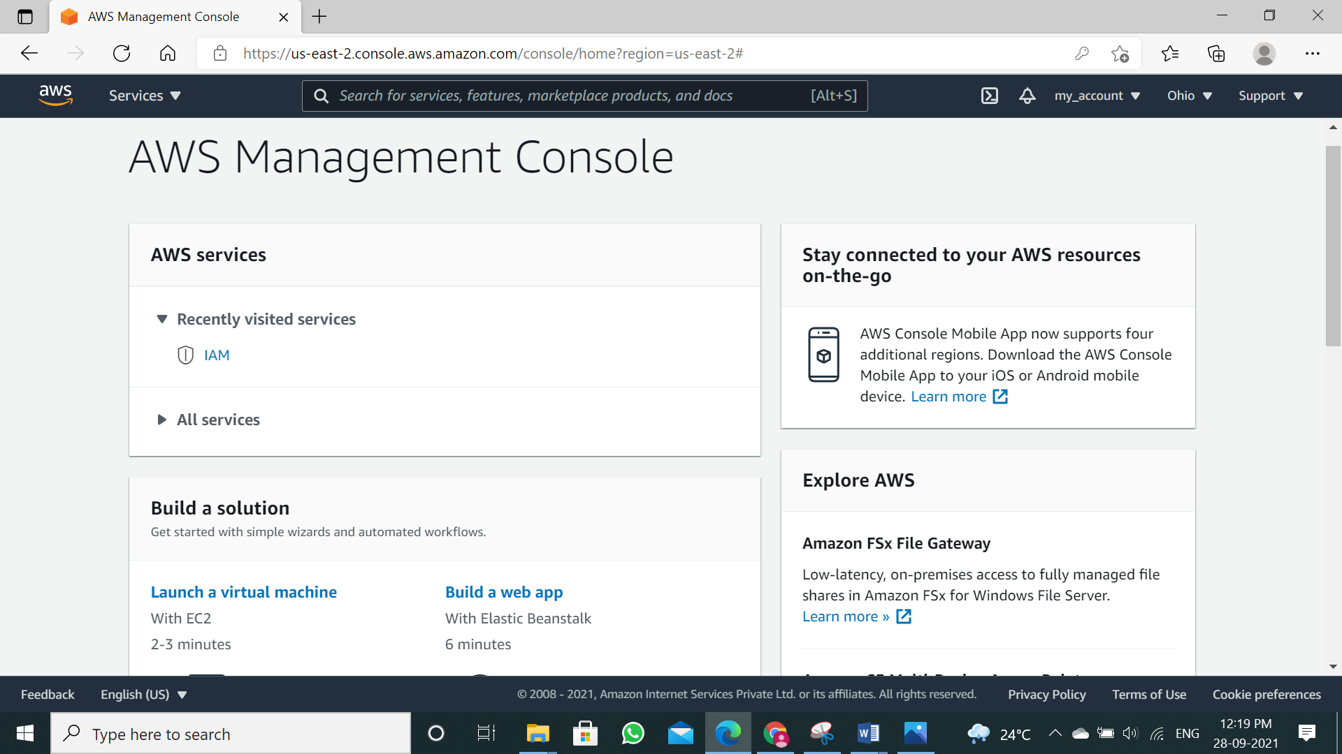

## CONCLUSION:

We have studied how to secure the cloud and its data. Amazon AWS provides the best security with its extended facilities and services like MFA device. It also gives you the ability to add your own permissions and policies for securing data more encrypted.